Links with the asia pacific region and
Australia’s connection with ASEAN countries
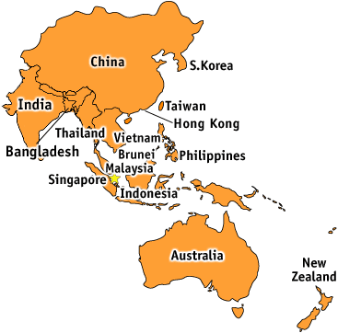
Asia is the world’s largest and most populated continent, covering 29.4% of earths land area and containing over 60% of the world’s population. Australia’s economic future is tied to the Asia as it buys 60% of Australian exports and provides half of all our imports. The main Asia- Australia’s links are with:
- South-East Asia: with Singapore being the fifth wealthiest country in the world and the 2003 Singapore- Australia free trade agreement trade has been strengthened between the 2 countries.
- Noth-East Asia: japan is Australia’s third largest source of tourist and 60 000 Japanese live in Australia.
There are several economic, cultural and strategic reasons for Australia to have a cooperative relationship with its Asian neighbours. Can you come up with 2 reasons why?
_______________________________________________________________________________________________________________________________________________________________________________________________________________________________
Plan a 2 week holiday to one of the 5 islands located in the Asia pacific region. Complete the table:
Name of country
Latitude and longitude
Time difference
Distance from Sydney to the capital city
Climate
Landforms
Natural disasters
Sights you may visit
Activities you might participate in

The association of south-east Asian nations promotes economic growth, cultural development and regional peace amongst its 10 members. Australia as one of ASEAN partners, aims to liberalise trade (removal or reduction or barriers), expand security, increase environmental protection, and stop illegal immigrants, transnational crime, piracy and terrorism. Australia has strengthened its relationships with ASEAN through 7 different links which include aid, trade, education, tourism, defence, migration, future plans.
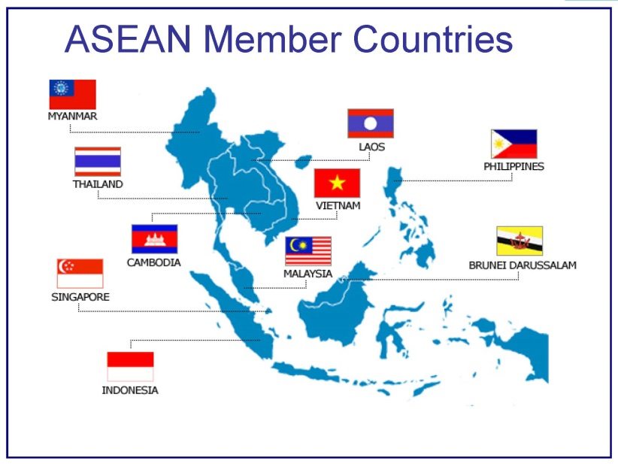
Above we have the members of the Association of south-east Asian nations. Complete the table below by researching 2 countries in the ASEAN that share the following links:
Links with Australia | Country A | Country B
Aid
Communication
Culture
Defence
Migration
Tourism
Trade
Sport
Agreements/treaties

