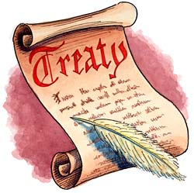
What is a treaty?
A treaty is a formal, written agreement between sovereign states or between states and international organizations.

- Research and explain 3 treaties Australia has signed ________________________________________________________________________________________________________________________________________________________________________________________________________________________________________________________________________________________________________________________________________________________________________________________________________________________________________________________________________________________________________________________________________________________________________________________________________________________

- Write a treaty between you and the school (remember it a treaty is an agreement) that is 1-2 pages long. You must include the following points in your treaty:

- People involved ( you and Verona school)
- Purpose
- The reason for and importance of the treaty
- The advantages to you and the school
- The benefits ( economic, social, political) that might outcome
Optional: select one of the Australian links from previous lesson. Write your treaty between Australia and one of the links ( eg. You can write a treaty between Australia and Asia-Pacific region and a migration problem)

