Modelling soil erosion

KEY INQUIRY SKILLS:
- processing and analysing data and information
- communicating

Equipment:
- stream tray or other metal or wooden tray
- sand
- wooden block
- rubber tubing to fit a water tap
- small plastic lid (from an orange juice container)
- twigs, matches or cotton buds to act as trees
Method
- Pack slightly damp sand into the tray so that it is fairly level.
- Use a small block of wood to raise one end of the tray slightly. Place the other end of the tray on the edge of a sink or over an empty bucket.
- With one finger, make a slightly winding groove in the sand as shown in the diagram below.
- Plant ‘trees’ along one edge of your model river using twigs, matches or cotton buds.
- Place the plastic lid in the sand at the top of the groove and aim the rubber tubing from the tap over it.
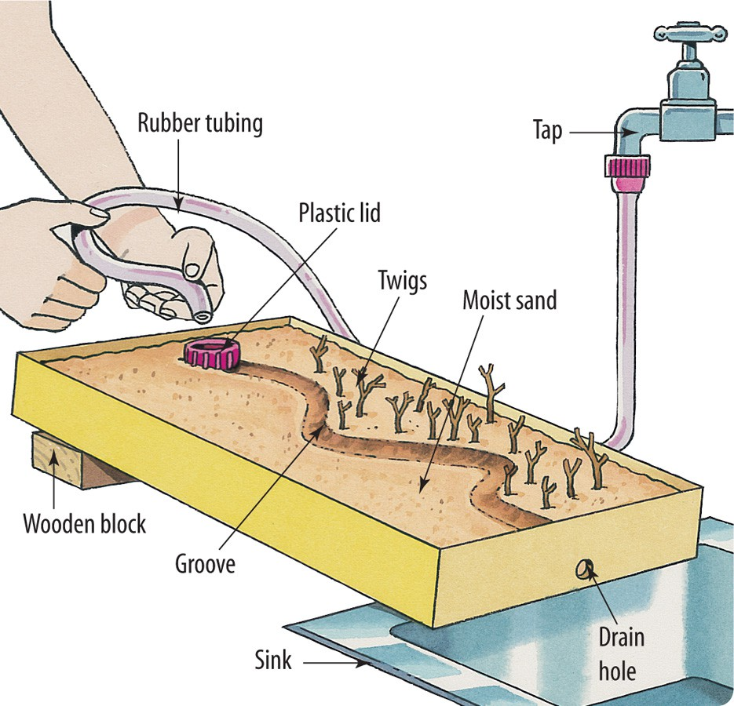
- Turn on the tap so that water flows slowly but steadily into the plastic lid, overflowing into the groove.

