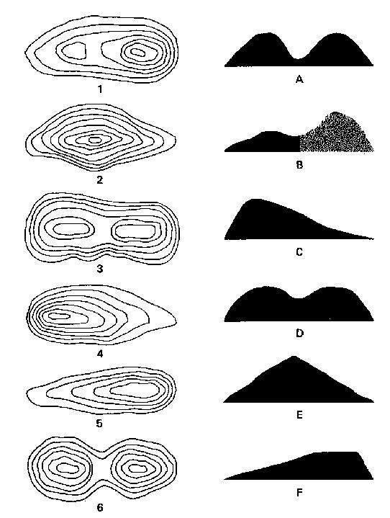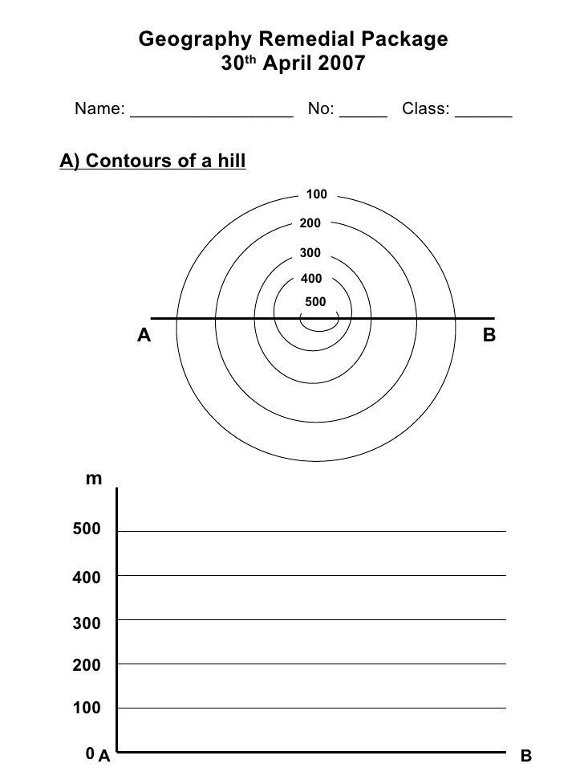

Match the contour lines to the cross sections of the hills of the hills they represent

Use a ruler and pen to draw a cross section of the hill represented by the contour lines