Task: In your own words define the term ‘Survival’:
Survival is
Task: You are to fill in the table below by predicting and questioning the provided scenarios. How would you survive in these places? Once the table is completed discuss openly, as a class, possible implications for the survivor.
 | What are the dangers? | How would you survive?
Snowy mountains
Deepest jungle
Desert

Tiny island
3km-deep mine
Being kidnapped

TREKKER LOST IN ANDES FOUND ALIVE

Pre-reading Task: TRUE / FALSE: Read the headline. Guess if below are true (T) or false (F).

a. | The man got lost in a sandstorm. | T / F
b. | He got into trouble after his motorbike broke down. | T / F
c. | He built a shelter 2,840 metres above sea level. | T / F
d. | The article said a country's president called this story a miracle. | T / F
e. | The man was found by people who were testing the depth of the snow. | T / F
f. | The man ate rats in order to survive. | T / F
g. | When he was rescued, he weighed just 20kg. | T / F
h. | People survived in the Andes for 72 days after their plane crashed. | T / F

TREKKER LOST IN ANDES FOUND ALIVE

A Uruguayan man who disappeared before the start of winter in the Andes Mountains has been found alive and well.
Raul Fernando Gomez, 58, got lost in a blizzard while trying to cross the Andes range from Chile to Argentina. The start of his ordeal began when his motorbike broke down in the middle of nowhere. Mr Gomez told reporters he had no choice but to walk in the hope of finding a town nearby.
He became disoriented in the heavy snowfall and could not find his way back to the road. He found a mountain shelter 2,840 metres above sea level and holed himself up there hoping to survive the long, freezing winter.
A local governor said: "The truth is that this is a miracle. We still can't believe it." Mr Gomez was found and rescued by a team of Argentine meteorological officials who had helicoptered to the shelter to record snowfall levels. He had survived by catching rats and eating leftover supplies he found in the shelter.
Doctors expressed surprise at how well he had fared. He was very thin and had lost 20kg in weight. A doctor said he was surprised by Mr Gomez's resilience, saying: "He's a patient with high blood pressure, a history of smoking and signs of undernourishment, but…in a few days we're going to discharge him." Members of a Uruguayan rugby team famously survived sub-zero temperatures in the Andes for 72 days in 1972 by eating the bodies of fellow plane-crash victims.
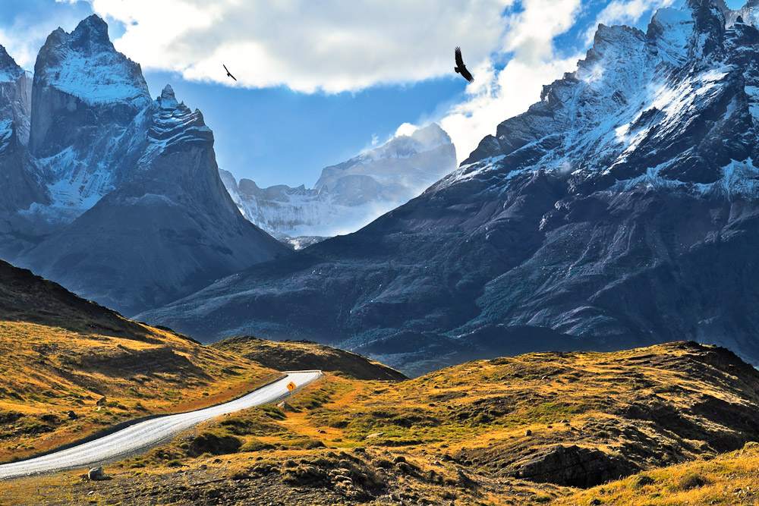

TREKKER LOST IN ANDES FOUND ALIVE
1 | When did Mr Gomez disappear? __________________________________________________________________________________________________________________________________________________
2 | Where was Mr Gomez going? __________________________________________________________________________________________________________________________________________________
3 | How did his nightmare begin? __________________________________________________________________________________________________________________________________________________
4 | What did he find high in the mountains? __________________________________________________________________________________________________________________________________________________
5 | What did a local governor call Mr Gomez's survival? __________________________________________________________________________________________________________________________________________________
6 | How did the snowfall recorders get to the shelter? __________________________________________________________________________________________________________________________________________________
7 | What did he find at the shelter? __________________________________________________________________________________________________________________________________________________
8 | How much weight did he lose? __________________________________________________________________________________________________________________________________________________
9 | How long will he stay in hospital? __________________________________________________________________________________________________________________________________________________
10 | 0 For how long did airplane passengers last in the Andes? __________________________________________________________________________________________________________________________________________________

