Concept:
Name
Shark Tank
An entrepreneur walks down a dimly lit corridor, alone and nervous, with nothing but a business proposal. The large wooden doors open. $1 billion stares back from leather seats.
Welcome to Shark Tank, Ten's newest reality TV show where hopeful entrepreneurs ask five Australian multimillionaires to invest hundreds of thousands, millions even, in their idea. In return, investing sharks get an ownership percentage. After contestants make their pitch, the sharks pick apart every fine detail in a swirl of facts and figures. It's an impressive display of expertise. Contestants who withstand the firing line of questions are made an offer.
The concept originated in Japan's Tiger of Money and has been recreated in America's Shark Tank and the UK's Dragon's Den. In 2005, Network Seven attempted an Australian version of Dragon's Den before discontinuing due to poor ratings. But Network Ten are hopeful given Shark Tank's success in America, nominated for an Emmy earlier this year.
Estimated by Ten to be collectively worth just under $1 billion, the sharks include Andrew Banks (of Talent2), Naomi Simson (RedBalloon), Janine Allis (Boost Juice Bars), Steve Baxter (entrepreneur and investor), and John McGrath (McGrath Estate Agents).
The Australian sharks are markedly kinder than their American counterparts. Shark Tank Executive Producer, Paul Leadon, says "it isn't like blood in the water, which tends to be the US version. This is far more gentle."
Shark Andrew Banks says this is because "Australians like to give people a go. They back the underdog."
"For an Australian shark to say 'I send my money out like soldiers and they come back each day' (as Canadian entrepreneur Kevin O'Leary famously did in the US Shark Tank), I mean Australians will go 'who is he kidding? He's dreaming! Is this a comedy show?' So I think we're real, we're a bit more grounded."
That said the successful chairman of Talent still loves a metaphor. "The thing I love about sharks is they have to keep swimming or they die. So I'm definitely one of those. [I have] to keep moving," Banks says. On the show, he is authoritative but rarely cruel.
Naomi Simson, who launched RedBalloon from home with a second-hand computer, opts for a straight-shooting attitude. "I did bring out my mummy voice a few times," she says.
"Fourteen years ago, I would've been the one at the other side of the table, pitching an idea that nobody had ever heard of," Simson says. "Probably the sharks would've said no to me. They would've said 'You're dreaming!' But that's what it takes to run a business: you've got to dream."
The show is full of dreamers. Mums, scientists, university students and teenagers from across Australia dared to present their ideas, from apps to medical technology to the "hamdog" (hamburger hotdog).
Many have put a lot on the line to launch their businesses. The sharks themselves know a lot about taking risks. Banks borrowed $5000 he didn't have for his first business, and $200,000 for his second.
So when does taking a risk turn into demise? 'I think it's going from the rational to the irrational," Banks says. "Ninety per cent of small businesses fail because a lot of people have too much courage and passion and not enough planning."
The sharks are kind, but they're not afraid to devour an idea that won't make money. "We're not in business for the donations!" Simson says.
"We don't have to be nice," she says. "In fact often we do people a far greater service by challenging people to greatness."
"This is not a "get rich quick, if you get on the show, everything's going to be okay'. Business is hard. Business is tough. There's never a silver bullet."

- Define the terms;
Entrepreneur
Demise
Invest
Irrational
Rational

- Watch the following presentation that displays some current ideas from the show in America.
https://prezi.com/w7bclvedqzoi/copy-of-shark-tank-assignment/
- Which one would you invest in and why?

- More recently, the Australian version of Shark tank began. Here is what two men came up with and pitched to the show.
https://www.youtube.com/watch?v=e2GIuVMsCSE

- Do you think it is a good idea? Why or why not?

- Who is the target population?

- What are the strengths and weaknesses to the idea?
Strengths | Weaknesses

- How would you advertise the product? Examples would be commercials, posters, magazines and newspapers.

- Choose one of the examples above and create your own advertisement for this new product. Include; what it is, price, availability, where to get it from and a slogan.

- How would you sell the idea to the sharks? Conclude all of the questions you have just completed into a short pitch.

Now it’s your turn!
You are a young student that has been invited to propose an idea on Shark Tank on the upcoming show. You must act fast and create an idea of your own that no one has seen before. This idea can be a new invention or it can be a different take on an existing product currently on the market. Create something innovative for your chance to become a wealthy business owner or entrepreneur like the sharks.
In creating your product you must follow these guidelines:
- Identify the product (What your idea is)
- Identify a target audience
- Identify what materials you will need to create your product
- Design your product
- Create an advertising campaign (Television Ad, posters, Radio etc).
- Identify what kind of financial aid you will need
- Create a pitch to the sharks (presentation or speech)

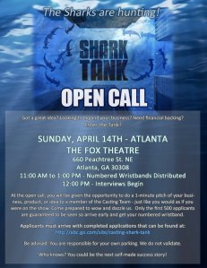

  - The idea.
Use the mind maps below to find areas or ideas you are interested in. You can then use the topic ideas to devise your product.

- Select one idea from above and explain exactly what it is below.

- What is your target audience and why?

- How can you direct this product towards them? Think of advertising techniques.

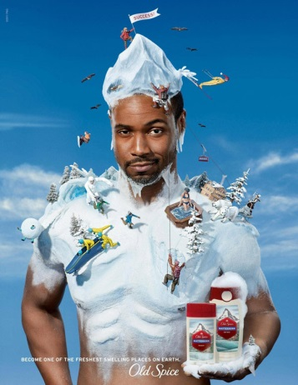
- What kind of materials would you need to make your product? Are they easily accessible?

- How can you promote/ advertise your product? What kind of advertising techniques could you use?

- Create 2 advertisements for your product that will be released to the public and the sharks. Ensure you plan out what is required before beginning.

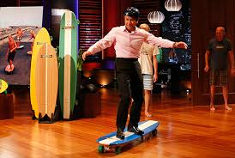

- It’s time to create your pitch. This can be in the form of a PowerPoint and a short speech. The pitch must include;
Introduction- What is your product.
Body- Who your target audience is, why your product will benefit them and how you plan to sell/ advertise the product.
Conclusion- Wrap up all you have stated in the introduction and the body. Finally, state how much money is required to get your idea off the ground and any other concluding statements.
*Really try to sell your idea! Say how great it is and that people will love it!
GOODLUCK!

