The Greenhouse Effect
Unit 8.1
Aim
To simulate the conditions required for the greenhouse effect

Equipment
Small cardboard box (e.g. a shoebox), 2 thermometers or temperature probes and datalogging equipment, sheet of glass or polythene plastic, lamp

Method
- Assemble the apparatus as shown in Figure 8.1.12.
- Turn on the lamp and measure the temperature at regular intervals (e.g. every minute) for 10 minutes.
- Turn off the lamp, but continue to measure temperature for another 10 minutes.
- If time permits, investigate the effect of an additional layer of glass or plastic.

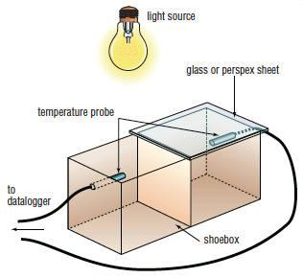
Figure 8.1.12

