The greenhouse effect on a small scale

KEY INQUIRY SKILLS:
- conducting
- processing and analysing data and information

Equipment:
- several kinds of flower seed
- moist soil
- 2 thermometers
- 2 seed trays
- plastic cling wrap
- 2 sticks
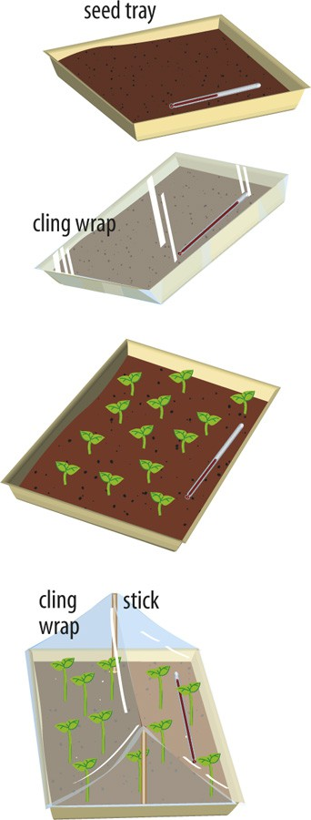
Method:
- Place the soil in two seed trays.
- Plant the flower seeds.
- Place a thermometer in each tray.
- Cover one of the trays with plastic cling wrap.
- Place the trays in an area exposed to the sun but protected from the rain.
- When the plants begin to grow, insert sticks in the covered tray to raise the cling wrap.
- Record the temperature in each tray every second day.
- Plot your temperature results on a graph using two different pencil colours, one for each tray.

