Bean Stalk Experiment

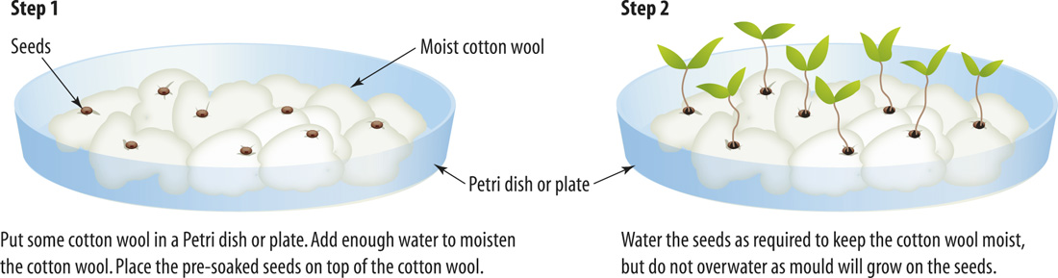

Research Question: ……………………………………………………………………............................

…………………………………………………………………………………………………………………….......

Independent variable: ……………………………………………………………………………………

…………………………………………………………………………………………………………………….......

Dependent variable: ………………………………………………………………………………………

…………………………………………………………………………………………………………………….......

Controlled variable: ………………………………………………………………………………………

…………………………………………………………………………………………………………………….......

Bean Stalk Experiment Report

Aim (A statement about why you did the experiment)

......................................................................................................................................................................

......................................................................................................................................................................

Materials (A list of the equipment and chemicals that were used)
- …………………………
- …………………………
- …………………………
- …………………………
- …………………………
- …………………………
- …………………………

Method (An account of what was done)

......................................................................................................................................................................

......................................................................................................................................................................

Results (A presentation of your data)
 | A (cm) | B (cm) | C (cm) | D (cm) | E (cm) | F (cm)

Week 1

Week 2

Week 3

Week 4

Week 5

Discussion (An explanation of your results)

......................................................................................................................................................................

......................................................................................................................................................................

......................................................................................................................................................................

......................................................................................................................................................................

......................................................................................................................................................................

......................................................................................................................................................................

Conclusion (A brief account of what you found out and how your findings relate to your aim)

......................................................................................................................................................................

......................................................................................................................................................................

......................................................................................................................................................................

......................................................................................................................................................................

......................................................................................................................................................................

......................................................................................................................................................................

