Excellence in Teaching
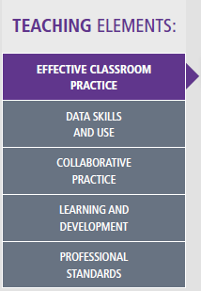
Excellence in Teaching is also linked closely to the Every Student, Every School policy (DEC, 2012) and Strong start, Great teachers (DoE, 2015). High quality teaching is demonstrated through professionalism, commitment, engaging learning opportunities, and the use of evidence-based practices. High quality teachers evaluate their practices individually and collaboratively, including sophisticated analysis of student engagement, learning growth and outcomes to plan future learning for students in their care (DEC, 2014a).
Link: Every Student, Every School; Great Teaching, Inspired Learning;& Quality Teaching Framework
The Elements provide a platform for communication with students and when used effectively with the continuums enable students to have a clear understanding of how to improve their learning. The Elements also provide the leadership teams with a document to demonstrate and promote effective, evidence-based practices throughout the school, and a means to reflect on their practice through the Quality Teaching Framework.
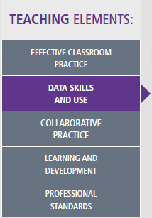
Link: Every Student, Every School; Australian Professional Standards for Teachers; Australian Curriculum
The Elements provide a means of collecting qualitative and quantitative data to track student progress. This data includes:
- Unit plan evaluations
- Work samples
- Student attendance rates
- Suspension rates
- Incident reports
- Student reward systems
- Whole school learning activities

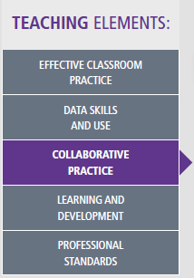
Link: Strategic Directions & Community of Schools
By developing a shared framework on a school and inter-school level, collaborative practice is embedded within the creation of the Elements and promotes sharing of resources to ensure the best practice is provided for our students. The Elements provide the school with explicit systems for collaboration, observations, feedback, professional areas of development and effective practice to continue collaborating with others to improve teacher practice and student outcomes.

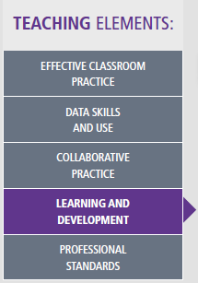
Link: Great Teaching, Inspired Learning
The Elements provide a framework that allows teachers to identify the most relevant professional learning for them, while linking it to the school plan, and Department of Education policies and reforms. It also supports all teachers by providing them with a clear and concise path to effective teaching within our setting.

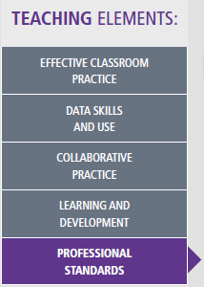
Link: Australian Professional Standards for Teachers
The Elements provide support for teachers working towards a range of levels within the Australian Professional Standards for Teachers (BOSTES, 2015). Through the Elements, teachers are able to collect relevant and explicit evidence linked to the standards, and have an opportunity to reflect on their professional practice against their Personal Learning and Development Plans.

