Excellence in Learning
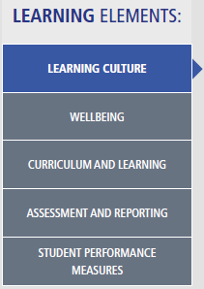
Excellence in Learning is linked closely to Every Student, Every School (DEC, 2012) and Strong start, Great teachers (DoE, 2015). Learning elements are focussed on developing an understanding of the skills, experiences and knowledge our students bring to class, and using this understanding to plan their personalised learning paths so that each student is engaged in rich learning experience and developing the skills they need to be successful throughout their lives (DEC, 2014a)
Links: Strategic Directions; Elements Pillars
The Elements of Learning and Achievement demonstrate our school-wide learning culture through the school plan addressing quality teaching and learning, quality relationships and quality systems through a creative, shared and consistent vision that is able to be shared with all key stakeholders. The framework encourages students to take responsibility through developing skills and giving them the ability to engage with the curriculum in a way that is relevant to them.
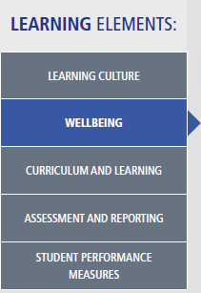
Links: Wellbeing Framework; Health and Wellbeing; Actions and Choices
The Elements were developed as a comprehensive and inclusive framework to support the range of needs our students have, while leaving room for individual adjustments that need to be made. Through Health and Wellbeing, and Actions and Choices, students are explicitly taught skills to manage their own cognitive, social, physical and spiritual wellbeing.
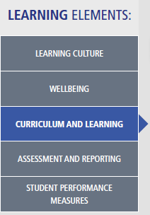
Link: Australian Curriculum; Students’ Elements
The Elements have been developed through working closely and collaboratively with the Community of Schools (CoS) group. It provides teachers with a means of collaboratively developing and sharing programs that incorporate the curriculum, continuums and relevant policies, while being aligned with the school’s vision, values and priorities. This means that curriculum planning is shared and discussed to ensure the best and most suitable programs are created and implemented for our students. The Elements ensure that the
programs remain relevant to our students’ needs and interests.
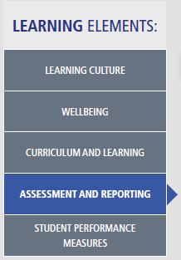
Link: School Plan; Literacy and Numeracy Continuums; PLSPs, Assessment
Through the Elements of Learning and Achievement, a range of personalised learning and support plans (PLSPs) have been developed, which utilise the literacy and numeracy continuums to keep accurate records of student progress and achievement. These PSLPs also provide staff with a common language to engage with the key stakeholders in the community.

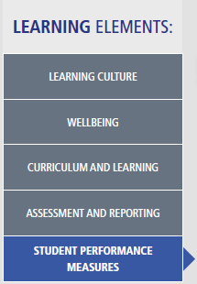
Link: Literacy and Numeracy Continuums
Through the Elements of Learning and Achievement, the school will strive to move our students to performing at or above national standards. The Elements allow staff to collect and measure students against internal school performance measures using practical activities and the continuums in ways which are relevant to our students.

