Excellence in Leading
"School leaders can play major roles in creating the conditions in which teachers can teach effectively and students can learn."
(Dinham, 2008)
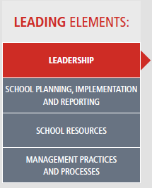
Excellence in Leading is closely linked to the higher levels in the Australian Professional Teaching Standards (BOSTES, 2015). Leadership should be strong, strategic and effective to support the highest levels of learning across the school (DEC, 2014a). The Elements of Learning and Achievement provide opportunities to develop leadership skills through aspects of the Elements Framework to engage the community in developing student learning and social outcomes.
Link: Australian Professional Teaching Standards
The Elements of Learning and Achievement provide a range of leadership opportunities and give both school executive and aspiring leaders a clear direction to support the school plan. It also provides a framework that can be used to clearly communicate the school curriculum and values to the community.

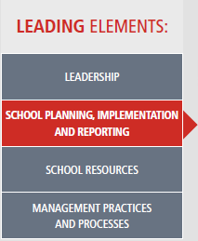
Link: Strategic Directions
Through the development of the Community of Schools group, the Elements provided a platform for planning at a whole school, and collaborate with other schools that have similar needs. The Strategic Directions of both the school and Department of Education are directly linked to the Elements of Learning and Achievement. This allows the strategic directions of the school to be reinforced across all levels of planning in the school.

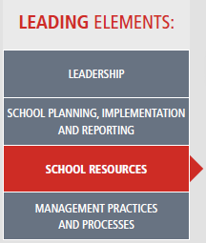
Link: Local Schools, Local Decisions
The Elements of Learning and Achievement provides schools with a means of developing and organising resources to suit the needs of their students. The Elements were established to support students with complex needs. The framework provides students with seven pillars based on a core skill set that is implemented and reinforced across all school plans and programs. The Elements allows staff to directly link decisions about resources at a local level to support and guide all members of the school community.
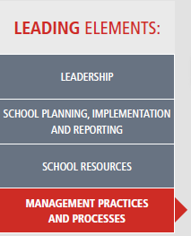
Link: Great Teaching, Inspired Learning
The Elements of Learning and Achievement provide schools with an explicit, systematic framework to develop, implement and evaluate management practices and processes across the school. These leading and management practices and processes will then link to not only supporting student outcomes, but also school programs.

