Sculpture Skills Checklist 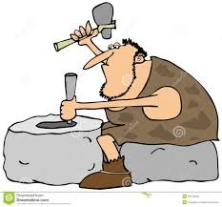
Student Name: | No | Sometimes | Usually | Yes | Always
Displays interest in the form of sculpture and 3D art
Achieves success when using and manipulating materials
Perseveres with a variety of sculpture tasks
Demonstrates skill in joining
Demonstrates skill in assembling
Pays close attention to details
Carefully plans and executes the task at hand
Demonstrates ability to use wire cutters when joining wire
Uses equipment with knowledge and skill
Enjoys exploring the possibilities of available materials
Demonstrates understanding of safety procedures when using tools
Creates 2D drawing/plan before commencing work
Is able to carry out process with minimal assistance
Can create suitable designs for sculpture
Demonstrates creativity and an aptitude for sculpture
ASSESSMENT - Achievement: Effort:
Comment:
ASSESMENT – YEARLY Achievement: Effort:
Comment:

