Edgeware School
Student: …………………………
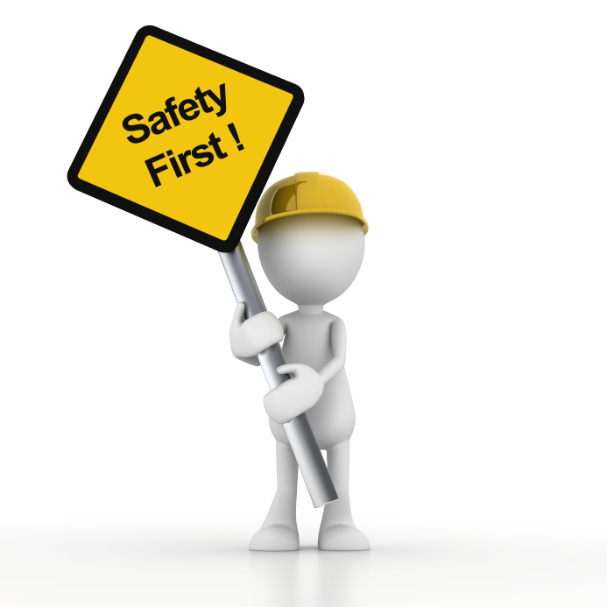

Safety in the
Woodwork Room

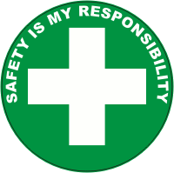
Woodwork Maintenance Elective
Safety Form

Student: ______________________________

Safety Rules for Woodwork
- Be safe, safety is the first priority
- Follow teachers directions
- Wear safety protection as required. Wear covered shoes.
- Ask first to use the tools
- Secure any loose clothing and hair
- Use the right tool for the right job.
- Check tools first and report any malfunctions
- Make sure your hands and body parts, cords and people are safely away from sharp, heavy and moving parts (hands and fingers must not be in front of cutting blades)
- Do not disturb people using tools
- Machine guards must be in place
- Do not damage tools, materials or school environment
- Keep work areas tidy
If you are not sure of something make sure you ask.

SAFETY AGREEMENT
I have watched the safety in the work shop video
I have read the rules above
I have participated in a safety tool talk with a staff member
I agree to be safe and follow the rules

Signed: _________________________ Date: _____ / _____ / _____
Woodwork Maintenance Elective
Safety

Student: ______________________________

Watch this video on youtube, mrmshow shop safety:
https://www.youtube.com/watch?v=qrOi-kJUyV0

Choose three rules and write what the consequnces (what might happen) if someone does not follow those rules.
- Rule: _______________________________________________________________________
Consequence: _______________________________________________________________

- Rule: _______________________________________________________________________
Consequence: _______________________________________________________________

- Rule: _______________________________________________________________________
Consequence: _______________________________________________________________

List what your top 5 safety rules would be:
__________________________________________________________________________________________________________________________________________________________________________________________________________________________________________________________________________________________________________________________________________________________________________________________________________________________

Fill out a risk assessment or hazard form on any risks or hazards in the wood work room.

