|  |
| --- |
| **Introduction** |

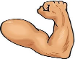

Don’t forget me!

|  |
| --- |
| **Body** |

|  |
| --- |
| **Conclusion** |