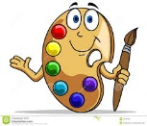Painting Skills Checklist 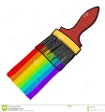
Student Name: | No | Sometimes | Usually | Yes | Always
Can identify and appreciate different styles of painting
Displays interest in the form of painting
Perseveres with a variety of painting tasks
Uses painting equipment with knowledge and confidence
Applies paint correctly and neatly when required
Enjoys experimenting with a variety of painting materials
Demonstrates understanding of how to use the colour wheel when painting
Individual painting style emerging
Is able to identify complementary colours on a colour wheel
Displays interest when appreciating artists and their artworks
Can identify and name primary colours
Can identify and mix secondary colours
Finishes painting tasks on regular basis
Can identify, name, and mix tertiary colours
Displays an ability to tint or shade colours
Demonstrates ability to use acrylic paints
Displays ability and knowledge on how to mix tones
Demonstrates ability to use a variety of brush strokes
Demonstrates ability to use tone effects
ASSESSMENT - Achievement: Effort:
Comment:
ASSESMENT – YEARLY Achievement: Effort:
Comment:

