|  |  |  |  |  |
| --- | --- | --- | --- | --- |
|  | **Campbell House School Teaching And Learning Program** | | | |
| **Title of Unit: Financial Mathematics**  **Duration: 10 weeks** | | | |
| **Syllabus Outcomes**  **Stage 4** | MA4-2WM: applies appropriate mathematical techniques to solve problems  MA4-3WM: recognises and explains mathematical relationships using reasoning  MA4-6NA: solves financial problems involving purchasing goods | | | |
| **Syllabus Outcomes**  **Stage 5** | MA5.1-4NA: solves financial problems involving earning, spending and investing money  MA5.2-2WM: interprets mathematical or real-life situations, systematically applying appropriate strategies to solve problems  MA5.2-1WM: selects appropriate notations and conventions to communicate mathematical ideas and solutions | | | |
| **Connectedness: Why does this learning matter** | **Students:**  Investigate and calculate the Goods and Services Tax (GST), with and without the use of digital technologies   * Investigate and calculate the Goods and Services Tax (GST), with and without the use of digital technologies * calculate GST and GST-inclusive prices for goods purchased in Australia, given the pre-GST price * interpret GST information contained on receipts (Communicating) * investigate efficient methods of computing the GST and GST-inclusive prices (Problem Solving) * explain why the value of the GST itself is not equivalent to 10% of the GST-inclusive price (Communicating, Reasoning) * determine the pre-GST prices for goods, given the GST-inclusive price * explain why the pre-GST price is not equivalent to 10% off the GST-inclusive price (Communicating, Reasoning)   Investigate and calculate 'best buys', with and without the use of digital technologies (ACMNA174)   * solve problems involving discounts, including calculating the percentage discount * evaluate special offers, such as percentage discounts, 'buy-two-get-one-free', 'buy-one-get-another-at-half-price', etc, to determine how much is saved (Communicating, Problem Solving) * calculate 'best buys' by comparing price per unit, or quantity per monetary unit, eg 500 grams for $4.50 compared with 300 grams for $2.75 * investigate 'unit pricing' used by retailers and use this to determine the best buy (Problem Solving) * recognise that in practical situations there are considerations other than just the 'best buy', eg the amount required, waste due to spoilage (Reasoning) * use price comparison websites to make informed decisions related to purchases under given conditions (Problem Solving)   Solve problems involving earning money   * calculate earnings from wages for various time periods, given an hourly rate of pay, including penalty rates for overtime and special rates for Sundays and public holidays * use classifieds and online advertisements to compare pay rates and conditions for different positions (Problem Solving) * read and interpret examples of pay slips (Communicating) * calculate earnings from non-wage sources, including commission and piecework * calculate weekly, fortnightly, monthly and yearly earnings * calculate leave loading as 17.5% of normal pay for up to four weeks * research the reasons for inclusion of leave loading provisions in many awards (Reasoning) * use published tables or online calculators to determine the weekly, fortnightly or monthly tax to be deducted from a worker's pay under the Australian 'pay-as-you-go' (PAYG) taxation system * determine annual taxable income by subtracting allowable deductions and use current tax rates to calculate the amount of tax payable for the financial year * determine a worker's tax refund or liability by comparing the tax payable for a financial year with the tax already paid under the Australian PAYG system (Problem Solving) * investigate how rebates and levies, including the Medicare levy and Family Tax Benefit, affect different workers' taxable incomes (Problem Solving) * calculate net earnings after deductions and taxation are taken into account | | | |
| **Background Information and Key Ideas** |  | | | |
| **The elements of learning and achievement** | **Teaching and Learning**  **Weekly Lesson Overview** | | | **Australian Curriculum General Capabilities** |
| **Literacy-**Reading, Writing ,Comprehension  F:\Mock ups\Square elements\Literacy.jpg  **Numeracy-** Number and Maths  F:\Mock ups\Square elements\Numeracy.jpg  **Work Education-** Work Readiness, Vocational Education    **Health and Wellbeing-**Fitness, Healthy Eating, Adolescent Health and Safety    **Actions and Choices-**Pro- social skills, Positive Relationships, Restorative Practices  **21st Century Learner-**Navigate Technology, Word Processing, Research Skills  E:\Final V1\Final sq NO border\Sq Technology no bdr.jpg  **Global Citizen-**General Knowledge, Current Affairs, Understanding cultures and community | **Formative Assessment / Background Information**  Prior to commencing this unit, it is imperative that students have a solid understanding of terms such as daily, weekly, fortnightly, monthly, leap year, and annually.  Students are to work on the worksheet Skill Check 1.  Adjustment: some students may need to use the printable calendar for support.    **Wages and Salary**  Write this information on the board and ask students to copy it down:  People who work usually earn a wage or a salary. A **wage** is calculated by the number of hours worked and is usually paid weekly. People such as supermarket cashiers, electricians and gardeners earn a wage. Wage earners can earn more income by working extra hours (overtime).  A **salary** is a fixed annual amount paid weekly, fortnightly or monthly. People such as architects, software designed and police earn a salary. Salary earners do not earn overtime pay but can receive benefits such as a company car, expense account, shares in the company or paid medical expenses.  Go through the following examples with the students:  Example 1:  Example 2:  Example 3:    Students to do Exercise 8-01 on pages 286-288 of New Century 9.  *Investigation*  Students are to [www.seek.com.au](http://www.seek.com.au) to find a job advertisement for 1-3 jobs, print the advertisement and share the following information with the class   * a brief job description and whether the job is full-time or part-time, permanent or casual * whether a salary or wage is paid, and how much * whether there are any other payments, incentives, or benefits that may come with the job.   **Overtime Pay**  Ask students to write the following information in their books:  Wage earners can receive **overtime** pay when they work more than their standard number of hours.  The two most common rates for overtime pay are:   * time-and-a-half = 1.5 X normal hourly rate * double time = 2 X normal hourly rate.   Go through the following examples with the students  Example 4:    Example 5:    and Example 6 and Example 7 on pages 290-91.  Students are to work through Exercise 8-02 on pages 291-93 on the New Century 9 textbook.  Technology: Calculating Incomes  Students are to use Microsoft Excel to calculate the incomes of employees at J-Mart.  Students to complete activity on page 293 of the New Century 9 textbook.  Steps to do this are:  **Step 1**  Open your income and expenses Excel worksheet.  **Step 2**  Select an empty cell beneath the last item in your "income" column.  **Step 3**  Type "Total Income" in this cell, then press the "Enter" key.  **Step 4**  Select the cell directly beneath the "Total Income" label.  **Step 5**  Type "=SUM(" into this empty cell.  **Step 6**  Select the first entry in your "Income" column, press the "Shift" key, select the last income item in that column, then press the "Enter" key to calculate your income total.  **Step 7**  Select an empty cell beneath the last item in your "Expenses" column.  **Step 8**  Type "Total Expenses" in this cell, then press the "Enter" key.  **Step 9**  Select the cell directly beneath the "Total Expenses" label.  **Step 10**  Type "=SUM(" into the empty cell.  **Step 11**  Select the first entry in your "Expenses" column, press and hold the "Shift" key, select the last expense item in the same column, then press the "Enter" key to calculate your total expenses.  **Commission, piecework and leave loading**  Some workers are paid by the amount of time they work, but by the number of items they make or process.  *Commission*  Commission is earned by salespeople or agents of a business or a company. It is calculated by the percentage of the value of items sold or income made. A fixed amount called a retainer may also be paid. Real estate agents and actors’ agents earn a commission.  Teacher to go through examples on pages 295-297.  Students to work through Exercise 8-03 on pages 297-299.  *Investigation*  Students to research a job where a salesperson is paid commission and calculate how much they would earn in a week, month, and year.  **Income Tax**  Teacher to go through examples on pages 300-301.  Students to go through activities on pages 301-302.  *Technology*  The ATO website has an online calculator for income tax. Visit the website and search ‘Simple Tax Calculator’ to find the income tax calculator for individuals.  Refer to page 302-303 for further instructions.  **PAYG tax and net pay**  To avoid paying income tax as a huge sum at the end of the financial year, tax is deducted from your gross pay every payday by your employer. This is called PAYG (Pay as you go) tax. The total amount of PAYG tax paid over the year is usually more than the actual income tax payable, so at the end of the financial year you will receive the difference as a **tax refund**. However, if the PAYG tax is paid less than the income tax payable, you will have a **tax debt** and have to pay more.  Teacher to go through Example 15 on 304 of the textbook.  *Gross pay and net pay*  **Gross pay** is the total amount a person earns or receives each payday.  Most income earners have a variety of deductions made against their gross pay before they receive it, including PAYG tax, superannuation contributions, union fees and health fund payments.  The amount of income left after the deductions is called **net pay**.  Teacher to go through Example 16 on 305 of the textbook.  Students to complete Exercise 8-05 on pages 305-307.  *Technology*: *PAYG Tax Calculator*  Students to find the PAYG tax payable and net pay for each of the following:   1. $505 a week 2. $1466 fortnightly 3. $2730 monthly   **Goal Setting**  Begin by asking students what career they like to pursue when they are older.  Ask students to go onto the following website and research how much someone in that field would get paid hourly, weekly, monthly and annually.  www.payscale.com/research/AU/Country=Australia/Salary  When students have completed doing their research, ask them to fill in the **Financial Mathematics** worksheet. | | | **Aboriginal and Torres Strait Islander histories and cultures boriginal and Torres Strait Islander histories and cultures**  **Asia and Australia's engagement with Asia sia and Australia's engagement with Asia**  **Sustainability ustainability**  **Critical and creative thinking ritical and creative thinking**  **Ethical understanding thical understanding**  **Information and communication technology capability nformation and communication technology capability**  **Intercultural understanding ntercultural understanding**  **Literacy iteracy**  **Numeracy umeracy**  **Personal and social capability ersonal and socail capability**  **Civics and citizenship ivics and citizenship**  **Difference and diversity ifference and diversity**  **Work and enterprise ork and enterprise** |
| **Quality Teaching** | | | | |
| **Intellectual Quality**   * IQ1 Deep Knowledge * IQ2 Deep Understanding * IQ3 Problematic Knowledge | **Quality Learning Environment**   * QLE1 Explicit Quality Criteria * QE2 Engagement * QE3 High Expectations * QE4 Social Support * QE5 Students’ Self-regulation * QE6 Student Direction | | **Significance**   * S1 Background Knowledge * S2 Cultural Knowledge * S3 Knowledge Integration * S4 Inclusively * S5 Connectedness * S6 Narrative | |
| **Literacy- One for each student** | **N/A this unit does not assess literacy outcomes** | | | |
| **Numeracy- One for each student** | **Student:**  **Literacy Aspect:**  **Element:**  **Teaching activities linked to program to increase learning:** | | | |
| **Special Needs Adjustments:** | | **School to work:** | | |
| Calm, relaxed and supportive work environment  No time restraints  Program targeted for students with high intrapersonal intelligence | | Working independently  Self-manage  Self-monitor | | |
| **Assessments:**  **Types of assessment:**  Student work sample  Observations  Instruction material  Formal assessment  In-class quiz | **Student:** Rebecca  **Numeracy Aspect:** Unit structure of length, area and volume  **Element:** Uses a single unit repeatedly (iterating) to measure or construct length  **Teaching activities linked to program to increase learning:** Activities throughout the program such as the metric unit conversion worksheets were included to assist students develop the foundation of numeracy skills in order to be able to work towards achieving the numeracy element of using a single digit repeatedly.  **Student:** Joshua  **Numeracy Aspect:** Unit structure of length, area and volume  **Element:** Uses a single unit repeatedly (iterating) to measure or construct length  **Teaching activities linked to program to increase learning:** Activities throughout the program such as the metric unit conversion worksheets were included to assist students develop the foundation of numeracy skills in order to be able to work towards achieving the numeracy element of using a single digit repeatedly.  **Student:** Maddison  **Numeracy Aspect:** Unit structure of length, area and volume  **Element:** Uses a single unit repeatedly (iterating) to measure or construct length  **Teaching activities linked to program to increase learning:** Activities throughout the program such as the metric unit conversion worksheets were included to assist students develop the foundation of numeracy skills in order to be able to work towards achieving the numeracy element of using a single digit repeatedly.  **Student:** Josh  **Numeracy Aspect:** Unit structure of length, area and volume  **Element:** Uses a single unit repeatedly (iterating) to measure or construct length  **Teaching activities linked to program to increase learning:** Activities throughout the program such as the metric unit conversion worksheets were included to assist students develop the foundation of numeracy skills in order to be able to work towards achieving the numeracy element of using a single digit repeatedly. | | | |
| **Resource List** | | **Unit Reflection** | | |
| Surface Area and Volume Booklet  Metric units conversion quiz  *New Century Maths 8* text book | | **What was successful:**  **What needed to be changed:**  **What overall level of understanding did students receive?**  **How well did this unit match the elements and general capabilities?** | | |

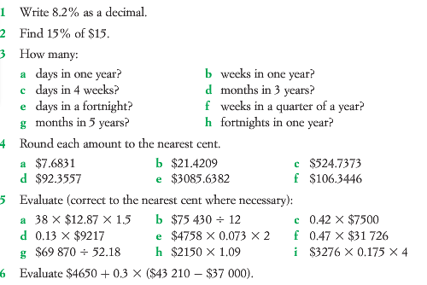



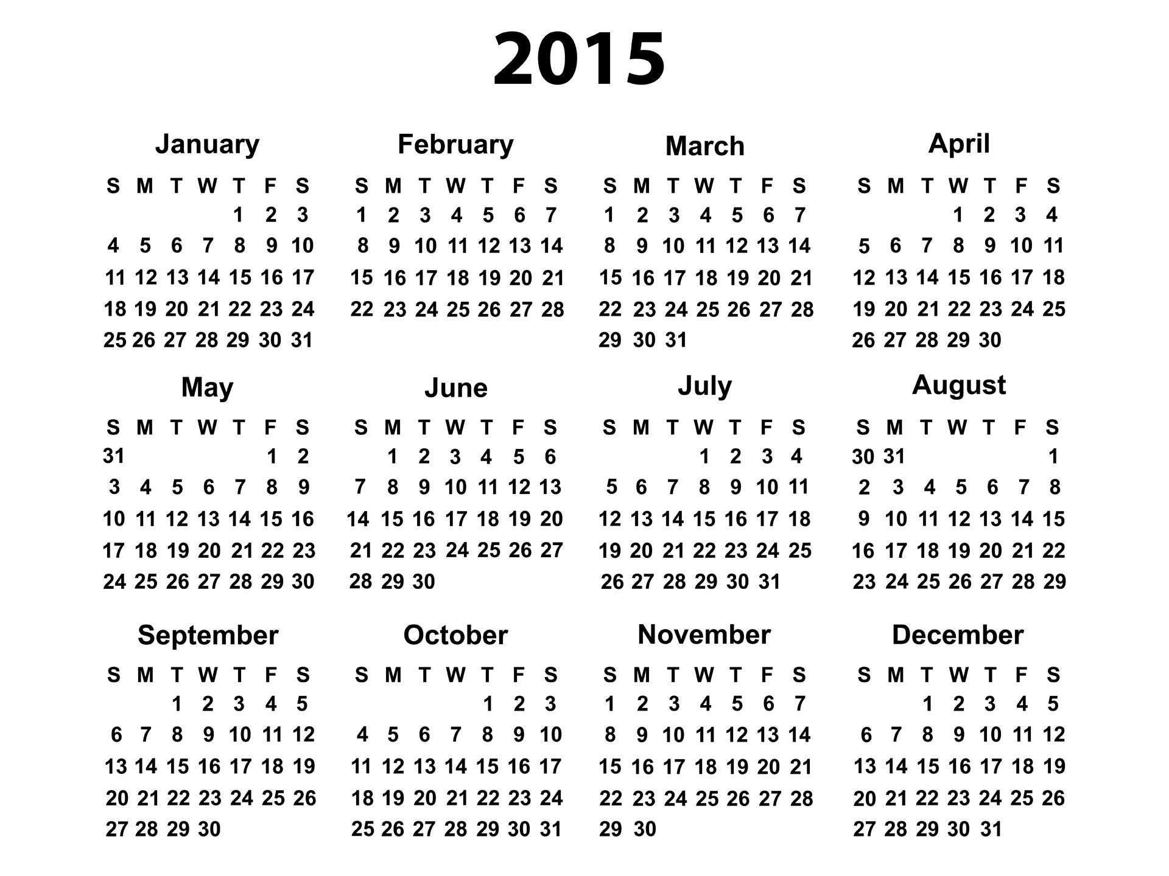

**Financial Mathematics**

www.payscale.com/research/AU/Country=Australia/Salary

|  |  |  |  |  |
| --- | --- | --- | --- | --- |
| **Occupation** | **Hourly** | **Weekly** | **Monthly** | **Annually** |
| Accountant |  |  |  |  |
| Cashier |  |  |  |  |
| Computer Technician |  |  |  |  |
| Hairdresser |  |  |  |  |
| Musician or singer |  |  |  |  |
| Personal Trainer |  |  |  |  |
| Physician/Doctor, General Practice Salary |  |  |  |  |
| Registered Nurse |  |  |  |  |
|  |  |  |  |  |
|  |  |  |  |  |