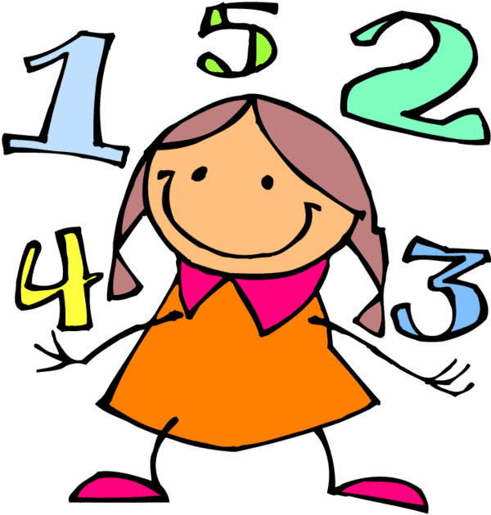
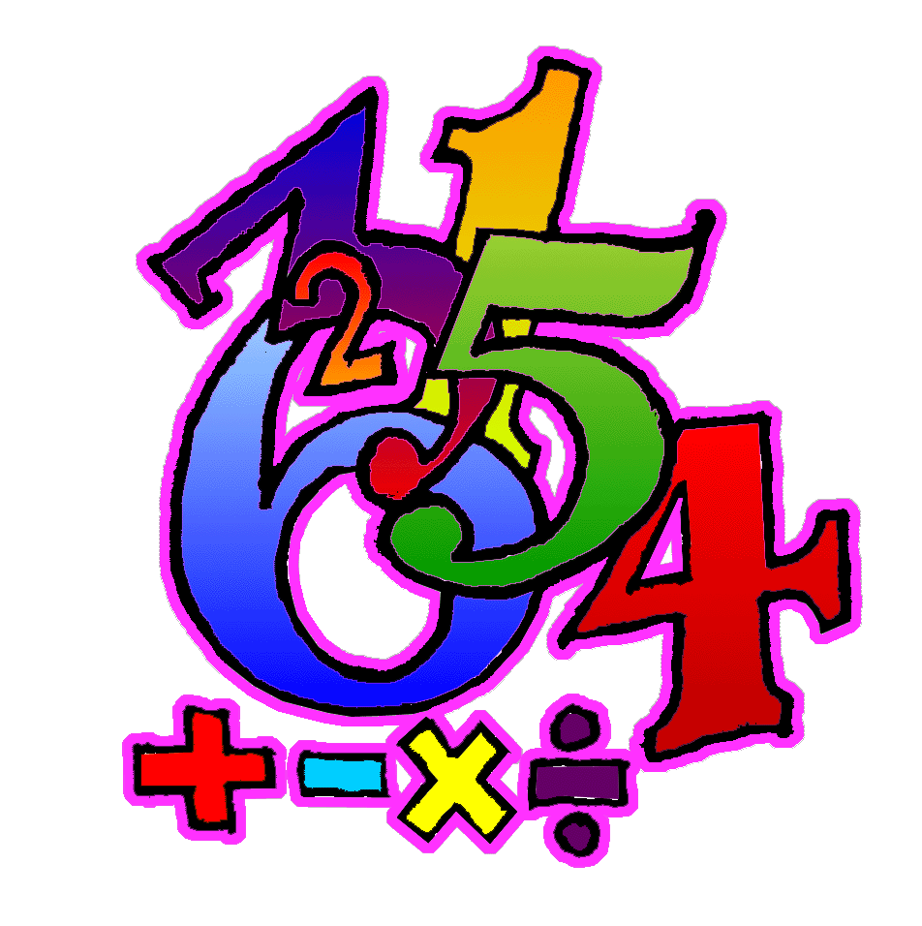
Maths Relay
Scoreboard

Question | Point Value | Team A | Team B | Team C
1
2
3
4
5
6
7
8
9
10
Total

Maths Relay Activity - 5

Each group is to attempt as many questions as possible. As soon as an answer is obtained for any question, a person from the group is to submit it to the teacher, giving the group number first, the question number next and then the answer. Provided the answer is correct, the group will be awarded the points allocated to that question. The group with the most points accumulated by the end of the session is declared the winner.

Question 1 (2 points)

Place the digits 1, 2, 3, 4 and 5 in the circle
so that the sum of the numbers in each line
is 8

Question 2 (2 points)

A car was driven at 110 km per hour for 4 ½ hours. How far did the car travel?

Question 3 (5 points)

Students in a class play tennis or swim or both. 15 play tennis, 10 swim and 5 play tennis and swim.
How many a) play tennis only?
b) swim only?
c) play tennis or swim but not both?
d) are in the class?

Question 4 (3 points)

The following sum was written on the board: 22 2 2 3 = 25

Unfortunately, the three symbols were rubbed out. Replace them to make the sum correct. You may only use the four symbols + - x ÷

Question 5 (4 points)

Finish the Pattern
a) 3, 7, 15, 31, 63, ___
b) 3, 5, 8, 13, 21, 34, ___
c) 4, 8, 16, 32, 64, ___

Question 6 (4 points)

A number of children have been asked to stand in a circle,
with even spaces between them.
If the 3rd child and the 9th child are directly opposite each other,
how many children are in the circle? Hint: Draw a diagram

Question 7 (2 points)

82 people were on the bus. At the first stop 36 people got off and 14 people got on. At the second stop 12 people got off and 28 people got on. How many people were on the bus?

Question 8 (4 points)

Ernie, his wife and three children went to the movies. B1, B2 and B3 were charged 1/2 half price. If the total of the tickets cost $31.50, how much did each adult ticket cost?

Question 9 (3 points)

a) 54 + 132 = b) 964 – 131 = c) 12 x 5 = d) 88 ÷ 11 =

Question 10 (5 points)

Matchstick problem
Move 4 matches to make 3 equilateral triangles

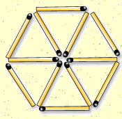

Question 10 (5 points)

Tangram Puzzle
Complete the puzzle by moving and rotating the seven shapes.

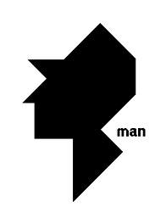
Maths Relay Activity – 5 Answers

Each group is to attempt as many questions as possible. As soon as an answer is obtained for any question, a person from the group is to submit it to the teacher, giving the group number first, the question number next and then the answer. Provided the answer is correct, the group will be awarded the points allocated to that question. The group with the most points accumulated by the end of the session is declared the winner.
3
Question 1 (2 points)

Place the digits 1, 2, 3, 4 and 5 in the circle
1
2
5
so that the sum of the numbers in each line
is 8
4

Question 2 (2 points)

A car was driven at 110 km per hour for 4 ½ hours. How far did the car travel? 495kms

Question 3 (5 points)

Students in a class play tennis or swim or both. 15 play tennis, 10 swim and 5 play tennis and swim.
How many a) play tennis only? 10
b) swim only? 5
c) play tennis or swim but not both? 15
d) are in the class? 20

Question 4 (3 points)

The following sum was written on the board: 22 2 2 3 = 25
÷ x +
Unfortunately, the three symbols were rubbed out. Replace them to make the sum correct. You may only use the four symbols + - x ÷

Question 5 (4 points)

Finish the Pattern
a) 3, 7, 15, 31, 63, ___ 127
b) 3, 5, 8, 13, 21, 34, ___ 55
c) 4, 8, 16, 32, 64, ___ 128

Question 6 (4 points)
12
A number of children have been asked to stand in a circle,
with even spaces between them.
If the 3rd child and the 9th child are directly opposite each other,
how many children are in the circle? Hint: Draw a diagram

Question 7 (2 points)

82 people were on the bus. At the first stop 36 people got off and 14 people got on. At the second stop 12 people got off and 28 people got on. How many people were on the bus? 76

Question 8 (4 points)

Ernie, his wife and three children went to the movies. B1, B2 and B3 were charged 1/2 half price. If the total of the tickets cost $31.50, how much did each adult ticket cost? $9

Question 9 (3 points)

a) 54 + 132 = 186 b) 964 – 131 = 833 c) 12 x 5 = 60 d) 88 ÷ 11 = 8

Question 10 (5 points)

Matchstick problem
Move 4 matches to make 3 equilateral triangles

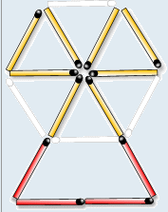

Question 10 (5 points)

Tangram Puzzle
Complete the puzzle by moving and rotating the seven shapes.

Maths Relay Activity – 6

Each group is to attempt as many questions as possible. As soon as an answer is obtained for any question, a person from the group is to submit it to the teacher, giving the group number first, the question number next and then the answer. Provided the answer is correct, the group will be awarded the points allocated to that question. The group with the most points accumulated by the end of the session is declared the winner.

Question 1 (4 points)
 | 8
9 |  |  | 10
 |  | 7

Insert the numbers 1, 2, 3, 4, 5 and 6 to this
addition square so that the outer rows
(across and down) add up to 18.

Question 2 (2 points)

A grocer bought a case of 120 mangoes for $10. He then sold them for 20c each. How much profit did he make?

Question 3 (5 points)

Warren has less than 35 marbles.
- When he puts them in piles of 3, he has no marbles left over.
- When he puts them in piles of 2, he has 1 left.
- When he puts them in piles of 5, he has 1 left.
How many marbles does he have?

Question 4 (3 points)

The following sums were written on the board: 3 3 10 = 19

Unfortunately, the three symbols were rubbed out. Replace them to make the sum correct. You may only use the four symbols + - x ÷

Question 5 (4 points)

What number comes next?
a) 1, 3, 6, 10, 15, 21, ___
b) 1, 1, 2, 3, 5, 8, 13, 21, ___
c) 4, 9, 16, 25, 36, 49, ___

Question 6 (4 points)

The dots below are joined by five straight lines. Now join them • • •
using only four straight lines without lifting your pen off the
paper.
• • •
• • •

• • • • • •

• • •

Question 7 (2 points)

What are four consecutive numbers under 10 that add up to 22?

Question 8 (4 points)

Kate has 9 pansies and 24 roses. Marco has twice as many pansies and half as many roses.
Between them how many pansies and how many roses do they have?

Question 9 (3 points)

a) 77 + 164 = b) 874 – 383 = c) 9 x8 = d) 132 ÷ 12 =

Question 10 (5 points)

Matchstick problem
Move 3 matches to make 3 squares

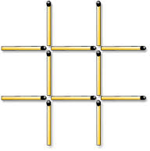

Question 11 (5 points)

Tangram Puzzle
Complete the puzzle by moving and rotating the seven shapes.

Maths Relay Activity – 6 Answers

Each group is to attempt as many questions as possible. As soon as an answer is obtained for any question, a person from the group is to submit it to the teacher, giving the group number first, the question number next and then the answer. Provided the answer is correct, the group will be awarded the points allocated to that question. The group with the most points accumulated by the end of the session is declared the winner.

Question 1 (4 points)
5 | 8 | 3 | 2
9 |  |  | 10
4 | 1 | 7 | 6

Insert the numbers 1, 2, 3, 4, 5 and 6 to this
addition square so that the outer rows
(across and down) add up to 18.

Question 2 (2 points)

A grocer bought a case of 120 mangoes for $10. He then sold them for 20c each. How much profit did he make? $14

Question 3 (5 points)

Warren has less than 35 marbles.
- When he puts them in piles of 3, he has no marbles left over.
- When he puts them in piles of 2, he has 1 left.
- When he puts them in piles of 5, he has 1 left.
How many marbles does he have? 21

Question 4 (3 points)

The following sums were written on the board: 3 x 3 + 10 = 19

Unfortunately, the three symbols were rubbed out. Replace them to make the sum correct. You may only use the four symbols + - x ÷

Question 5 (4 points)

What number comes next?
a) 1, 3, 6, 10, 15, 21, ___ 28
b) 1, 1, 2, 3, 5, 8, 13, 21, ___ 34
c) 4, 9, 16, 25, 36, 49, ___ 64

Question 6 (4 points)

The dots below are joined by five straight lines. Now join them • • •
using only four straight lines without lifting your pen off the
paper.
• • •
• • •

• • • • • •

• • •

Question 7 (2 points)

What are four consecutive numbers under 10 that add up to 22? 4, 5, 6 and 7

Question 8 (4 points)

Kate has 9 pansies and 24 roses. Marco has twice as many pansies and half as many roses.
Between them how many pansies and how many roses do they have? 27 pansies & 36 roses

Question 9 (3 points)

a) 77 + 164 = 241 b) 874 – 383 = 491 c) 9 x8 = 72 d) 132 ÷ 12 = 11

Question 10 (5 points)

Matchstick problem
Move 3 matches to make 3 squares

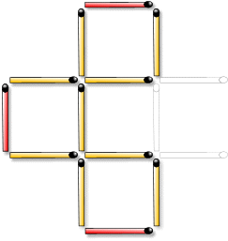

Question 11 (5 points)

Tangram Puzzle
Complete the puzzle by moving and rotating the seven shapes.

Maths Relay Activity – 7

Each group is to attempt as many questions as possible. As soon as an answer is obtained for any question, a person from the group is to submit it to the teacher, giving the group number first, the question number next and then the answer. Provided the answer is correct, the group will be awarded the points allocated to that question. The group with the most points accumulated by the end of the session is declared the winner.

Question 1 (4 points)
5

Place the numbers 1 to 8 in the squares so that
The sum along each line is the same.

Question 2 (2 points)

The school has a student population of 1200 students. If 60% are girls how many are boys?

Question 3 (5 points)

What four –digit numbers can be made using each of these digits only once?
7
5
1
6

Question 4 (3 points)

The following sum was written on the board: 8 3 5 = 1

Unfortunately, the three symbols were rubbed out. Replace them to make the sum correct. You may only use the four symbols + - x ÷

Question 5 (4 points)

Complete the next four in each sequence?
a) 1, 4, 9, 16, __, __, __, __
b) Z, W, T, Q, N, __, __, __, __
c) 128, 64, 32, 16, __, __, __, __

Question 6 (4 points)
Draw a straight-line across the clock face so that numbers in each of the two parts add up to the same
number.
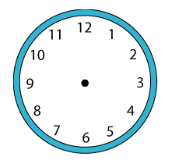

Question 7 (2 points)

You are the sixth person in a queue and there are seven people behind the
person in front of you. How many people are there in the queue?

Question 8 (4 points)

Marco entered his pet frog “Hoppy” in a jumping competition. Frogs were judged on the total distance jumped after five consecutive jumps. “Hoppy” jumped 24 metres with his first jump. Each jump after that was only half the distance of the previous jump. The best jumping total of the other frogs was 47 metres. Did “Hoppy” win or lose and by how much?

Question 9 (3 points)

a) 86 + 125 = b) 763 – 236 = c) 8 x 6 = d) 108 ÷ 9 =

Question 10 (5 points)

Matchstick problem
Move 3 matches to make 4 squares

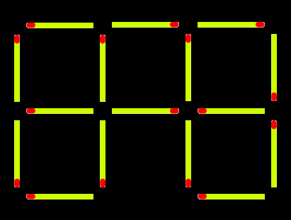

Question 11 (5 points)

Tangram Puzzle
Complete the puzzle by moving and rotating the seven shapes.
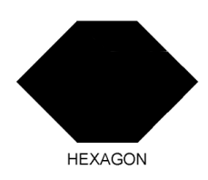

Maths Relay Activity –7Answers

Each group is to attempt as many questions as possible. As soon as an answer is obtained for any question, a person from the group is to submit it to the teacher, giving the group number first, the question number next and then the answer. Provided the answer is correct, the group will be awarded the points allocated to that question. The group with the most points accumulated by the end of the session is declared the winner.

Question 1 (4 points)
1 | 7 | 5
4 |  | 6
8 | 3 | 2
8 | 1 | 5
2 |  | 6
4 | 7 | 3

Place the numbers 1 to 8 in the squares so that
The sum along each line is the same.

Question 2 (2 points)

The school has a student population of 1200 students. If 60% are girls how many are boys? 480

Question 3 (5 points)

What four –digit numbers can be made using each of these digits only once? 24 numbers
7
5
1
6

Question 4 (3 points)

The following sum was written on the board: 8- 3÷ 5 = 1

Unfortunately, the three symbols were rubbed out. Replace them to make the sum correct. You may only use the four symbols + - x ÷

Question 5 (4 points)

Complete the next four in each sequence?
a) 1, 4, 9, 16, __, __, __, __ 25, 36, 49, 64
b) Z, W, T, Q, N, __, __, __, __ K, H, E, B
c) 128, 64, 32, 16, __, __, __, __ 8, 4, 2, 1

Question 6 (4 points)
Draw a straight-line across the clock face so that numbers in each of the two parts add up to the same
number.

Question 7 (2 points)

You are the sixth person in a queue and there are seven people behind the 12
person in front of you. How many people are there in the queue?

Question 8 (4 points)

Marco entered his pet frog “Hoppy” in a jumping competition. Frogs were judged on the total distance jumped after five consecutive jumps. “Hoppy” jumped 24 metres with his first jump. Each jump after that was only half the distance of the previous jump. The best jumping total of the other frogs was47 metres. Did “Hoppy” win or lose and by how much? Hoppy lost by 0.5 of a metre

Question 9 (3 points)

a)86 + 125 = 211 b) 763 – 236 = 527 c) 8 x6 = 48 d) 108÷ 9 = 12

Question 10 (5 points)

Matchstick problem
Move 3 matches to make 4 squares

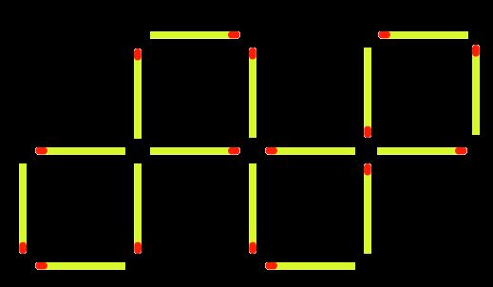

Question 11 (5 points)

Tangram Puzzle
Complete the puzzle by moving and rotating the seven shapes.

Maths Relay Activity – 8

Each group is to attempt as many questions as possible. As soon as an answer is obtained for any question, a person from the group is to submit it to the teacher, giving the group number first, the question number next and then the answer. Provided the answer is correct, the group will be awarded the points allocated to that question. The group with the most points accumulated by the end of the session is declared the winner.

Question 1 (3 points)

Place the digits 1, 2, 3, 4, and 5 in the squares
so that the sum along each line is the same.

Question 2 (2 points)

Write 72 in Roman Numerals?

Question 3 (3 points)

Using the numbers 5,6,7 and 8 put one in each box to make a true sentence.
There are a few possible answers.

 | + |  | - |  | =

Question 4 (5 points)

Of the 19 people in Kate’s family 6 have visited an aquarium and 9 have visited a zoo. 2 people have visited both an aquarium and a zoo. How many people have visited an aquarium but not a zoo? How many have visited neither? Hint: Use the Venn Diagram

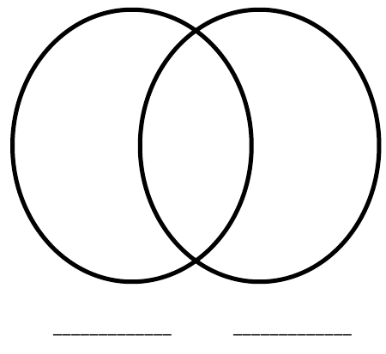

Question 5 (4 points)

Complete the next four in each sequence?
a) 2, 4, 6, 8, __, __, __, __
b) A, C, E, G, __, __, __, __
c) AL, BM, CN, DO, __, __, __, __
d) 1, 2, 4, 7, 11, __, __, __, __

Question 6 (4 points)
Draw a straight-line across the clock face so that the sum of the numbers on one side is twice the sum
of the other side.

Question 7 (2 points)

You arrive at the bank and get into the lift on the first floor. The lift then travels up 8 floors, down 5 floors, up 3 floors, down 6 floors and then up 9 floors to reach the top floor. How many floors does the building have? Hint: Draw a picture

Question 8 (3 points)

a) 126 + 177 = b) 453 - 64 = c) 7 x 13 = d) 132 ÷ 11 =

Question 9 (5 points)

Matchstick problem - With this key, move 4 matches to make 3 squares

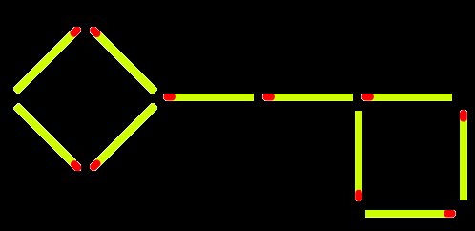

Question 10 (5 points)

Tangram Puzzle - Complete the puzzle by moving and rotating the seven shapes.

Maths Relay Activity – 8 Answers

Each group is to attempt as many questions as possible. As soon as an answer is obtained for any question, a person from the group is to submit it to the teacher, giving the group number first, the question number next and then the answer. Provided the answer is correct, the group will be awarded the points allocated to that question. The group with the most points accumulated by the end of the session is declared the winner.

 | 4
5 | 1 | 2
 | 3
Question 1 (3 points)

Place the digits 1, 2, 3, 4, and 5 in the squares
so that the sum along each line is the same.
There are a few possible answers
Question 2 (2 points)

Write 72 in Roman Numerals? LXXII

Question 3 (3 points)

Using the numbers 5,6,7 and 8 put one in each box to make a true sentence.
There are a few possible answers

7 | + | 6 | - | 5 | = | 8

Question 4 (5 points)

Of the 19 people in Kate’s family 6 have visited an aquarium and 9 have visited a zoo. 2 people have visited both an aquarium and a zoo. How many people have visited an aquarium but not a zoo? How many have visited neither?
Hint: Use the Venn Diagram Answer: 4 people have visited the aquarium and 6 have visited neither

Question 5 (4 points)

Complete the next four in each sequence?
a) 2, 4, 6, 8, __, __, __, __ 10, 12, 14, 16
b) A, C, E, G, __, __, __, __ I, K, M, O
c) AL, BM, CN, DO, __, __, __, __ EP, FQ, GR, HS
d) 1, 2, 4, 7, 11, __, __, __, __ 16, 22, 29, 37

Question 6 (4 points)
Draw a straight-line across the clock face so that the sum of the numbers on one side is twice the sum
of the other side.

Question 7 (2 points)

You arrive at the bank and get into the lift on the first floor. The lift then travels up 8 floors, down 5 floors, up 3 floors, down 6 floors and then up 9 floors to reach the top floor. How many floors does the building have? Hint: Draw a picture 10 floors

Question 8 (3 points)

a) 126 + 177 = 303 b) 453 - 64 = 389 c) 7 x 13 = 91 d) 132 ÷ 11 = 12

Question 9 (5 points)

Matchstick problem - With this key, move 4 matches to make 3 squares

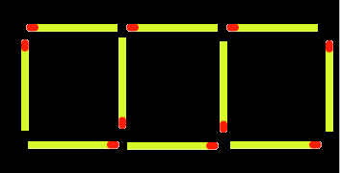

Question 10 (5 points)

Tangram Puzzle - Complete the puzzle by moving and rotating the seven shapes.

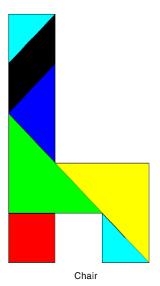
Maths Relay Activity – 9

Each group is to attempt as many questions as possible. As soon as an answer is obtained for any question, a person from the group is to submit it to the teacher, giving the group number first, the question number next and then the answer. Provided the answer is correct, the group will be awarded the points allocated to that question. The group with the most points accumulated by the end of the session is declared the winner.

Question 1 (3 points)

Place the numbers 1, 2, 3, 4, 5, 6, and 7 in the boxes.
Make the sum along each line equal to. Use each
Number only once.

Question 2 (2 points)

In a normal school week, Tim travels a total of 80km to and from school. How far from school does he live?

Question 3 (3 points)

What number am I?
? | X 2 |  | + 3 |  | ÷ 5 | = 9

Question 4 (5 points)

There were 60 students in Reiby. 25 students were approved to attend Shop Fitting and 20 students attended Info Tech classes. If 7 students were in both the classes, how many students were not approved for either Shop Fitting or Info Tech classes?
Hint: Use the Venn Diagram

Question 5 (4 points)

Complete the next four in each sequence?
a) 6, 12, __, 24, __, __, 42, __
b) __, 20, 30, __, __, 60, __
c) 15, 18, __, __, __, 30, __
d) 27, __, 45, 54, __, __, 81, __

Question 6 (4 points)
Divide the clock face into 3 parts with 2 lines so that the sum of the numbers in the three parts is equal.

Question 7 (3 points) Hint: Draw a picture

Boden, Dylan, Alex and Derek each live on a different corner of the same block. If you walked clockwise around the block starting at Boden’s house you would first come to Dylan’s house, then Alex’s house, then Derek’s house. Each side of the block is 150 metres long. If Boden visited Alex, then Derek, then Dylan and then returned home, what is the shortest distance he would need to travel?
Question 8 (3 points)

Which three numbers add up to 60?
23, 31, 24, 15, 32, 46,25, 18, 27, 37

Question 9 (5 points)

Matchstick problem - Move 4 of the matches to make 5 squares
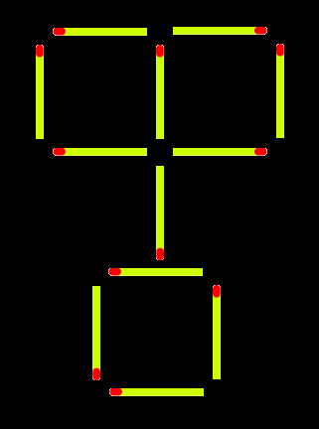

Question 10 (5 points)

Tangram Puzzle - Complete the puzzle by moving and rotating the seven shapes.

Maths Relay Activity – 9 Answers

Each group is to attempt as many questions as possible. As soon as an answer is obtained for any question, a person from the group is to submit it to the teacher, giving the group number first, the question number next and then the answer. Provided the answer is correct, the group will be awarded the points allocated to that question. The group with the most points accumulated by the end of the session is declared the winner.

Question 1 (3 points)
1 |  | 3
5 | 2 | 6
7 |  | 4

Place the numbers 1, 2, 3, 4, 5, 6, and 7 in the boxes.
Make the sum along each line equal to. Use each
Number only once.

Question 2 (2 points)

In a normal school week, Tim travels a total of 80km to and from school. How far from school does he live? 8km

Question 3 (3 points)

What number am I? 21
? | X 2 |  | + 3 |  | ÷ 5 | = 9

Question 4 (5 points)

There were 60 students in Reiby. 25 students were approved to attend Shop Fitting and 20 students attended Info Tech classes. If 7 students were in both the classes, how many students were not approved for either Shop Fitting or Info Tech classes?
Hint: Use the Venn Diagram Answer: 22 students

Question 5 (4 points)

Complete the next four in each sequence?
a) 6, 12, __, 24, __, __, 42, __ 18, 30, 36, 48
b) __, 20, 30, __, __, 60, __ 10, 40, 50, 70
c) 15, 18, __, __, __, 30, __ 21, 24, 27, 33
d) 27, __, 45, 54, __, __, 81, __ 36, 63, 72, 99

Question 6 (4 points)
Divide the clock face into 3 parts with 2 lines so that the sum of the numbers in the three parts is equal.

Question 7 (3 points) Hint: Draw a picture

Boden, Dylan, Alex and Derek each live on a different corner of the same block. If you walked clockwise around the block starting at Boden’s house you would first come to Dylan’s house, then Alex’s house, then Derek’s house. Each side of the block is 150 metres long. If Boden visited Alex, then Derek, then Dylan and then returned home, what is the shortest distance he would need to travel? 900 metres
Question 8 (3 points)

Which three numbers add up to 60?
23, 31, 24, 15, 32, 46,25, 18, 27, 37 15, 18, 27

Question 9 (5 points)

Matchstick problem - Move 4 of the matches to make 5 squares
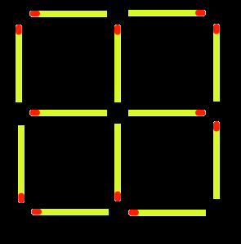

Question 10 (5 points)

Tangram Puzzle - Complete the puzzle by moving and rotating the seven shapes.

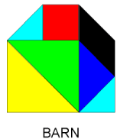

Maths Relay Activity – 10

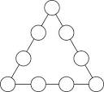
Each group is to attempt as many questions as possible. As soon as an answer is obtained for any question, a person from the group is to submit it to the teacher, giving the group number first, the question number next and then the answer. Provided the answer is correct, the group will be awarded the points allocated to that question. The group with the most points accumulated by the end of the session is declared the winner.

Question 1 (3 points)
8
Fill the circles with the numbers 1 to 9 so that
the sum of each side of the triangle is the same

4
5
Question 2 (2 points)

For a big night out Ernie buys a pair of shorts for $43, a shirt for $28, a pair of shoes for $59 and gets his haircut costing $18.50. How much change does he have left from $200?

Question 3 (3 points)

4 | 3 | 6 | 2
4 |  | 2
 | 2 |  | 1
Replace each blank with the correct number. +

=
Question 4 (4 points)

150 students were attending university. 85 were registered for a Math class. 55 were registered for an English class. 20% of the students were registered for both Math and English.
a) How many signed up only for a Math Class? b) How many signed up only for an English Class?
c) How many signed up for Math and English? d) How many signed up neither for Math nor English?
Hint: Use the Venn Diagram

Question 5 (4 points)

Complete the next four in each sequence?
a) 4, __, 12, __, 20, __, __
b) 12, __, __, 48, __ 72, __
c) 56, __, 70, 77, __, __, __,
d) 4, 9, __, 25, 36, __, __, 81, __
Question 6 (5 points)
Use any of the numbers 1 – 9 in place of the ? Don’t use the same number twice in the same problem.

a) ? x ? - ? = 10

b) ? x ? + ? = 25

c) ? x ? ÷ ? = 6

Question 7 (3 points) Hint: Draw a picture

In the Warby 100 metre race Kate finished 2 metres ahead of Marco. Ernie finished 4 metres ahead of Warren. Warren was 1 metre ahead of Marco. Julie came second. What was the finishing position of the competitiors?

Question 8 (3 points)

Work out: 1 X 2 X 3 X 4 X 5 =

Question 9 (5 points)

Matchstick problem - Move 3 of the matches to make 3 squares

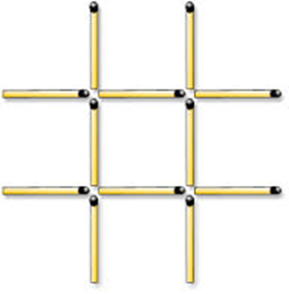

Question 10 (5 points)

Tangram Puzzle - Complete the puzzle by moving and rotating the seven shapes.

Maths Relay Activity – 10 Answers

Each group is to attempt as many questions as possible. As soon as an answer is obtained for any question, a person from the group is to submit it to the teacher, giving the group number first, the question number next and then the answer. Provided the answer is correct, the group will be awarded the points allocated to that question. The group with the most points accumulated by the end of the session is declared the winner.
5
Question 1 (3 points)
9
8
Fill the circles with the numbers 1 to 9 so that
the sum of each side of the triangle is the same
1
2
Total of each side is 20
6
7
3
4
5
Question 2 (2 points)

For a big night out Ernie buys a pair of shorts for $43, a shirt for $28, a pair of shoes for $59 and gets his haircut costing $18.50. How much change does he have left from $200? $51.50

Question 3 (3 points)

4 | 3 | 6 | 2
4 |  | 2
 | 2 |  | 1
Replace each blank with the correct number. +
All 9’s

Question 4 (4 points)

150 students were attending university. 85 were registered for a Math class. 55 were registered for an English class. 20% of the students were registered for both Math and English.
a) How many signed up only for a Math Class? b) How many signed up only for an English Class?
c) How many signed up for Math and English? d) How many signed up neither for Math nor English?
Hint: Use the Venn Diagram Answer: 55, 25, 30, 40

Question 5 (4 points)

Complete the next four in each sequence?
a) 4, __, 12, __, 20, __, __ 8, 16, 24, 28
b) 12, __, __, 48, __ 72, __ 24, 36, 60, 84
c) 56, __, 70, 77, __, __, __, 63, 84, 91, 98
d) 4, 9, __, 25, 36, __, __, 81, __ 16, 49, 64 , 100

Question 6 (5 points)
Use any of the numbers 1 – 9 in place of the ? Don’t use the same number twice in the same problem.

a) ? x ? - ? = 10 4 x 3 – 2 = 10

b) ? x ? + ? = 25 6 x 4 + 1 = 25

c) ? x ? ÷ ? = 6 2 x 3 ÷ 1 = 6

Question 7 (3 points) Hint: Draw a picture

In the Warby 100 metre race Kate finished 2 metres ahead of Marco. Ernie finished 4 metres ahead of Warren. Warren was 1 metre ahead of Marco. Julie came second. What was the finishing position of the competitiors? 1st Ernie, 2nd Julie, 3rd Kate, 4th Warren, 5th Marco
Question 8 (3 points)

Work out: 1 X 2 X 3 X 4 X 5 = 120

Question 9 (5 points)

Matchstick problem - Move 4 of the matches to make 5 squares

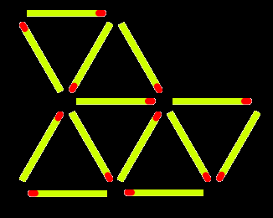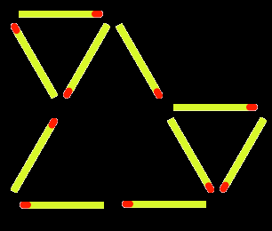

Question 10 (5 points)

Tangram Puzzle - Complete the puzzle by moving and rotating the seven shapes.

