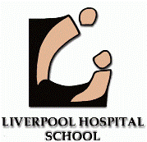

**SCHOOL STRATEGIC DIRECTIONS**

**The Elements of Learning and Achievement**

**Excellence in** Personalised **Learning**

**High Quality,** innovative**, resilient and collaborative staff**

**Strong, positive, respectful community partnerships**

**REFORMS / POLICY**

**School Excellence**

**Framework**

**Wellbeing**

**Framework**

**Aboriginal Education**

**Local Schools Local Decisions**

**Transition School to Community**

**Great Teaching Inspired Learning**

**Every Student Every School**

**Literacy and Numeracy Continuum**

ZZ

**AUSTRALIAN CURRICULUM: GENERAL CAPABILITIES**

Literacy

Numeracy

Critical and Creative Thinking

Personal and Social Capability

Ethical Understanding

ICT Capability

Intercultural Understanding

Everything we do is learning………. Developed by Kay Howe - Dec2015

**Core**

**Literacy**

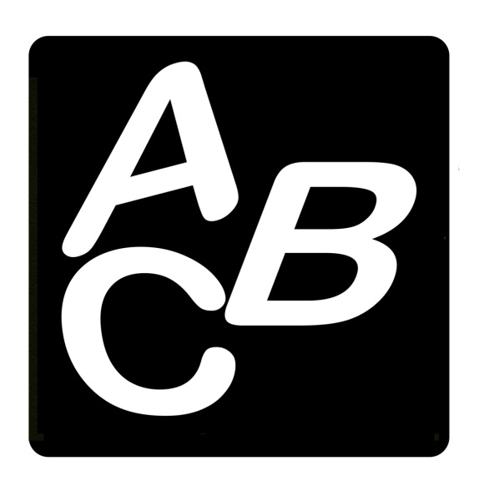

Liverpool Hospital School has a focus on core literacy skills. Every morning session, literacy is taught with the aim of implementing a “teaching moment” for every child. A teaching moment = X+1 where X indicates the learning point the child is at right now.  
 LHS takes advantage of the smaller classroom experience to identify and address gap learning.

**Global Citizen**



Liverpool Hospital School encourages students to celebrate the diversity of peoples and cultures of the world.  
 LHS conducts a daily morning routine to connect students with the world beyond the hospital walls. Students explore, discuss and analyse topics such as current affairs, history, news and weather maps/charts.

**21st Century Learner**



Liverpool Hospital School supports students in using a variety of technology devices to access learning; develop critical research skills; and present assessment tasks. LHS promotes self-directed/ independent and inquiry learning.

**Core Numeracy**



Liverpool Hospital School has a focus on core numeracy skills. LHS focuses on the number strand but educates across the entire numeracy continuum according to individual educational needs/plans. Every morning session, numeracy is taught with the aim of implementing a “teaching moment” for every child. This process allows gap learning to be identified and addressed.

**Creative/ Project Based Learning**

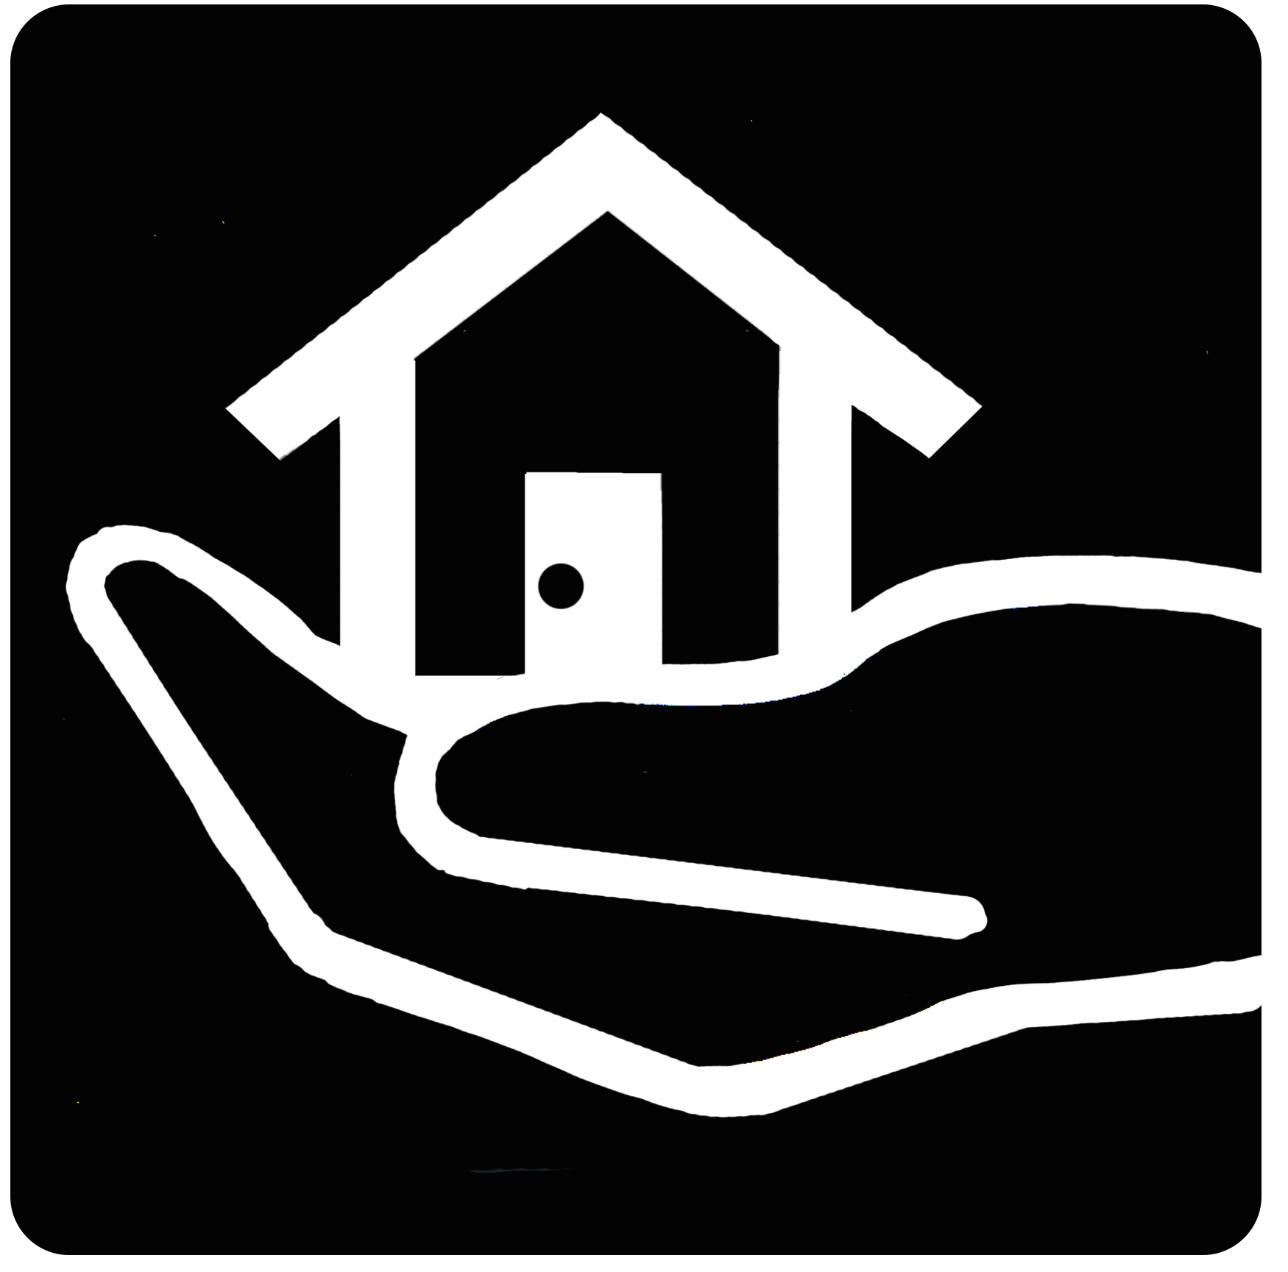

Liverpool Hospital School has a philosophy of “broaden and build” to return students to a happy state.

LHS encourages students to re-write their hospital experience through expressive programs including music, art, craft and therapeutic activities. LHS provides opportunities for project based learning.

**Health and Wellbeing**

.

Liverpool Hospital School educates students about human body parts, organ and skeletal systems and specific illnesses with a particular focus on assisting students to understand their hospital experience. The school delivers focus lessons on well-being, safety, nutrition and the five senses.

**Actions and Choices**



Liverpool Hospital School explicitly teaches pro-social skills and learning behaviours. The aim is to maximise the use of the smaller classroom to identify and address deficits in social skills so that students can experience future success in post-hospital environments. LHS provides a learning environment that promotes individual, pair and group learning experiences.

**Cultural Self Awareness**



Liverpool Hospital School ensures all students develop deeper understanding of Aboriginal histories, culture, languages and perspectives. LHS encourages all cultures to engage in self-awareness and acknowledge their identity whilst sharing and assimilating with others.