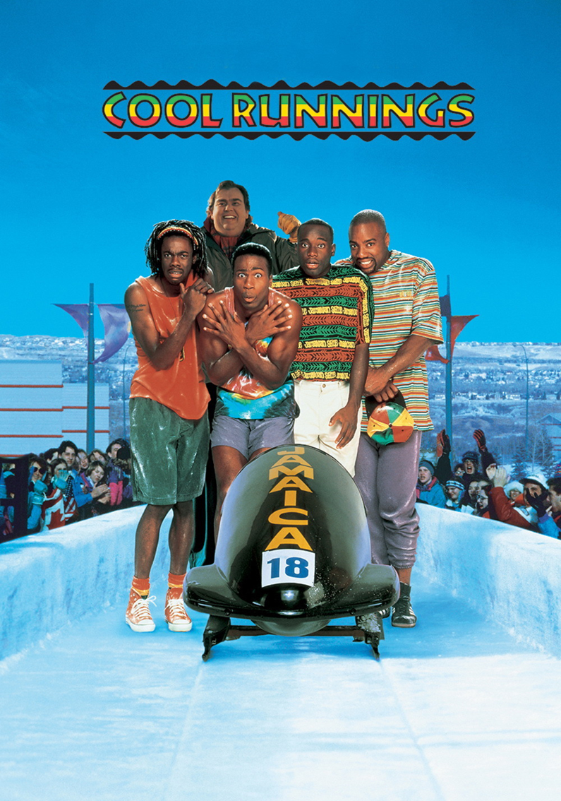

Derice Bannock, a top 100m runner, fails to qualify at the Olympic Trial for the 1988 Summer Olympics when fellow runner Junior Bevil trips and falls, taking Derice and another runner, Yul Brenner, with him. To compete in the Olympics, he and his best friend, Sanka Coffie, a champion push cart racer, seek out Irv Blitzer, an old friend of Derice's father Ben who tried to recruit sprinters to help them achieve their goal.

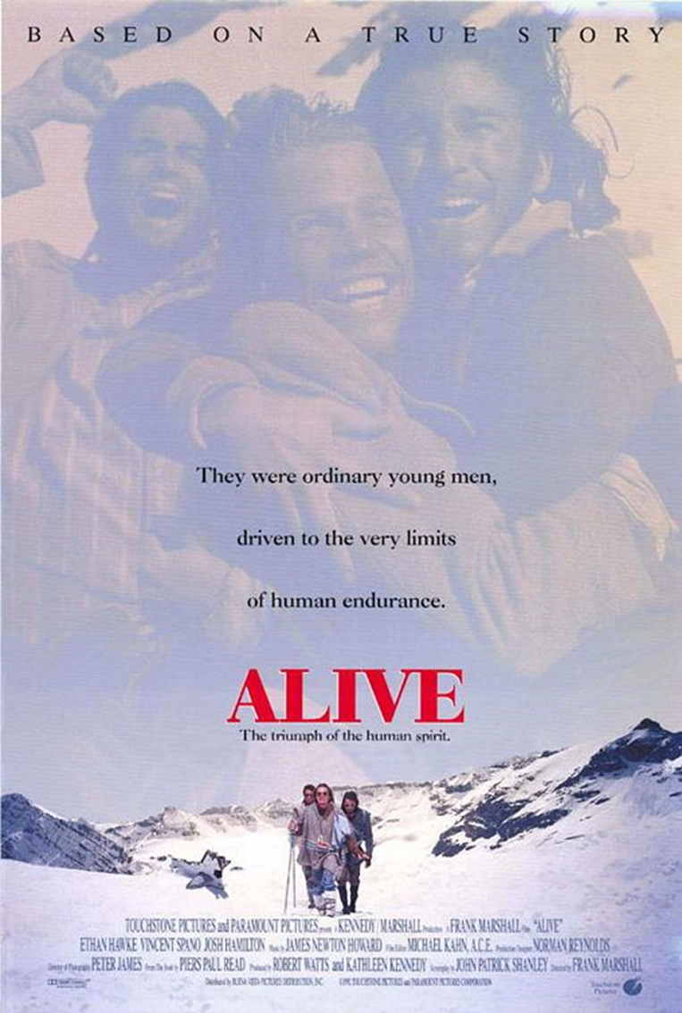

Stranded after a plane crash in the mountains ranges, members respond differently to their predicament. Group leader Nando tries to keep everyone's spirits up; medical student Roberto diligently treats cases of frostbite and gangrene; loose cannon Antonio gradually loses his composure. Once all available food stuffs run out, the group faces a terrible dilemma.

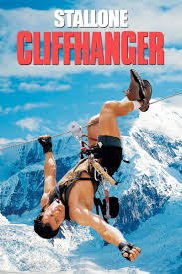

Outdoor thriller in which a former mountain rescuer is pitted against a group of criminals who have lost their $100 million stash during a plane crash in the Rocky Mountains. After being persuaded to help rescue a group of stranded hikers, he discovers that they are in fact a gang of violent robbers who need help to locate their missing loot.

An international competition for junior league teams is being held in Los Angeles. Coach Gordon Bombay (Emilio Estevez) is picked to lead Team U.S.A. He reunites the "old team," the teen misfits he once coached to victory. This time, crass sports promoter Tibbles (Michael Tucker) tempts the team to cash in on their prior fame, but the team eventually gets back into training and takes on Iceland and their violence-prone coach, Wolf Stansson (Carsten Norgaard).
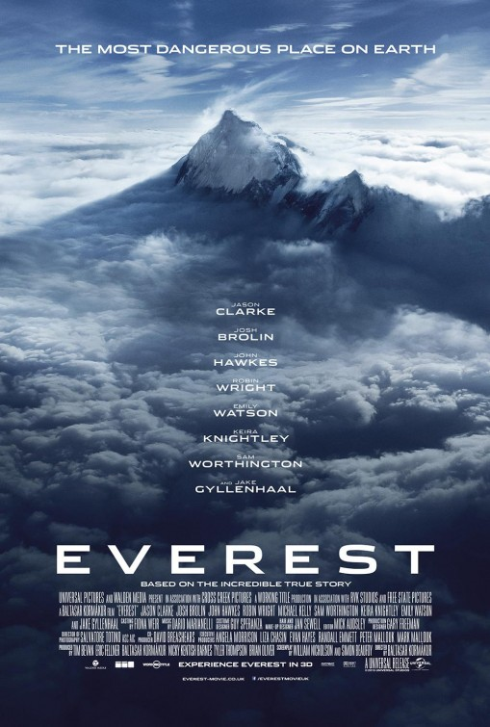
On the morning of May 10, 1996, climbers (Jason Clarke, Josh Brolin) from two expeditions start their final ascent toward the summit. With little warning, a violent storm strikes the mountain, engulfing the adventurers in one of the fiercest blizzards. Challenged by the harshest conditions imaginable, the teams must endure blistering winds and freezing temperatures in an epic battle to survive against nearly impossible odds.

