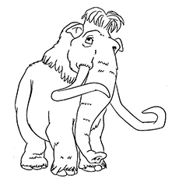
Ice Age: Using adjectives (describing words)

Manny the Woolly Mammoth
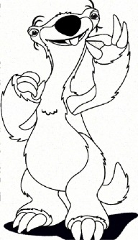
________________________________________________________________________________________________________________________________________________________________________________________________________________________________________________________________________________________________________________________________________________________

Sid the Sloth

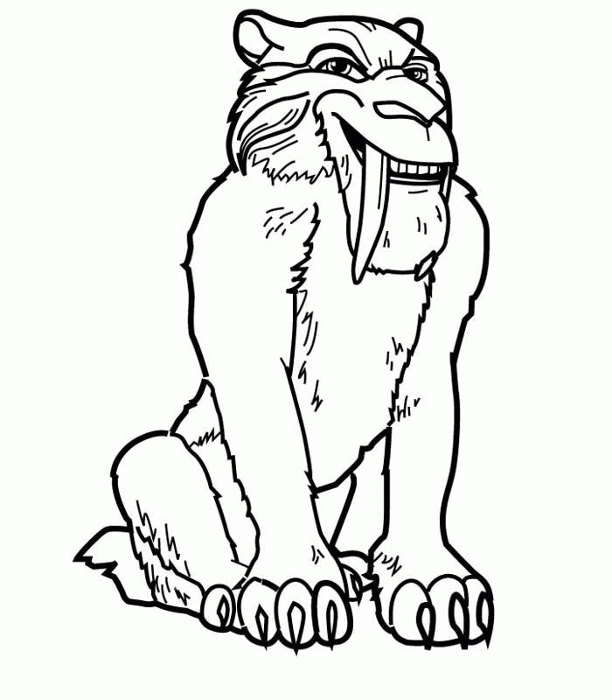
_________________________________________________________________________________________________________________________________________________________________________________________________________________________________________________________________________________________________________________________________________________________

Diego the Sabre Tooth Tiger

___________________________________________________________________________________________________________________________________________________________________________________________________________________________________________________________________________________________________________________________________________________________________________________________________________________________________________________________________________________________________

Ice Age word search
Nuts about Ice Age? Find the Ice Age words hidden in this puzzle.
I | C | E | A | G | E | L | K | H | G | F | D | S | A | A
Z | X | C | V | B | N | M | N | Q | P | W | O | I | S | E
R | T | Y | O | P | P | O | S | U | M | U | I | O | Q | P
S | A | D | F | G | D | H | J | K | L | Z | N | X | U | V
B | C | N | M | O | Q | E | W | R | T | W | Y | U | I | O
A | S | R | L | D | F | M | G | H | O | J | K | L | R | Z
Q | A | I | A | P | X | O | A | D | P | O | S | T | R | P
W | M | D | R | T | V | I | T | N | R | I | L | G | E | O
S | D | A | H | W | N | L | O | U | N | D | O | B | L | I
I | F | K | M | S | E | Y | A | T | A | Y | T | Y | W | U
D | G | E | X | M | J | S | W | G | I | U | H | H | E | Y
E | H | W | K | D | O | R | S | B | A | C | O | R | N | T
R | J | A | O | N | S | T | A | Y | H | I | S | N | D | R
T | K | Q | I | X | E | W | H | H | E | L | L | I | E | E
Y | L | D | I | E | G | O | Z | N | S | P | Z | M | G | Q
ICE AGE, MANNY, SCRAT, DIEGO, ELLIE, SID, DINOSAUR, MELTDOWN,
MAMMOTH, SLOTH, OPPOSUM, SMILODON, SQUIRREL, ACORN
