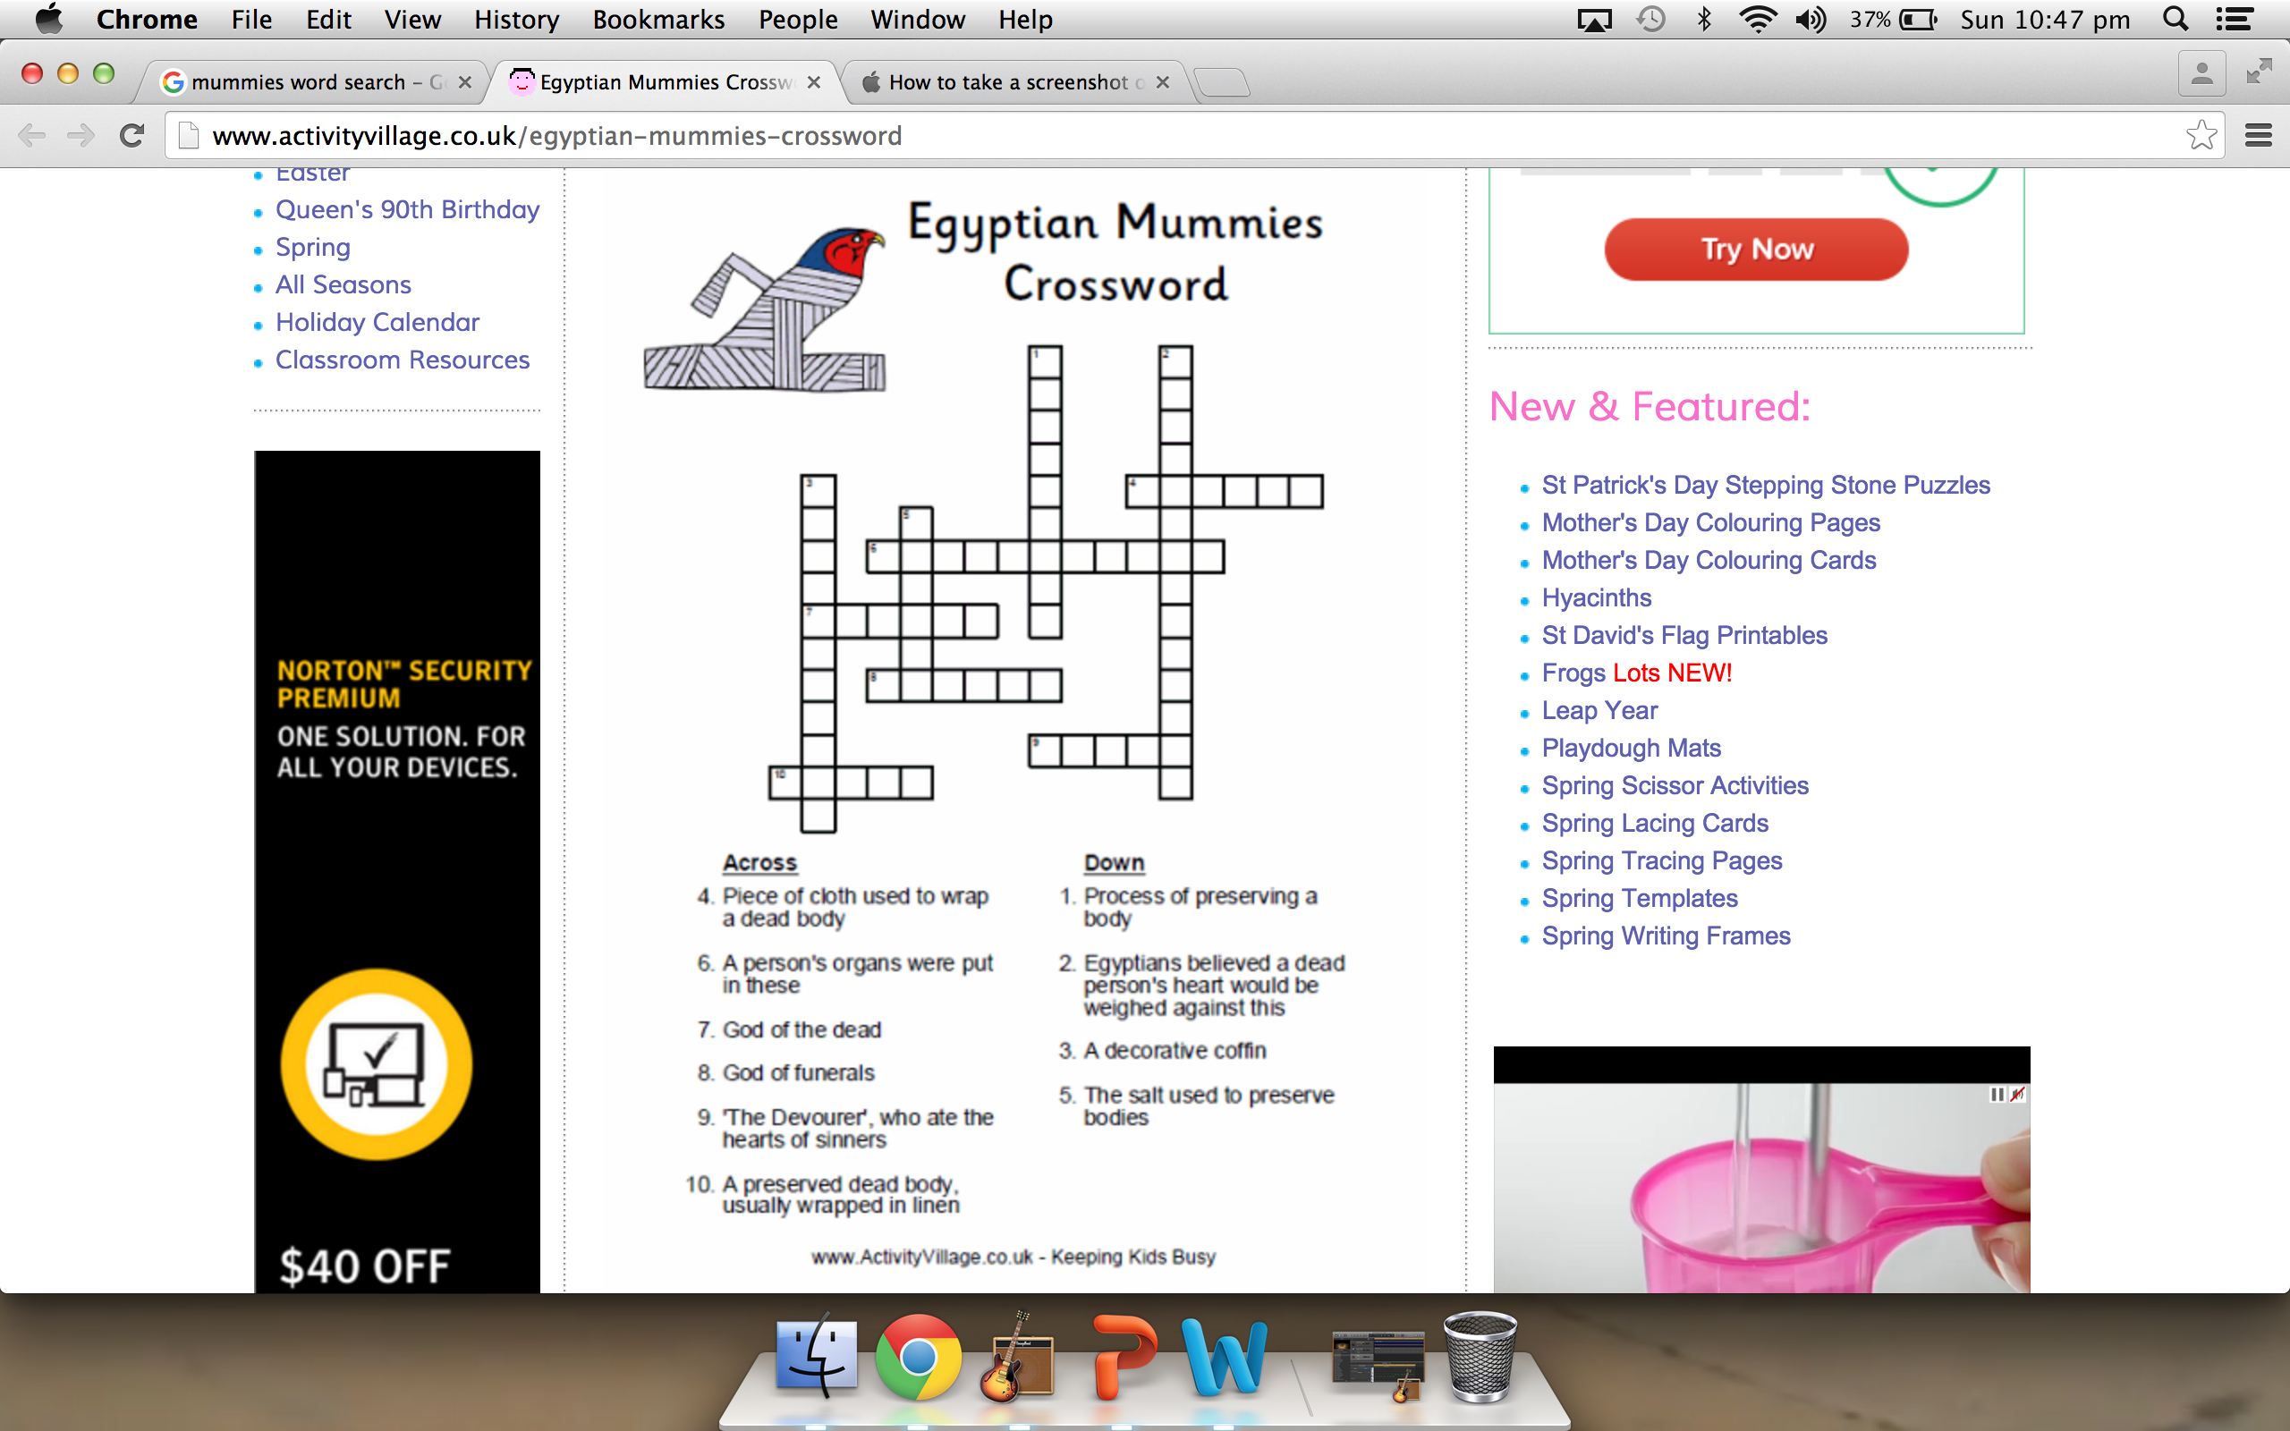

**Word Bank**

Anubis, Natron, Canopic Jars, Embalming, Mummy, Osiris, Ammut, Shroud, Feather of truth, Sarcophagus

**Mummification Process: Sort Activity**

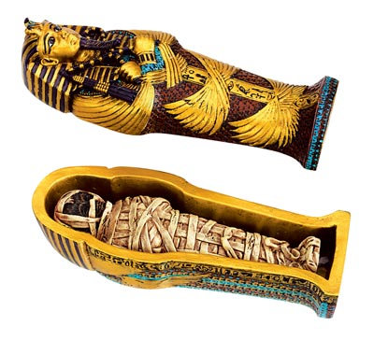

After wrapping ta mask is placed over the mummies face and the body was placed in a coffin.

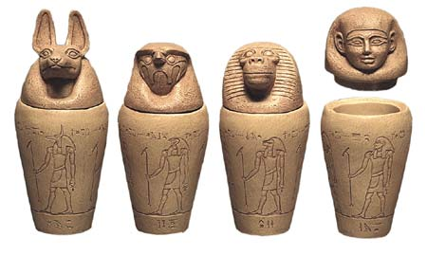

The insides that were removed, were put into four special jars called canopic jars.

- Lungs, jar with the baboon head god.

- Stomach, jar with the jackle headed god.

- Liver, jar the human headed god.

- Intestines, jar the falcon headed god.

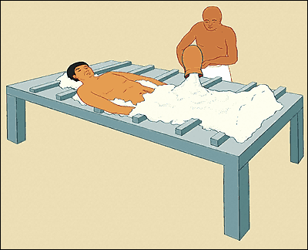

After the organs were placed in canopic jars, the body was filled with a mix of perfume and salt(natron). The body was then covered in natron salt to dry out the body and left for 30 to 90 days.

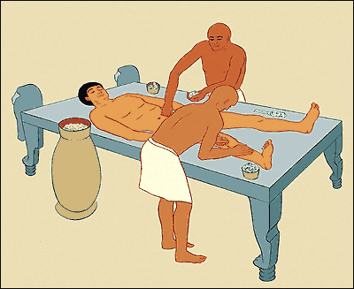

After the body was dried out, the body was stuffed with spices, sawdust, leaves and linen.

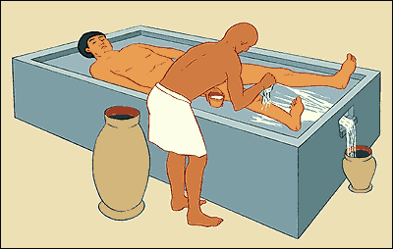

**Start:** The body was first washed near the River Nile as a sign of rebirth.

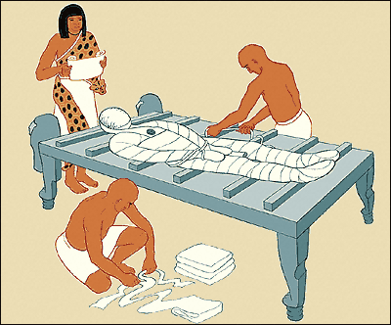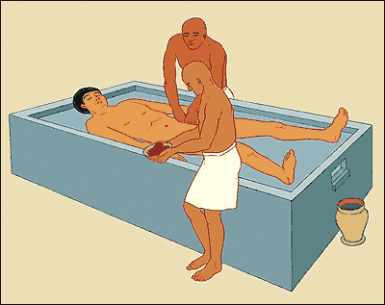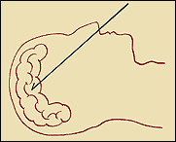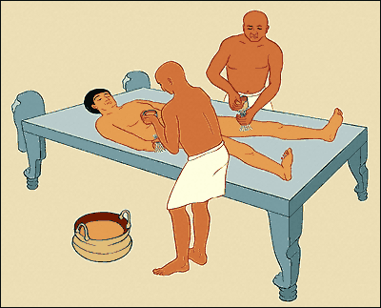

After the body was oiled, the body was wrapped with 150 metres of linen.

After the brain was removed the body was cut open and all the internal organs taken out.However, the heart was put back in because it was believed it was the soul lived.

After the body was stuffed, it was sewn up and covered with oils to help the skin stay elastic.

After washing a priest got a hook and pulled the brain out through the nostrils.