**Ancient Egyptian Society**

At the top of the social pyramid were pharaohs, who were believed to

be gods. They had absolute power over their subjects. The pharaoh directed

the army and made laws.

Just below the Pharaoh was the Vizier, who was also sometimes the high priest as well. It was the Viziers job to give the Pharaoh advice and to run the country on behalf of the Pharaoh.

Below the Vizier were powerful nobles and priests. Only nobles could hold

government posts; in these positions they profited from taxes paid to the

Pharaoh. Priests were responsible for pleasing the gods.

Working with the nobles were scribes who kept government records. They could read and write. Soldiers fought in wars or controlled rebellions at home. During long periods of peace, soldiers also supervised the peasants, farmers, and slaves who werebuilding pyramids and palaces.

Skilled workers such as doctors and craftsmen made up the middle class.

They made and sold jewellery, pottery, papyrus products, tools, and other

useful things. Naturally, there were people needed to buy goods from artisans

and traders. These were the merchants and storekeepers who sold these

goods to the public.

At the bottom of the social structure were farmers and slaves and servants.

Farmers tended the fields and worked in the stones quarries and built pyramids.

They paid taxes in form of grain. Slaves came mostly from wars and had to work, slaves in Egypt had rights and many were freed after a certain amount of time.

**Tasks**

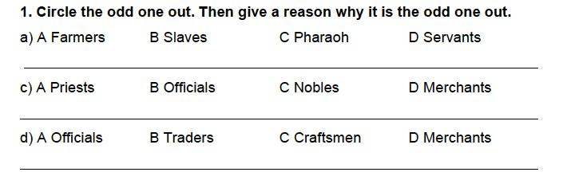

**2.** What was the job of the Vizier?

____________________________________________________________________________________________________________________________________________________________________________________________________________

**3.** Who worked in the government of ancient Egypt? How did they get paid?

____________________________________________________________________________________________________________________________________________________________________________________________________________

**4.** Why were scribes important? What did they do?

____________________________________________________________________________________________________________________________________________________________________________________________________________**5.** What responsibilities did soldiers have?

____________________________________________________________________________________________________________________________________________________________________________________________________________

**6.** What jobs did farmers do when the Nile was flooded?

____________________________________________________________________________________________________________________________________________________________________________________________________________

**7.** Where did most slaves in Egypt come from?

____________________________________________________________________________________________________________________________________________________________________________________________________________

