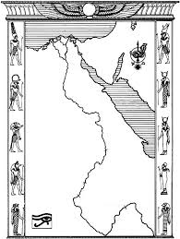

**The flooding of the Nile**

Every **summer** the Nile river would spill over its banks and **flood**.

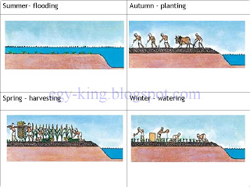

In **autumn** flood waters would go, leaving very fertile soil. The Egyptians would **plant** their **seeds** in this soil.

In **Spring** the Egyptians would **harvest** the **crops.** This harvest would give the Egyptian food for the next year.

In **winter** the Egyptians would **water** and take care of the **crops** that had **grown** from the **seeds**.