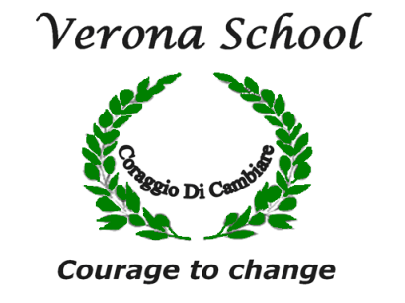
Verona School
Term 1 English Assessment Task
Film Review – Icy Poles

Task: This term in English Verona School have been studying film within the theme of Icy Poles. Your assessment for Term 1 is to imagine that you are a film reviewer for a popular teenage magazine. You are to create a film review between 300 – 500 words on the film “Ice Age”. You are to ensure that you inform, entertain and evaluate the film so that the reader is persuaded whether to view the film or not. Your film review should be word process and presented on one page that is visually appealing to the reader.

Marking Criteria:
You will be assessed on how well you:
• Use Structural and Language features: that makes judgements of plot, characters, film techniques and themes.
• Achieve your purpose in expressing your personal response to the animated film in the form of a written review.
• Edit your writing with a focus on vocabulary, spelling and punctuation.

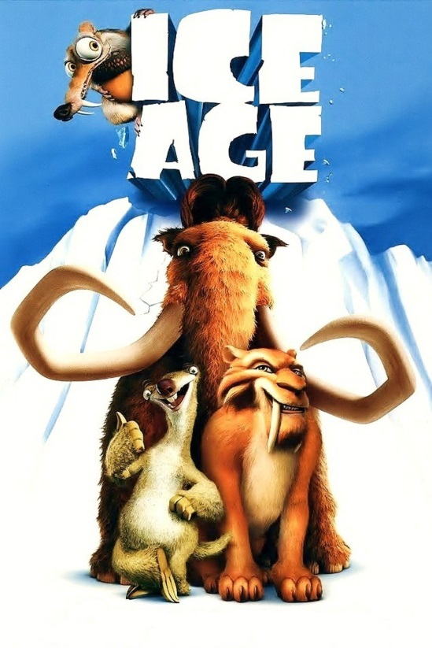

Name: ………………………………….. Class:………………
Term 1: Icy Poles- Film Review.
MARKING CRITERIA /35
 | 5 | 4 | 3 | 2 | 1 | TOTAL  / 35
STRUCTURAL and LANGUAGE FEATURES

Begins with an Introduction that includes: title, director, genre, setting, audience, your position, characters. |  |  |  |  |  | /5
Provides a brief summary of plot points without retelling the whole story or giving the ending away, including adjectives and adverbs used to describe characters and events. |  |  |  |  |  | /5
Provides comments on themes and techniques supported with evidence from the film, including abstract nouns for ideas |  |  |  |  |  | /5
Concluding paragraph provides overall opinion of the film, evaluation and recommendation. |  |  |  |  |  | /5
GRAMMAR & LANGUAGE
/15
Correct and relevant vocabulary (ie shows use of descriptive language). |  |  |  |  |  | /5
Correct spelling and punctuation. |  |  |  |  |  | /5
Grammatically correct sentences. |  |  |  |  |  | /5

Comment:

