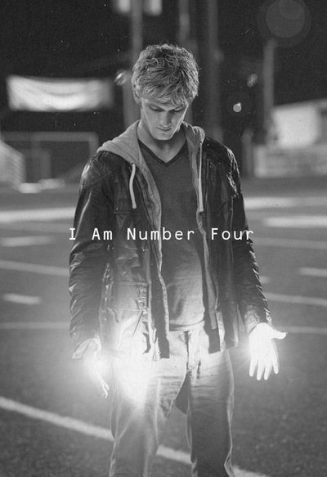

_________________________________________________ By Kate
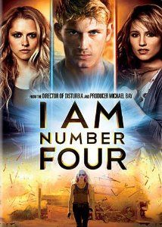
Plot Summary
I am Number Four takes a look at the consequences of alien contact and survival of the human species. Lorien is a planet that is a hundred times older than Earth. It has already faced the myriad of problems with which Earth is only beginning to struggle now - global warming, food shortages, overpopulation, and pollution are all part of Lorien's history. Twenty five thousand years ago, long before they were able to travel through the universe, their planet began to die. The inhabitants of Lorien knew that something drastic had to be done to ensure their survival. They made a commitment to change their way of life, and slowly do away with the harmful chemicals, bombs, pollutants and guns. In time, the damage began to reverse itself, and Lorien survived.
Another planet, Mogadore, faced the same issues, but its inhabitants were less concerned. Instead of making changes to ensure their survival, they continued to use and abuse the planet they called home. They used their resources up and then travelled to the next closest life-sustaining planet - Lorien. The battle was fierce and the Lorien citizens fought valiantly, but failed to save their planet from the Mogadorian invasion.
Nine children were sent into space with their Cêpans on a year long journey to Earth. Once there, they separated, each protected by a Loric charm. They had to survive until they came into their Legacies and became powerful enough to return to Lorien and reclaim their home. Their Cêpans were tasked with their education and their safety and as long as they remained apart from each other, the Lorien children known as the Garde could only be killed in specific order. As an added safety measure, if the first of the nine (called Number One) was killed, a ring would immediately be burned into the ankles of the remaining five. As such, Number Four knew the Mogadorians would come for him next when the third ring formed on his ankle.
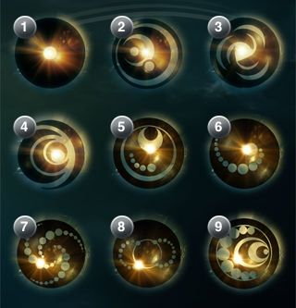
Number Four also knew that it meant they would be moving again, as they had every few months since their arrival on Earth ten years earlier. He would have to leave this identity behind, taking on a new name and finding a way to fit into yet another small town. This time, the move was to Paradise, Ohio. Known now as John, he and his Cêpan, Henri, began the process of blending in once again. Now fifteen years of age, John would come into the first of his Legacies at any time, and Henri was overly vigilant. Until John's powers fully developed, they would never be safe. John's first Legacy power announced itself on John's first day in his new school. His hands suddenly lit up, and he was unable to turn them off. He hid, and called Henri to come for him. Now, the training would begin. John's inheritance, contained in a Loric chest, would help him to learn to use the Legacies he receives, and hopefully give him the tools he needs to fight off the Mogadorians who roam the Earth in search of him and the remaining Garde.

The final battle has John, Number Six and Henri facing Mogadorian Soldiers, Scouts, Beasts and Weasels. With the help of John's first love, Sarah, friends Sam and Mark, and a Chimera named Bernie Kosar, they manage to overpower the Mogadorian attack and escape once again, losing Henri to the battle.

Book Vs Movie
 | Book | Movie
Initial Reaction
How did it make you feel?

Differences
Similarities

Did you prefer the book or the movie?

Why?

Questions:
1. Where is Number Four at the start of the movie?
_____________________________________________________________________________________
2. Where does Number Four move to?
_____________________________________________________________________________________
3. What does Number Four begin to call himself?
_____________________________________________________________________________________
4. What does Sarah Short do when she first sees Number Four?
_____________________________________________________________________________________
5. Who is Mark Jacobs?
_____________________________________________________________________________________
6. What happens to Number Four's hands in class?
_____________________________________________________________________________________
7. What will Number Four have to learn to control?
_____________________________________________________________________________________
8. What is the name of Number Four's dog?
_____________________________________________________________________________________
9. What can Number Four's dog do?
_____________________________________________________________________________________
10. What does Sam think happened to his father?
_____________________________________________________________________________________

Questions 2:
1. Why did Number Four and the other Loric children come to Earth?
__________________________________________________________________________________________________________________________________________________________________________
2. What protects Number Four and the other Loric children?
__________________________________________________________________________________________________________________________________________________________________________
3.
a. What does Mark do when he first meets John?
b. Why does he behave the way he does?
c. How does John resolve this situation?
______________________________________________________________________________________________________________________________________________________________________________________________________________________________________________________________________________________________________________________________________________________________________________________________________________________________________________________________________________________________________________________________
4.
a. How is John forced to reveal his Legacy to Sam?
b. How does Sam react to seeing John's Legacy for the first time?
____________________________________________________________________________________________________________________________________________________________________________________________________________________________________________________________________________________________________________________________________________________

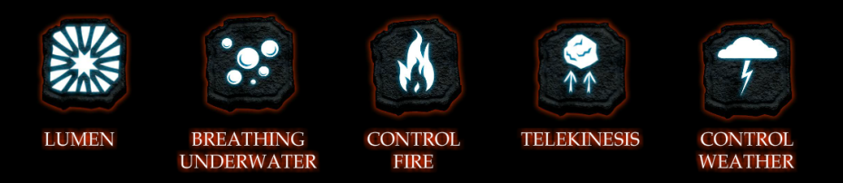
Legacies
http://www.iamnumberfour.co.uk/legacy/

1. What is a Legacy?
____________________________________________________________________________________________________________________________________________________________
2. What other legacies can be found in the movie?
Name | Description | Image
2. Which legacy would you want? _________________________________________________
3. Why? ______________________________________________________________________________
______________________________________________________________________________________________________________________________________________________________________________________________________________________________________________________________________________________________________________________________________________________________________________________________________

Legacies 2
http://www.iamnumberfour.co.uk/legacy/

1. Which legacies do Number Four and Number Six have? (Yes/No/Unsure)
Legacy | Number Four | Number Six
Lumen
Control Fire
Telekinesis (power to move objects without touching them)
Control Weather
Telepathy (Communicate mind to mind)
Breathing underwater
Invisibility
Super hearing
Super speed
Super strength
Night vision
2. Did seeing the whole movie change which legacy you wanted? ______________________
3. Why/why not? ______________________________________________________________________________
______________________________________________________________________________________________________________________________________________________________________________________________________________________________________________________________________________________________________________________________________________________________________________________________________

Garde Symbols
Each Garde has a symbol that identifies them.
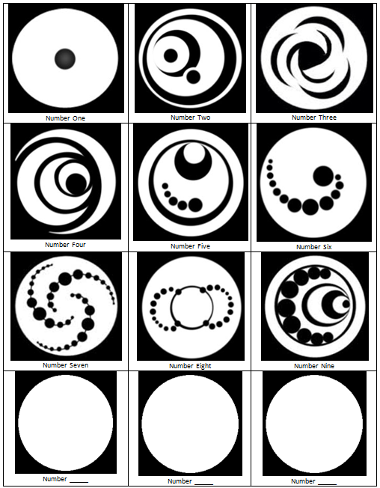
Create a symbol that could be used to identify you.
Choose one of the three. What aspects of you does it represent?
__________________________________________________________________________________________________________________________________________________________________________
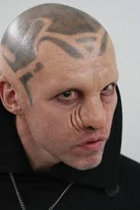
Mogadorians
Mogadorians are the species from the planet Mogadore. They invaded Lorien. There are two roles of Mogadorian: soldiers and scouts. They fight for their planet and are trying to hunt down the Garde.
1. Describe the Mogadorian___________________________________
___________________________________________________________
___________________________________________________________
___________________________________________________________
2. What is their goal?
___________________________________________________________________
___________________________________________________________________
3. Why is it so important that they achieve this goal?
___________________________________________________________________
______________________________________________________________________________________________________________________________________
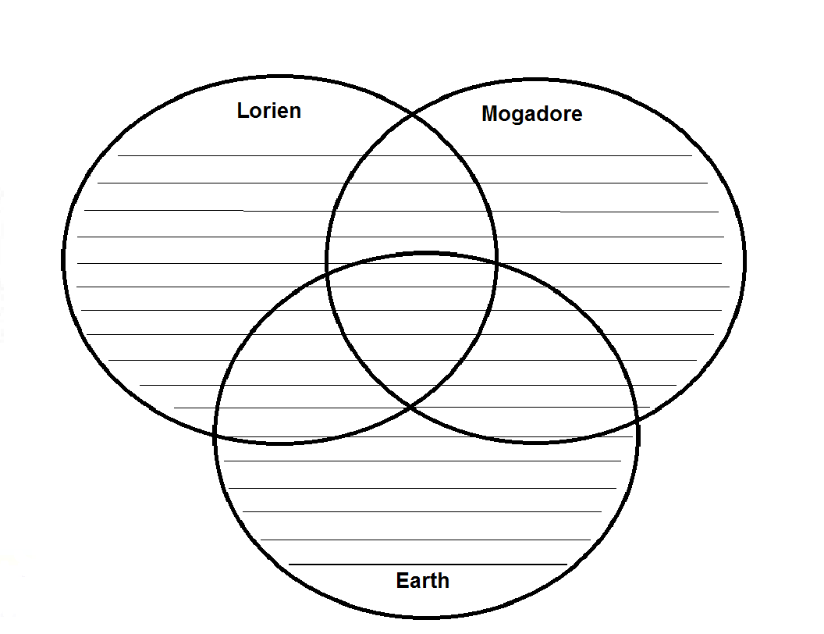
4. What does Mogadore have in common with Loien and Earth?

Cêpan
Cêpan is one of the two kinds of citizens on Lorien. A Cêpan has no Legacies or powers. Some Cêpan are chosen to become mentor Cepan, who teach the Garde as children to control their Legacies. Other Cêpan run the planet while the Garde defend it.
1. What is a Cêpan?
______________________________________________________________________________
______________________________________________________________________________
2. Who is Number Four's Cêpan?
______________________________________________________________________________
______________________________________________________________________________
3. What did Number Four's Cêpan do to protect Number Four?
________________________________________________________________________________________________________________________________________________________________________________________________________________________________________________________________________________________________________________________
4. What qualities do you think a Cêpan would need and why?
Quality | Reasons Why
Physically strong | To fight Mogadorians and protect the Garde
Theme: Good vs Evil
 | Good/Hero | Evil/Villain
Name the good and evil characters
How did the movie show the differences between good and evil? (lighting? sound?)
What do you think it means to be good or evil?

What were the goals of the good/evil characters?
Who do you want to win the war between Mogadore and Lorien? Why?
Characters
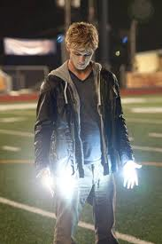
Number Four (aka Daniel Jones; John Smith)
Number Four has been on Earth now for ten years with the other eight Legacies. He is aided by Henri, a fifty year old
man who is also from his home world. Wherever he goes, he carries his emergency kit.

Number Four was only five when they arrived and the first scar didn't show up until he was nine. He got the second when he was twelve and the third when he was fifteen. Now, he knew he was next. He is Number Four. His Cêpan, Henri, is charged with keeping him safe, and teaching him how to control and use his Legacies as they appear.

Number Four is sorry when he has to leave the identity of Daniel Jones. He had only just begun making friends for the first time, and they had been in Florida longer than they had remained anywhere else. For the first time, he had almost begun to believe that they were safe. Then, his ankle showed the ring that announced Number Three was dead, and everything changed. The next move was to Paradise, Ohio and his new name was John Smith.

His first Legacy appeared to John on the first day of school. Without warning, his palms began to glow. From there,
along with regular exercise, his training began in earnest. Paradise would be the place where John and his Cêpan would have to make a stand, fighting the Mogadorians for their very survival.

Number Six

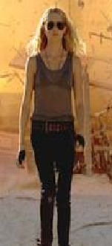
Number Six is a girl who is every bit as strong as John. Another Garde, she arrives just in time to help him fight the Mogadorians when they surround John and Sarah in the school. She is slightly older than John, with hazel eyes and long blonde hair. Her cheekbones are high, she has olive toned skin and a wide mouth underneath a strong nose.

Number Six has come into her Legacy as well. She is able to control the elements, bending them to her will, and she has the power of invisibility like John's grandfather had. Her Cêpan has been dead for three years now, and she has been on her own since. Number 6 tells John that she has been looking for him since she realized Number Three had been killed. She recognizes that they are at war and that time is short.

Number Six stands in battle with John, Henri, Sam, Mark, Sarah and Bernie Kosar as they temporarily defeat the Mogadorians. Though the battle is won, the war is far from over. She knows that they must somehow find Number Five and prepare to make a stand against the many Mogadorians who still inhabit Earth.

Character Profile
Name:
Description:
- clothing, costume or uniform
- physique
- facial features
- distinguishing features
Legacies:
- special traits and abilities
Using his/her legacies:
Example 1
- what happens?
- who is involved?
- where does it happen?
Using his/her legacies:
Example 2
- what happens?
- who is involved?
- where does it happen?
Why did you choose this character?
- What is it about them that you relate to?
- Is there anything that you admire about them?

Character Profile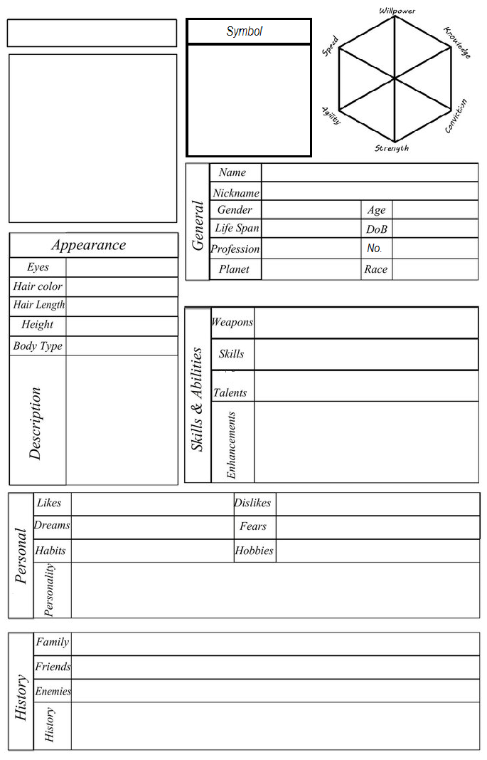
Plot Tension Graph
Tension is the feeling you get when involved in a conflict with no obvious solution. Tension can develop from opposition between people, between people and their surroundings, between hopes and realities, between tradition and change.

This is a typical example of plot tension:
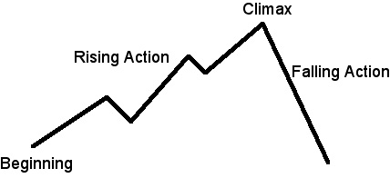
Use the graph below to plot the high and low tension points in the movie.

Low Tension High Tension

Beginning End

Personal Response

Initial reaction: | Other thoughts:

What type of movie is it?

What characters can you name or do you remember?
Is there anything that stood out to you in particular from the movie? If so what was it?
What would you like to explore further?

In Your Book

Help John Plot  Plot out John and Number Six's next moves to take out the Mogadarians on Earth. | Magazine reporter  Interview John for People Magazine.
Travel agent  As a travel agent, convince a person to visit Lorien. | New Title  Rename I am Number Four and explain your choice.
TV Reporter  Pretend you are a TV reporter and provide an on-scene report about the fight against the Mogadarians at John's school. | Book Cover  Create the art for a front cover for I Am Number Four.
Synopsis  Create a short paragraph for the back of I Am Number Four that would entice people to watch the movie. | Movie Review  Write a book review for the New York Times about I Am Number Four.
Quiz Questions  Create a quiz of 10 questions for the movie I am Number Four. | Prediction  What do you think will happen to Number Four, Six and Sam next?

__________________________________________________________________________________________________________________________________________________________________________________________________________________________________________________________________________________________________________________________________________________________________________________________________________________________________________________________________________________________________________________________________________________________________________________________________________________________________________________________________________________________________________________________________________________________________________________________________________________________________________________________________________________________________________________________________________________________________________________________________________________________________________________________________________________________________________________________________________________________________________________________________________________________________________________________________

Quick Quiz Questions
Part 1 – 0 to 20 minutes
1. What is about to happen as Number Four is settling in?
They have to move on again
2. What is going on with Number Three?
Number Three is dead.
3. How many "Numbers" are there?
9
4. How does Number Four have to act in order to blend in?
Like a normal fifteen-year-old boy.
5. Why was Sarah Short in the principal’s office?
taking pictures without permission.
6. Who is Henri
A warrior from No. 4s planet, his protector
7. What was left to Number Four by his father?
A box
8. When did No 4 get his first and second scars?
9 and 12
9. How was receiving his third scar different from his first two?
He could see and feel what was happening to number 3. He sensed the others knew too
10. Why does Henri take No. 4’s picture?
Wipe out evidence of him on the internet.

Discussion: How do you think Number Four felt on his first day of school?

Quick Quiz Questions
20-40 Minutes
- What picture is on Sam’s locker? Planet
- Where does Henri find John? Closet
- How does John control his power and stop his hands lighting up? Clalming down.
- Why did John sneak out of the house once Henri picked him up? To test out his new found powers.
Discussion1: What do you think is in the truck and why? (clues: lots of turkey, black truck no windows, must be large as lots of shaking)
Discussion 2: Why didn’t John hit Mark after stopping him hitting Sam? (keep control, stay hidden, right thing to do?)
Would you have reacted differently? Why?

Quick Quiz Questions
40-60 minutes
- What is the ‘hottest attraction at the fair’? haybale ride
- What happened on the haybale ride? Sarah and John got attacked.
- Who kidnapped Sarah and John? (mark)
- Why did he kidnap them? (he wanted to talk to sarah about their relationship
- What could he have done instead that may have gone better? Talked to her like a normal person
- What did Sam see that he wasn’t supposed to? John using his powers

