Geography assessment
Term two, 2016
Stage 5

Name: ______________________________

You have 1 hour to complete all sections of the assessment.

- Australia has become increasingly connected with the world. What are the 8 Links that have connected Australia with the world?

- What does globalisation mean?

- When Australia share information and technologies with America only and don’t share with the rest of the globe.

- When there is a breakdown of traditional barriers between countries around the world allowing movement of goods, people, communication and information.

- When Australia doesn’t share their ideas

- The Global nation

- Australia is isolated from the world

- What is a treatie?

- A reward for being good

- A international law to import goods

- An agreement between two government bodies

- The agreement that Australia will let anyone from around the world into the country to live

- A Choropleth map uses different shading of colour to represent where things are from or how much of something is in an area. Shade the countries you think most of your belongings ( eg. Hat, bag, shoes) come from.

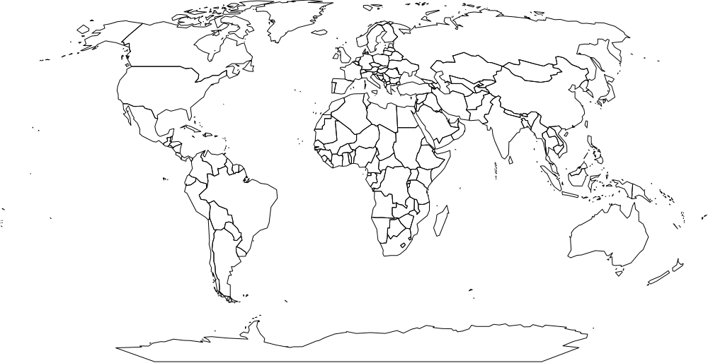

- Australia to have a cooperative relationship with its Asian neighbours. Can you come up with 2 reasons why?

- What is the purpose of protecting world heritage sites like the Harbour Bridge?

- Name two landmarks you could see from the top of Sydney Tower Eye.

- Why is tourism important to Australia?

- it’s fun
- It brings money, people, culture and connects Australia globally
- It’s not important
- It is dangerous for Australia bevause strangers come into the country and destroy it.

- Identify the tri-service of defence in Australia and identify some of their roles. ( hint: who defends our country)

END OF ASSESSMENT

