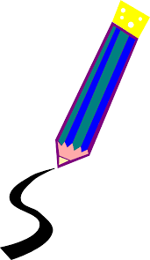Drawing Skills Checklist
Student Name: | No | Sometimes | Usually | Yes | Always
Perseveres with a variety of drawing tasks
Demonstrates a positive attitude towards drawing related tasks
Achieves success when drawing from observation
Complains that drawing tasks are too difficult
Enjoys experimenting with a variety of drawing materials
Enjoys a ‘drawing’ challenge
Individual drawing style emerging
Demonstrates skill in still life drawing
Drawing show Improvement
Finds drawing frustrating
Displays interest during drawing appreciation lessons
Finishes drawing tasks on a regular basis
Colours neatly with pencil
Pays close attention to details
Displays interest when appreciating artists
Draws on a regular basis without prompting
Is able to use the upside-down drawing method to complete a drawing
Requires teacher assistance with drawing tasks
Executes drawing tasks carefully
Demonstrates ability to use tone and tonal effects
Uses different lines to create tone; eg. Stippling, cross-hatching.
Draws geometric shapes well.
Enjoys drawing
ASSESSMENT - Achievement: Effort:
Comment:
ASSESMENT – YEARLY Achievement: Effort:
Comment:

