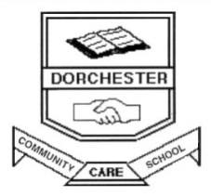

**The Elements of Learning and Achievement**

**QUALITY SYSTEMS CONSISTENT VISION**

**QUALITY RELATIONSHIPS**

**SHARED VISION**

**QUALITY TEACHING AND LEARNING CREATIVE VISION**

ZZ

**Wellbeing Framework**

**Great Teaching, Inspired Learning**

**Every Student, Every School**

**Aboriginal Education**

**Transition School to Community**

**Literacy and Numeracy Continuum**

**Local Schools, Local Decisions**

**School Excellence Framework**

**AUSTRALIAN CURRICULUM: GENERAL CAPABILITIES**

Literacy

Numeracy

ICT Capability

Ethical Understanding

Intercultural Understanding

Critical and Creative Thinking

Personal and Social Capability

|  |  |  |  |  |  |  |
| --- | --- | --- | --- | --- | --- | --- |
|  |  |  |  |  |  |  |

**Actions and**

**Choices**



**Pro-social Skills, Positive Relationships, Respectful, Responsible and Safe Behaviour**

Students will develop the pro-social skills to become respectful, responsible and safe learners by understanding the relationship between choices and consequences. Students will gain the ability to appropriately reflect on and resolve issues and learn to restart in a positive way.

**Independent Living Skills**



**Housekeeping &Organisation, Work Readiness,**

**Vocational Education**

Dorchester ETU promotes the importance and development of independent living skills to empower students as they make the transition to adulthood.

**Health and Wellbeing**



**Basic Fitness, Healthy Eating, Adolescent Health and Safety Related Topics**

Students will gain an understanding of the importance of Basic Fitness, Healthy Eating and related Adolescent Health and Safety topics to make positive lifestyle choices.

**Practical**

**Numeracy**

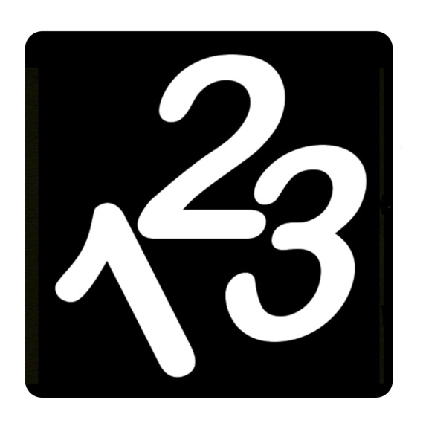

**Basic Operations, Measurement, Time, Money, Calculator Skills**

Numeracy is a key priority at Dorchester ETU. The importance of numeracy is taught on a daily basis across all curriculum areas. It supports the students in developing the numeracy skills to operate successfully within the community.

**Global**

**Citizen**



**General Knowledge Current Affairs,**

**Map Reading**

Dorchester will encourage students to become global citizens. Students will explore, discuss and analyse current issues on both a local and global level to broaden their awareness of their place in the world.

**Functional**

**Literacy**

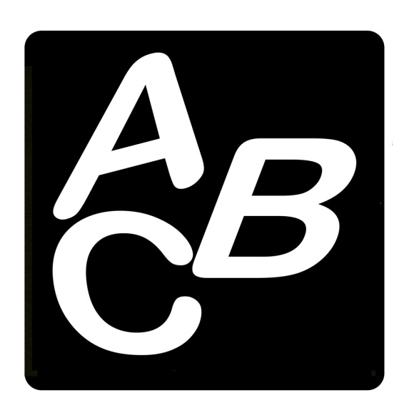

**Reading, Writing and Comprehension**

Literacy is a key priority at Dorchester ETU. Everyday functional Literacy is taught on a daily basis across all Key Learning Areas with the aim to provide students with the skills to support themselves in a literate society.

**21st Century**

**Learner**



**Navigate Technology, Word Processing, Research Skills, Computer Operations**

Students at Dorchester ETU will use technology across a number of devices. Students will develop functional computer operational skills and an awareness of technology in today’s society.