Marco

Cultural Cooking Studies

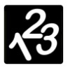****

[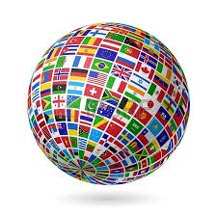](http://www.google.com.au/url?sa=i&rct=j&q=globe&source=images&cd=&cad=rja&uact=8&ved=0CAcQjRw&url=http://www.123rf.com/stock-photo/globe.html&ei=p7SHVKabH4fn8gWTyYDIDA&bvm=bv.81456516,d.dGc&psig=AFQjCNGR6nfGL0JxSU0txfz_9tKOa6sfmA&ust=1418266137566548)

____________________________________________________

[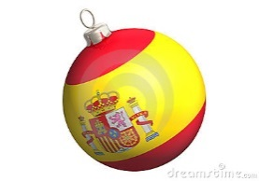](http://www.google.com.au/url?sa=i&rct=j&q=german%20flag&source=images&cd=&cad=rja&uact=8&ved=0CAcQjRw&url=http://promos.nephewsonew.org/german-flag-cutout-wall-decoration.aspx&ei=HsaHVKK-M4zl8AWnuILYAw&bvm=bv.81456516,d.dGc&psig=AFQjCNHwzUzfLs7x6xypfrkb6lVaGZDJpQ&ust=1418270617958872)****

**Spain – Fact Sheet**

‘Hola’ – Hello in Spanish

Money – Euros 1AUD = 0.67 Euros

* The Spanish name for Spain is España.
* The Spanish language is spoken in many areas of the world due to the early influence of the Spanish Empire.
* Spain is located in Europe.
* It is a developed country with a high quality of life.
* The largest city and capital of Spain is Madrid.
* The second largest city is Barcelona, which is located in Catalonia.
* The population of Spain in 2012 was around 47 million.
* In Spain they drive on the right-hand side of the road.
* It is believed that modern humans first arrived in Spain around 32000 years ago.
* Mount Teide is the highest mountain in Spain (3718 m, 12198 ft) and an active volcano.
* The Pyrenees is a mountain range that divides Spain and France.
* Spain includes a number of islands including Mallorca, Tenerife, Ibiza and Gran Canaria. Many can be found in the Canary Islands, an archipelago off the northwest coast of Africa.
* The Spanish tourism industry is one of the largest in the world, bringing in billions of Euros into the Spanish economy.
* Spain produces a large amount of renewable energy, including wind power and solar power.
* Spain has a variety of foods and unique dishes such as paella (a type of rice dish) and tapas (a range of small snacks or appetizers).
* Football (soccer) is the most popular sport in Spain.
* The 1992 Summer Olympic Games were held in Barcelona

<http://video.nationalgeographic.com/video/destinations/spain-overview-dest> – Spain’s Culture



Using these facts create a Powerpoint/iPad quiz/

**Running of the bulls**

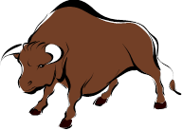

Every year from July 7th-14th thousands pack into Pamplona to start Spain's most famous bull-running fiesta to honour Navarre capital's patron saint, San Fermin. Spain stages more than 3,000 fiestas (festivals) each year but the 7 days of bull-running are the favorite in terms of spectacle and excitement.

After the daybreak of July 7th, runners (mainly young men) gather at the bottom of Santo Domingo, which is the starting line. They crowd together and sing to the image of San Fermin which is placed in a niche on a wall. The song goes: "A San Fermín pedimos, por ser nuestro patrón, nos guíe en el encierro dándonos su bendición" ("We ask San Fermín, as our Patron, to guide us through the Bull Run and give us his blessing.")

Then, as a rocket goes off, a number of fighting bulls are let out onto the streets. A second rocket is then let off to make sure everyone knows the bulls are loose in the street. The bulls run along the narrow street 825 metres (half a mile) to a bull ring. The runners dash along in front of the bulls, aiming to feel the breath of the bull on their backs, getting as close as possible - all whilst trying to avoid getting gored by their sharp horns.

The supposed way to do this is to start off slowly when the bulls are quite a distance behind. Then as they get nearer start running like hell! You can then go near them for a short time, as near as you are prepared to risk it, and then quickly get out of the way. Runners look for a gap in the fence to slip through or jump over, or a space against the wall of the street.

When the bulls finally reach the end of the street, they go into pens and are kept until later that day they are killed in a bullfight.

The tradition is said to have come from practicality when, in 1591 residents merely had to herd the bulls to the bull-fighting arena. At first only the drovers were used to lead the bulls. But it seems that at some date, the butchers guild, who had the responsibility of buying the bulls, began to join in with the drovers and began to chase behind the bulls and heifers up to the bull-ring from Santo Domingo street - the starting point of the run.

As time passed the event became more and more popular and some people began to run in front of the bulls and not behind them, as the drovers do. In 1852, a new bull-ring was built and a new route - becoming much shorter also, because as from 1899, it was decided to bring the bulls up to a small corral in Santo Domingo street the night before they fight in the ring.

Originally only a few daring souls ran with the bulls but the adrenaline rush of running in front of a 1500lb bull has since caught on. People now journey from all around the world to run with the bulls.

Other cities in Spain also have bull running festivals if you can´t make San Fermin or don´t like crowds. Aravaca-Pozuelo, a suburb of Madrid, for example, has a bull running festival in late summer.

**Imagine that you are a bull runner in Pamplona, write a version of your running with the bulls.**

**________________________________________________________________________________________________________________________________________________________________________________________________________________________________________________________________________________________________________________________________________________________________________________________________________________________________________________________________________________________________________________________________________________________________________________________________________________________________________________________________________________________________________________________________________________________________________________________________________________________________________________________________________________________________________________________________________________________________________________________________________________________________________________________________________________________________________________________________________________________________________________________________________________________________________________________________________________________________________________________________________________________________________________________________________________________________________________________________________________________________________________________________________________________________________________________________________________________________________________________________________________________________________________________________________________________________________________________________________________________________________________________________________________________________________________________**

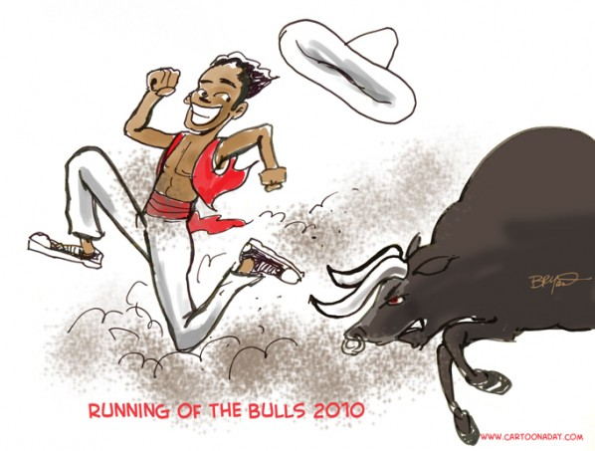

**Bullfighting**

Bullfighting is a great event that attracts many tourists to Spain and Spanish speaking countries. There it is an important element of culture and has a great tradition. Modern bullfighting goes back to the 1700s when the first bullrings were built in Spain.

A bullfight takes place in bullring. The matador, or bullfighter, has special training and is often a national hero in his homeland. The bulls used for bullfighting are very powerful, wild animals that are bred to attack. They weigh up to 500 kg or even more. Today many animal activists are against bullfighting because bulls are treated in a cruel way and have to suffer pain in the arena. Bullfights can also end with a matador’s death or injury if he is pierced by a bull’s horns.

A bullfight usually consists of six fights. Three matadors with their teams fight two bulls each. A bullfight has three acts. After the trumpets sound at the beginning, the bull is let into the ring. The bullfighter waves a colorful cape at the bull and tries to make it attack. During this part he studies the movements of the bull. A picador enters the arena on horseback. He makes the bull weaker by piercing his neck with sharp spikes.

In the second act, the assistants of the matador, called banderilleros, come into the ring on foot, run around and throw barbed darts into the animal’s neck to make it even madder.

In the final act the bullfighter is in the ring alone with the bull. He uses a small cape, waves at the bull and lures it into attacking him. He tries to be as close to the bull as possible. Finally, he thrusts his sword into the bull’s neck and kills it. If he succeeds in pushing the sword into the bull’s shoulder blades it dies at once. After the successful performance of the matador the spectators get up and applaud. The bullfighter gets one or maybe even two of the bull’s ears as a reward.

**Find the meanings of the following words:**

Tradition: _______________________________________

Picador: ________________________________________

Matador: _______________________________________

Lure: __________________________________________

Pierce: _________________________________________

Thrust: _________________________________________

Cape: __________________________________________

**Bacon and cheese croquettes**

|  |  |  |
| --- | --- | --- |
| **Prep time**  30 mins | **Cook time**  16 mins | **Total time**  46 mins |

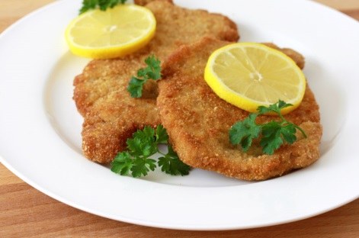

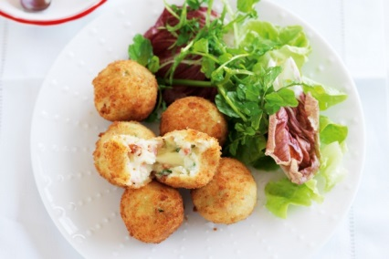

**Ingredients**

* 4 rashers middle bacon, trimmed, finely chopped
* 2 cups cold mashed potato
* 1 egg yolk
* 2 green onions, finely chopped
* 3/4 cup plain flour
* 40g mozzarella cheese, cut into 1cm cubes
* 1 1/2 cups fresh breadcrumbs
* 1 egg
* 1/4 cup milk
* Azalea grape seed oil, for shallow-frying
* Mixed salad leaves, to serve

**Instructions**

* Heat a medium non-stick frying pan over medium heat. Cook bacon for 3 to 4 minutes or until crisp. Drain on a plate lined with paper towel.
* Combine mashed potato, egg yolk, onion, bacon and 1/4 cup flour in a large bowl. Roll heaped tablespoons of mixture into 20 balls. Push 1 cheese cube into the centre of each ball. Mould mixture around cheese to enclose.
* Place remaining flour on a plate. Place breadcrumbs on another plate. Whisk egg and milk together in a shallow bowl. Roll croquettes in flour, shaking off excess. Dip in egg mixture. Coat in breadcrumbs.
* Heat oil in a deep frying pan over medium-high heat. Cook croquettes, in batches, turning, for 3 to 4 minutes or until golden. Using a slotted spoon, transfer to a plate lined with paper towel. Serve with salad.

**Review**

Time taken: ___________________

Notes: _________________________________________________________________________________ ______________________________________________________________________________________________________________________________________________________________________________

**Churros**

|  |  |  |
| --- | --- | --- |
| **Prep time**  20 mins | **Cook time**  10 mins | **Total time**  30 mins |

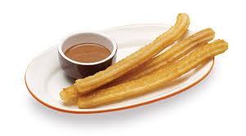

**Ingredients**

* 17 fl oz water
* 9 oz sifted flour
* 1 tsp salt
* Plenty of oil for frying
* Sugar (optional)
* Churro maker

**Instructions**

* Bring the salted water to a boil in a high-sided pot.
* When it starts to boil, pour in all the flour and mix with a wooden spatula over the heat until a consistent, even dough is formed.
* Remove from the heat and continue to work the dough with the same spatula.
* When completely smooth, fill the churrera, a large tin or brass syringe that has a variety of nozzles and several handles to grip it while pressing the dough through.
* Heat the oil to 375 degrees F in a large frying pan and drop in strips of dough forming loops. Cook as many as will fit without touching each other.
* After 3-4 minutes, when golden, remove with a slotted spoon or a spike and leave to drain in a colander or on kitchen paper. Serve hot, sprinkled with sugar if desired.

**Review**

Time taken: ___________________

Notes: _________________________________________________________________________________ ______________________________________________________________________________________________________________________________________________________________________________

**Spanish Omellette**

|  |  |  |
| --- | --- | --- |
| **Prep time**  10 mins | **Cook time**  25 mins | **Total time**  35 mins |

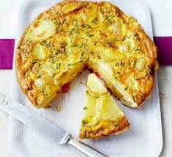

**Ingredients**

* 1 tablespoon extra virgin olive oil
* 1 (about 120g) chorizo sausage, thinly sliced
* 1 red onion, chopped
* 1 small (about 200g) red capsicum, halved, deseeded, cut lengthways into strips
* 2 garlic cloves, crushed
* 1 (about 150g) ripe tomato, roughly chopped
* 1/2 teaspoon sweet paprika
* 6 eggs
* 2 tablespoons water
* Salt & freshly ground black pepper
* 2 tablespoons roughly chopped fresh continental parsley

**Instructions**

* Heat oil in a 22cm (base measurement) heavy-based frying pan over medium heat. Add sausage and cook, stirring, for 3-4 minutes or until golden brown. Transfer sausage to a bowl. Reduce heat to medium-low. Add onion and capsicum, and cook, stirring, for 5 minutes or until onion is soft. Add garlic and cook, stirring, for 1 minute or until aromatic.
* Return sausage to pan. Add tomato and paprika, and cook, stirring, for 1 minute. Spread mixture evenly in pan and set aside until required.
* Crack eggs into bowl. Add water and whisk until combined. Season with salt and pepper. Preheat grill on medium. Pour egg mixture over sausage mixture in pan. Cook over medium heat for 8-10 minutes or until almost set. Place under preheated grill and cook for 1-2 minutes or until just cooked through. Remove from heat and sprinkle with parsley.

**Review**

Time taken: ___________________

Notes: _________________________________________________________________________________ ____________________________________________________________________________________________________________________________________________________________________________

****[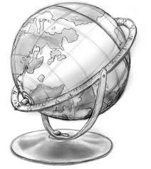](http://www.google.com.au/url?sa=i&rct=j&q=globe%20stencil&source=images&cd=&cad=rja&uact=8&ved=0CAcQjRw&url=http://www.deviantart.com/morelikethis/102255309/digitalart/paintings?offset%3D300%26view_mode%3D2#skins&ei=vrWHVMSKJtbe8AWgi4H4CQ&bvm=bv.81456516,d.dGc&psig=AFQjCNFOcT07qaypgmOv99a8O9w6KbYpOg&ust=1418266393499757)**Geography**

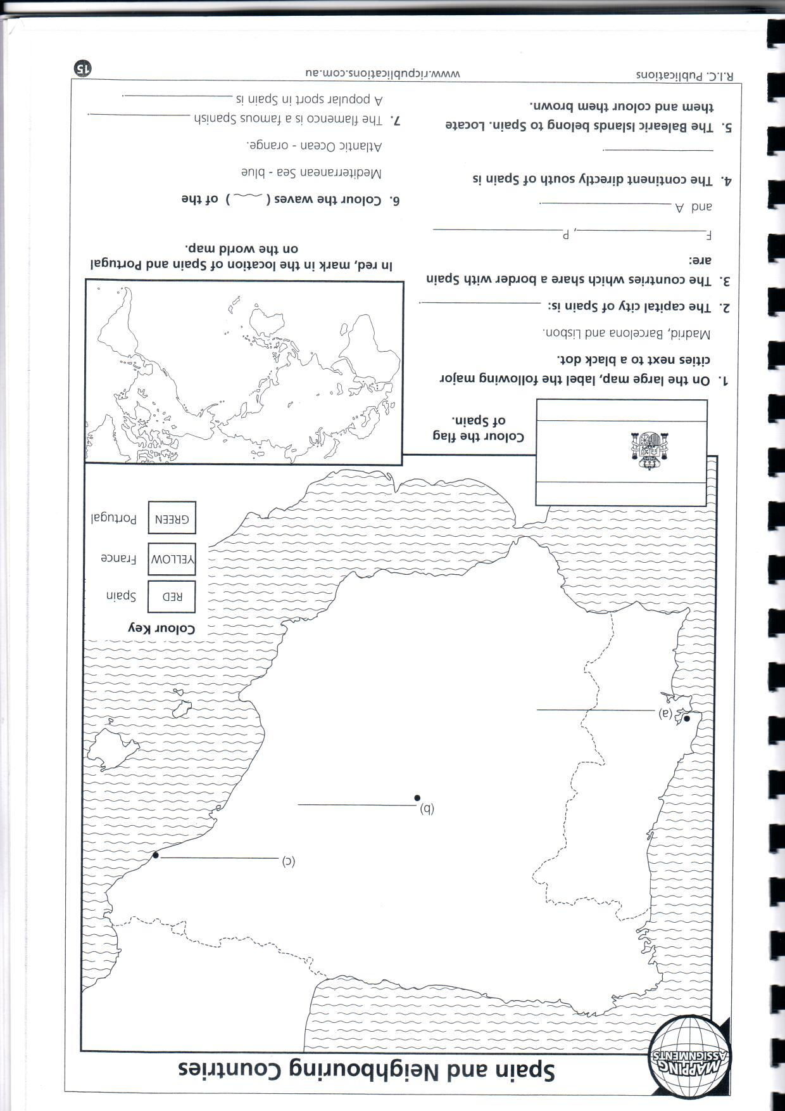

**Rafael Nadal– Biography**

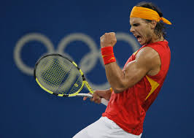

**Early Years**

Rafael Nadal was born in Majorca, Spain, on June 3, 1986. When he was 3 years old, his uncle, Toni Nadal, a former professional tennis player, started working with him, seeing an aptitude for the sport in young Rafael. At the age of 8, Nadal won an under-12 regional tennis championship, giving Toni Nadal the incentive to step up his training. Toni noticed at the time that Rafael played his forehand shots with two hands, so he encouraged him to play left-handed, thinking it could give Rafael an edge on the court.

When Nadal was just 12 years old, he won the Spanish and European tennis titles in his age group, and at age 15, he turned pro and started playing on the junior circuit.

**A Young Professional**

At the age of 16, in his first ITF junior event, Nadal made it to the semi-finals of the Boys' Singles tournament at Wimbledon. By age 17, he became the youngest man to reach the third round at Wimbledon since Boris Becker. At the age of 19, in 2005, Nadal won the French Open the first time he played it, and his world ranking went to No. 3. Nadal won 11 singles titles that year, eight of which were on clay, and he was soon dubbed the "King of Clay."

**Hitting His Stride**

Nadal went on to win the next three French Opens. In 2006, after winning the French Open— despite both shoulder and foot injuries—he won four other titles. The following year, he won again at Roland Garros and took home five other titles. Nadal poured it on in 2008, winning the French Open again, in addition to winning Wimbledon—where he beat long-time rival Roger Federer in the longest final in Wimbledon history—gold at the Beijing Olympics, and five other titles. After Wimbledon, Nadal's winning streak stood at a career-best 32 matches.

Since 2008, despite being occasionally hampered by injuries, Nadal has been one of the superstars of the tennis world, winning 15 titles and hitting No. 1 in the world-ranking twice (in August 2008 and again in June 2010). He won the Australian Open in 2009 and came back to win his second Wimbledon in 2010, as well as his first U.S. Open and fifth French Open title. The following year, a No. 1-ranked Nadal lost his top ranking as well as Wimbledon 2011 to Serbian tennis player Novak Djokovic. In June 2012, however, Nadal defeated top-ranked Novak Djokovic to win his record seventh French Open title—a feat never accomplished before in men's tennis. That same month, a No. 3-ranked Nadal lost to Czech player Lukas Rosol in the Wimbledon semfinals—Rosol's fifth Grand Slam win, and a match that some commentators labeled one the biggest upsets in tennis history.

In June 2013, Nadal won his eighth French Open title against fellow Spaniard David Ferrer, 6-3, 6-2, and 6-3— marking his eight French Open victory in nine attempts. "I never like to compare years, but it's true that this year means something very special for me," Nadal said after the match, in an interview with ESPN. "Five months ago nobody of my team dreamed about one comeback like this because we thought that [was] going to be impossible. But here we are today, and that's really fantastic and incredible."

Nadal is only the second male player in tennis history to complete the Career Golden Slam—winning the French, Australian and U.S. Opens; Wimbledon; and the Olympic Gold medal. Additionally, by 2011, he had taken the Spanish Davis Cup team to victory four times (2004, 2008, 2009 and 2011).

In 2013, the future of Nadal's career became the subject of much speculation. He won the French Open that year, but he made a poor showing at Wimbledon. At Wimbledon, Nadal was eliminated in the first round of competition. He seemed to be back on the upswing, however, at the U.S. Open. He defeated Novak Djokovic to win the men's singles title.

In June 2014, Nadal won his ninth French Open title against Novak Djokovic, 3-6, 7-5, 6-2, 6-4, earning him 14 Grand Slam titles. To date, Roger Federer holds the lead with with 17. In August of the same year, the reigning U.S. Open champ withdrew from the 2014 Grand Slam competition citing a wrist injury.

*Questions*

* How old was Nadal When his Uncle Toni started to train him?
* How old was Nadal when he won his first Grand Slam?
* What year did Nadal lose his number 1 ranking and who took his number 1 spot?
* How many Grand Slams has Rafael won to date?
* Do you think Nadal will beat Roger Federer in winning more Grand Slams?

