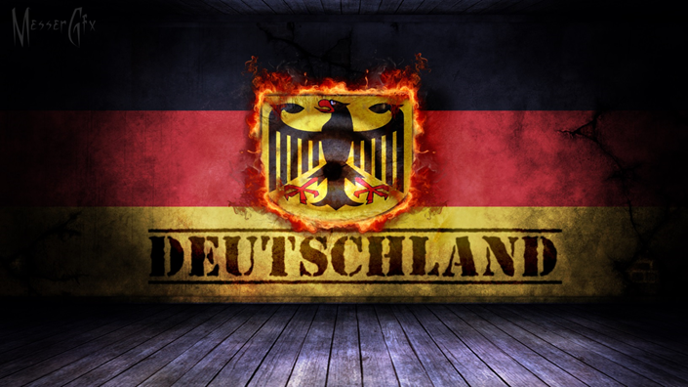

Kate

Cultural Cooking Studies

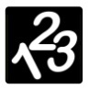****

[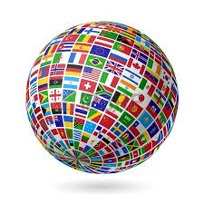](http://www.google.com.au/url?sa=i&rct=j&q=globe&source=images&cd=&cad=rja&uact=8&ved=0CAcQjRw&url=http://www.123rf.com/stock-photo/globe.html&ei=p7SHVKabH4fn8gWTyYDIDA&bvm=bv.81456516,d.dGc&psig=AFQjCNGR6nfGL0JxSU0txfz_9tKOa6sfmA&ust=1418266137566548)

____________________________________________________

****[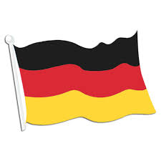](http://www.google.com.au/url?sa=i&rct=j&q=german%20flag&source=images&cd=&cad=rja&uact=8&ved=0CAcQjRw&url=http://promos.nephewsonew.org/german-flag-cutout-wall-decoration.aspx&ei=HsaHVKK-M4zl8AWnuILYAw&bvm=bv.81456516,d.dGc&psig=AFQjCNHwzUzfLs7x6xypfrkb6lVaGZDJpQ&ust=1418270617958872)

**Germany – Fact Sheet**

* The name for Germany in the German language is Deutschland.
* Germany uses Euros as currency. 1AUD = 0.67 Euros
* The population of Germany was 82,652,256 July 1, 2014.
* The capital of Germany is Berlin, it is also the largest city.
* Germany is a member of the European Union.
* Countries that border Germany include Belgium, [the Netherlands](http://www.sciencekids.co.nz/sciencefacts/countries/netherlands.html), Denmark, Austria, the Czech Republic, France, Luxembourg, Poland and Switzerland.
* Germany has the largest economy in Europe.
* Large German companies include BMW, Adidas, SAP, Mercedes-Benz, Nivea, Audi, Bayer, Volkswagen and Siemens.
* Germany has a number of important natural resources, including copper, nickel, natural gas, uranium and coal.
* Germany is in the process of phasing out nuclear power plants.
* There are many national parks in Germany include the Bavarian Forest National Park, Jasmund National Park, Harz National Park, and the Wadden Sea National Parks among others.
* Over 100 Germans have been awarded the Nobel prize in their field, including [Albert Einstein](http://www.sciencekids.co.nz/sciencefacts/scientists/alberteinstein.html), who was born in Germany.
* Germany has been home to famous composers such as Johann Bach, Ludwig van Beethoven and Richard Wagner.
* The German coat of arms features a black eagle against a yellow shield.
* Fußball (soccer) is the most popular sport in Germany.

<https://www.youtube.com/watch?v=XK1dazJppJE> – top 10 German things

Using these facts create an iPad quiz

**German Comics – Feuerwerk**

**Kapitel 1 – Heh, das is mein Hamburger!**

1. Do you speak German? ______________________________________________________________
2. Look at the pictures. What do you think is happening? ___________________________________________________________________________________________________________________________________________________________________________________________________________________________________________________
3. What happens to Waldorf’s hamburger? ________________________________________________
4. What day of the week is it? __________________________________________________________
5. What do you think these German words mean?

*Hint: say them out loud, what English words do they remind you of?*

Hallo ____________________________________________________________________________

Hamburger _______________________________________________________________________

Montag __________________________________________________________________________

Freund ___________________________________________________________________________

Nicht ____________________________________________________________________________

Gut ______________________________________________________________________________

Computer ________________________________________________________________________  
Intelligent ________________________________________________________________________  
Hier _____________________________________________________________________________

1. Use the iPad to listen to a few more German words. Which ones can you say? What do they mean?

|  |  |
| --- | --- |
| **Word** | **Meaning** |
|  |  |
|  |  |
|  |  |
|  |  |
|  |  |
|  |  |
|  |  |

[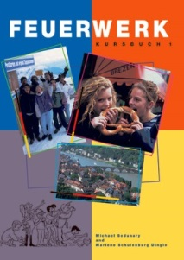](http://www.google.com.au/url?sa=i&rct=j&q=feuerwerk+text+book&source=images&cd=&cad=rja&uact=8&ved=0CAcQjRw&url=http://www.pearson.com.au/products/S-Z-Sedunary-Michael/Feuerwerk-1-Student-Book/9781863911085?R%3D9781863911085&ei=N-34VIrTJJXn8AXL_oKoDg&bvm=bv.87611401,d.dGc&psig=AFQjCNFInIgmcXT07kGP85yqsRtc6tEBmw&ust=1425686168101366)

**Comprehension Activity**

In 1933, the year Adolf Hitler assumed power, this cartoon was published in a German newspaper.

It was titled “The Sculptor of Germany” by O. Gavens.

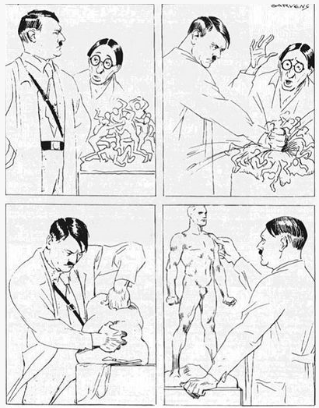

What is happening in each panel?

What is this cartoon trying to say?

_________________________________________________________________________________________________________________________________________________________________________________________________________________________________

iPad – create own using comic life

****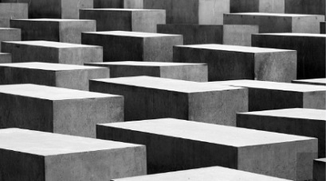**Memorials**

Germany is a country that has had little choice but to confront its dark past, and you’ll find many memorials and historic sites that commemorate those who suffered and were killed during WWII. Across the country there are also various museums that document this sinister period in human history.

**East Side Gallery**

The longest open air gallery in the world, the East Side Gallery is created from the longest segment of the Berlin Wall that is still standing. It is 1316m long and was painted by 118 artists from 21 different countries. The artworks were created to comment on the events that took place in 1989 and 1990.

[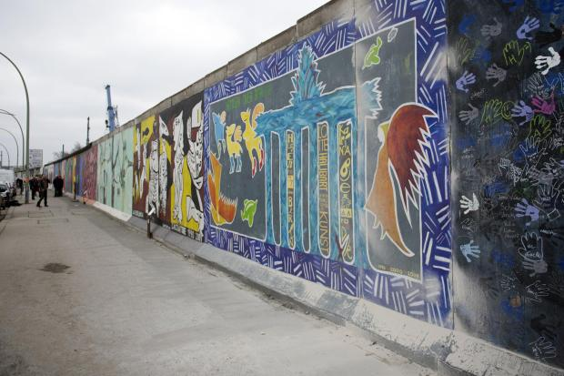](http://www.google.com.au/url?sa=i&rct=j&q=east+side+gallery+germany&source=images&cd=&cad=rja&uact=8&ved=0CAcQjRw&url=http://www.morgenpost.de/berlin-aktuell/article114015764/Menschenkette-soll-Abriss-der-East-Side-Gallery-verhindern.html&ei=2eP4VOfgEafpmQXfooFo&v6u=http://s-v6exp1-ds.metric.gstatic.com/gen_204?ip%3D153.107.97.166%26ts%3D1425597375285791%26auth%3Djkeqb6q5pgdmxfv2p2mcj6fe3atv3hta%26rndm%3D0.24797925477756127&v6s=2&v6t=26564&bvm=bv.87611401,d.dGY&psig=AFQjCNHBKnZkU-E1i10kivLpoZtuKNB3Ug&ust=1425683775213855)

Below you can find 2 of the artworks from the wall. What do you think they meant and why?

|  |  |
| --- | --- |
| [http://t3.gstatic.com/images?q=tbn:ANd9GcSG1iNleMlr7VIjpmgPccokUxjX2lGffNWi1Xne-JL9o1Yripb4bQ](http://www.google.com.au/url?sa=i&rct=j&q=East+Side+Gallery+Berlin&source=images&cd=&cad=rja&uact=8&ved=0CAcQjRw&url=http://artelocal.eu/east-side-gallery/&ei=OsmHVKuYDIT78QXg4oLgBw&bvm=bv.81456516,d.dGc&psig=AFQjCNE9lEDd9IIeGw17umApjjrvbNvPww&ust=1418271294882498) |  |
| [http://t1.gstatic.com/images?q=tbn:ANd9GcRvrxA_MjXPrBYJYAMqC0bpe71YCak84G1f65b7gneRrdijcboTxg](http://www.google.com.au/url?sa=i&rct=j&q=East+side+gallery+berlin+wall&source=images&cd=&cad=rja&uact=8&ved=0CAcQjRw&url=http://caroundtheworld.com/2010/10/27/die-mauern-the-berlin-wall-east-side-gallery/&ei=-8qHVLO9J8Tf8AXj2ILQCg&bvm=bv.81456516,d.dGc&psig=AFQjCNFBJlIiprRJwkb6T_RgLpo22QffJQ&ust=1418271806473334) |  |

**Pork Schnitzel (Schweineschnitzel)**

http://www.daringgourmet.com/2014/03/12/traditional-german-pork-schnitzel/

|  |  |  |
| --- | --- | --- |
| **Prep time**  10 mins | **Cook time**  6 mins | **Total time**  16 mins |

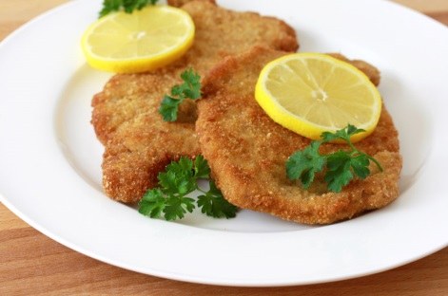

**Ingredients**

4 pork fillets (200g each)

Salt & pepper

½ cup all-purpose flour combined with 1 teaspoon salt

2 large eggs, lightly beaten

¾ cup plain breadcrumbs

Oil

**Instructions**

1. 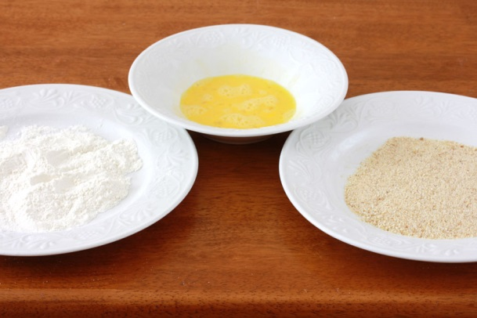Place the pork chops between two sheets of plastic wrap and pound them until just ¼ inch thick with the flat side of a meat tenderizer. Lightly season both sides with salt and freshly ground black pepper.
2. Place the flour mixture, egg, and breadcrumbs in 3 separate shallow bowls. Dip the chops in the flour, the egg, and the breadcrumbs, coating both sides and all edges at each stage. Be careful not to press the breadcrumbs into the meat. Gently shake off the excess crumbs. Don't let the schnitzel sit in the coating or they will not be as crispy once fried - fry immediately.
3. Make sure the cooking oil is hot enough at this point (about 330 degrees F) as you don't want the Schnitzel to sit around in the coating before frying. Use enough oil so that the Schnitzels "swim" in it.
4. Fry the Schnitzel for about 2-3 minutes on both sides until a deep golden brown. Transfer briefly to a plate lined with paper towels.
5. Serve immediately with slices of fresh lemon and parsley sprigs or with your choice of sauce.

**Review**

Time taken: ___________________

Notes: _________________________________________________________________________________ ______________________________________________________________________________________________________________________________________________________________________________

****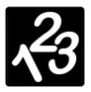**Budgeting**

Below are the ingredients you will need to have or buy to make schnitzel. Circle the best value for each product.

|  |  |
| --- | --- |
|  |  |
|  |  |
|  |  |
|  |  |

How much will it cost to buy:

Salt ______________

Pepper ______________

Flour ______________

Eggs, lightly beaten ______________

Breadcrumbs ______________

Oil ______________

TOTAL ______________

This recipe needs 4 pork fillets at 200g each. How many grams will you need for 4 fillets? _______________

How much will 4 fillets cost? ________________

Adding the cost of your meat to the other ingredients, what is your new total? _______________________

**Potato Pancakes (Kartoffelpuffer)**

|  |  |  |
| --- | --- | --- |
| **Prep time**  15 mins | **Cook time**  10 mins | **Total time**  25 mins |



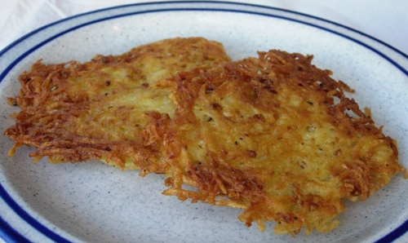**Ingredients**

2 medium potatoes

½ an onion

1tsp salt

Pepper

1 egg

Oil for frying

**Instructions**

1. Peel and grate potatoes.
2. Place grated potatoes in a clean dishcloth and squeeze liquid out.
3. Grate the onion over the potatoes.
4. Add salt, pepper and egg.
5. Mix thoroughly
6. Heat oil in frying pan.
7. Drop ½ cup of potato mixture into the oil and flatten with the back of a spoon.
8. Fry 4-5 minutes each side or until golden brown.
9. Drain on paper towels and serve hot with applesauce (optional).

**Review**

Time taken: ___________________

Notes: _________________________________________________________________________________ ______________________________________________________________________________________________________________________________________________________________________________

****[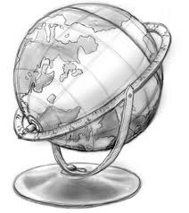](http://www.google.com.au/url?sa=i&rct=j&q=globe%20stencil&source=images&cd=&cad=rja&uact=8&ved=0CAcQjRw&url=http://www.deviantart.com/morelikethis/102255309/digitalart/paintings?offset%3D300%26view_mode%3D2#skins&ei=vrWHVMSKJtbe8AWgi4H4CQ&bvm=bv.81456516,d.dGc&psig=AFQjCNFOcT07qaypgmOv99a8O9w6KbYpOg&ust=1418266393499757)**Geography**

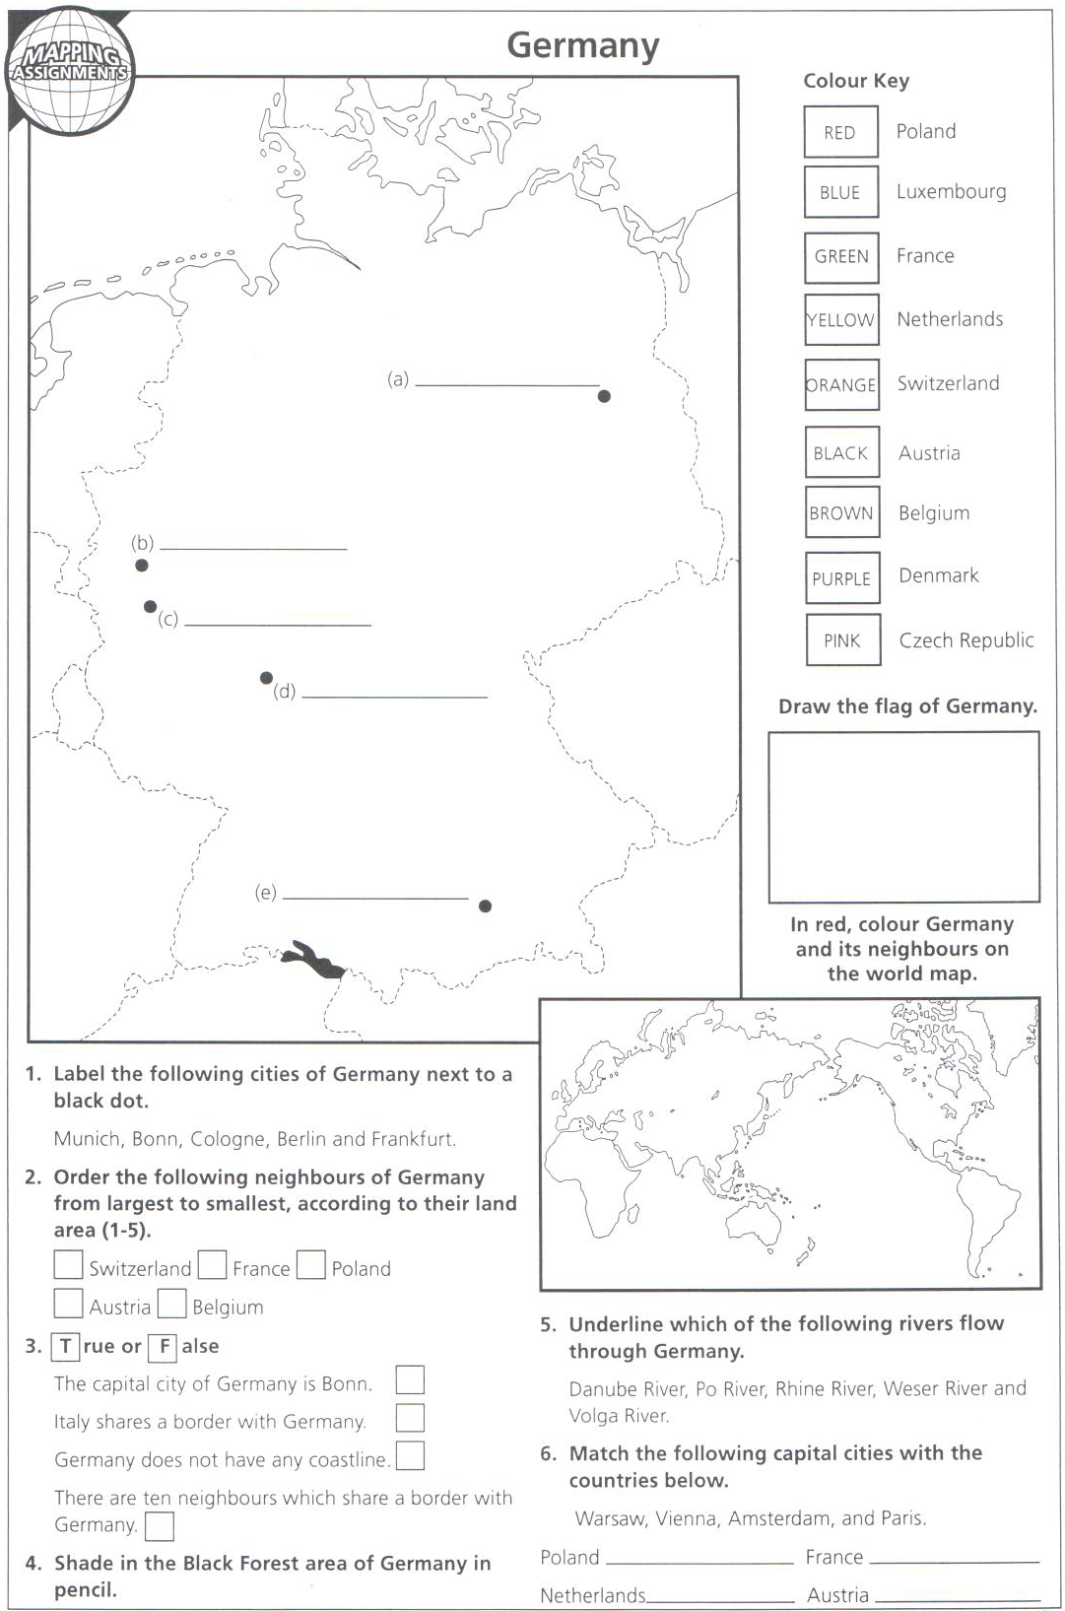

**Sport – Fußball – Biography**

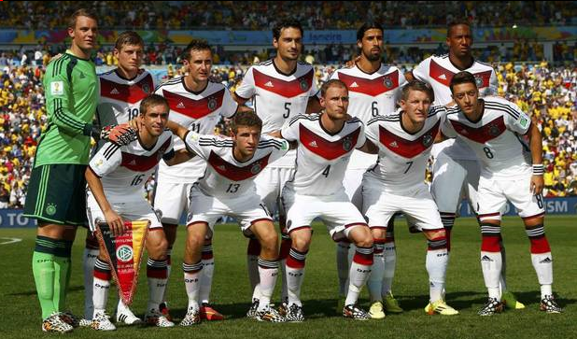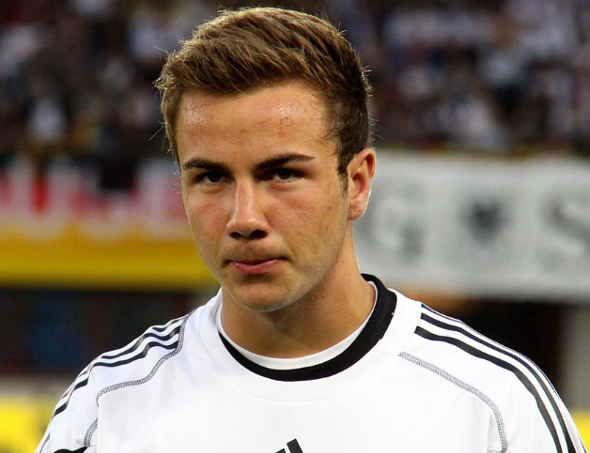

**Mario Götze**

Present club: Bayern Munich

Position: Midfielder

Salary: 7 million EUR

Mario Götze is a German footballer who plays as an attacking midfielder for FC Bayern Munich in the German Bundesliga. He is actually more than a number 10 player. Mario Götze is capable of playing as either a left or right winger and also as a false nine. He was first selected for the Germany National Football team in 2010, only at the age of 18. Götze was become a proud member of the 2012 Euro team. And two years later he scored the surprising winning goal of the 2014 FIFA World Cup final was scored by this young talent.

Between 2009 and 2013, Götze played for the German Bundesliga club Borussia Dortmund. He was the member of the team that reached the 2013 UEFA Champions League Final. He was moved to FC Bayern Munich for a €37 million bid in April 2013. Being the second most expensive German player Götze is now at the 4th rank in the list of top 10 highest paid soccer players in German Bundesliga.

Mario Götze was born on June 3, 1992 in Memmingen, Germany. This German playmaker plays as an attacking midfielder for Bayern Munich in the German Bundesliga and the German National team. The 22-year-old marked his signature in the World Cup history by scoring a stunning goal in the 2014 World Cup finals against Argentina. This young talent has played 83 games for his club with 22 goals. Among the youngster, Mario Götze has become the most popular figure after German’s world cup campaign.

Portrait of a Figher - <https://www.youtube.com/watch?v=J4cjfVl3EeA> – published 2012

**Sport – Fußball – Biography**

1. What game does Mario Götze play? ______________________________________________________
2. When was Mario born? ______________________________________________________________
3. Where was Mario born? ______________________________________________________________
4. From the video clip what other sport does Mario enjoy? ______________________________________
5. What positions can Mario play? __________________________________________________________
6. How many games has Mario played? ______________________________________________________
7. How many goals has he kicked? __________________________________________________________
8. What does Fußball mean? _____________________________________________________________
9. What year was Mario first selected for the Germany National Football team? _____________________
10. How old was he when he was first selected for the German National Football team? _______________
11. In the 2014 FIFA World Cup final, what surprising thing did Mario do? __________________________
12. Why is Mario the most popular figure in German Fußball? ____________________________________
13. How much does Mario earn? ___________________________________________________________

[](http://www.google.com.au/url?sa=i&rct=j&q=soccer&source=images&cd=&cad=rja&uact=8&ved=0CAcQjRw&url=http://www.alliancecityschools.org/district_news_and_events/district_news/middle_school_girls_soccer&ei=m24HVbf7EseC8gWLrICgAg&bvm=bv.88198703,d.dGc&psig=AFQjCNFtm758VV2JzpBF2Bqyk3gGOT9vPg&ust=1426636820548649)

**Planning a Trip - Budgeting**

Using the travel brochure provided, plan a trip to Berlin with a budget of $6000 AUD

Decision 1: Length of stay. Will you stay 1 or 2 weeks in Germany? ____________________

|  |  |  |
| --- | --- | --- |
| **Activity** | **Details** | **Cost** |
| Flights |  |  |
| Accommodation |  |  |
| Transport  *hire a car OR*  *public transport* |  |  |
| Food |  |  |
| Shopping |  |  |
| Additional Costs? |  |  |
|  | Total |  |

[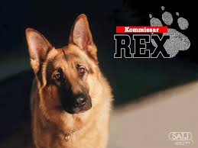](http://www.google.com.au/imgres?imgurl=http://1.bp.blogspot.com/-w0NLiueJye8/Tv01SlFKVwI/AAAAAAAAAEo/JRWtsalhc70/s1600/Get%2BUp%2Band%2BGo%2BRex%2BArthritis.jpg&imgrefurl=http://getupandgodog.blogspot.com/2011/12/puparazzi-inspector-rex.html&h=768&w=1024&tbnid=L7u7PRpM8518VM:&zoom=1&q=inspector+rex&docid=k_NFHrcCz7yvUM&ei=Wuz4VJT-FI3V8gWMlIKwCw&tbm=isch&ved=0CCsQMygPMA8)[](http://www.google.com.au/url?sa=i&rct=j&q=inspector+rex&source=images&cd=&cad=rja&uact=8&ved=0CAcQjRw&url=http://www.fernsehserien.de/kommissar-rex-2008&ei=eOz4VMTaEJfm8AXhgYFI&bvm=bv.87611401,d.dGc&psig=AFQjCNEynofX82DQ2O_GwJ0NfDL1rZYTQA&ust=1425685978529112)**Kommissar (Inspector) Rex**

**Language**

See if you can match the German phrases to the English phrases

|  |  |
| --- | --- |
| ja  nein  bitte  danke  guten morgan  guten abend  auf wiedersehen  wie geht es ihnen?  entschuldigung  sprechen sie Englische?  Das ist gut  Wann?  Wie?  Warum?  Wer?  Wo ist…?  Ich bin…  Ich habe… | Do you speak English?  Please  Good morning  Goodbye  Where?  Where is…?  Good evening  I have…  How?  How are you?  Sorry  When?  I am…  No  That’s good  Why?  Thank you  Yes |

**Zurcher Gerschnetzeltes**

|  |  |  |
| --- | --- | --- |
| **Prep time**  10 mins | **Cook time**  6 mins | **Total time**  16 mins |

**Ingredients:**

[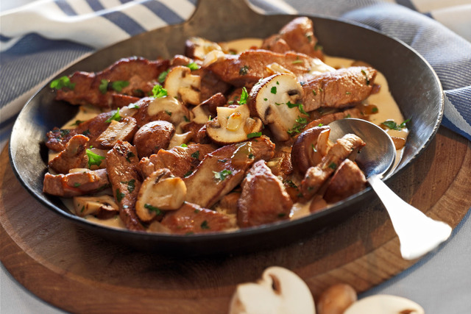](http://www.google.com.au/url?sa=i&rct=j&q=Zurcher+Geschnetzeltes&source=images&cd=&cad=rja&uact=8&ved=0CAcQjRw&url=http://www.so-schmeckts.de/rezepte/zuercher-geschnetzeltes&ei=_uH4VP_oNtXr8AXI54CADg&bvm=bv.87611401,d.dGc&psig=AFQjCNHUTPsj7Z_bXPyB-Qp0LYuyYGBnRw&ust=1425683306065360)1 kg veal, cut into strips

3 tbsp. plain flour

2 tbsp. butter

2 tbsp. olive oil

1 onion, chopped

2 cloves garlic, minced

200g mushrooms, thickly sliced

½ tsp. lemon zest

1 tbsp. lemon juice

½ cup dry white wine (apple juice)

1 cup heavy cream

Paprika (optional)

Chopped parsley to serve

**Method:**

1. Coat the veal strips in seasoned flour.

2. In a fry pan melt 12/ the butter and oil.

3. When the butter foams, add the meat and brown. Set aside.

4. Add remaining butter and oil to pan and sauté the onion and garlic, 2 mins.

5. Stir in the mushroom and lemon zest and cook till mushrooms begin to soften.

6. Add the wine and deglaze the pan, scraping up any browned bits.

7. Stir in the veal and any juice and cook over low heat for 10 mins.

8. Stir in the cream and season to taste with paprika.

9. Let simmer for a few minutes and stir in the lemon juice and parsley.

**Apple Strudel (Apfelstrudel)**

|  |  |  |
| --- | --- | --- |
| **Prep time** | **Cook time** | **Total time** |

***Apple Strudel***

[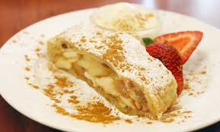](http://www.google.com.au/imgres?imgurl=http://slappedham.com/wp-content/uploads/2014/09/Austrian-Apple-Strudel.jpg&imgrefurl=http://slappedham.com/most-delicious-desserts-from-around-the-world/austrian-apple-strudel/&h=356&w=590&tbnid=rJOy2804U9qBqM:&zoom=1&q=apple+strudel&docid=4a2AD7nyt2JuMM&ei=IeL4VLmMMYvV8gWd-oDwBA&tbm=isch&ved=0CCkQMygOMA4)**Ingredients**

1 tin pie apple

1 sheet puff pastry

1 cup brown sugar or to taste

1 cup sultanas or to taste

1 egg

¼ cup milk

**Method:**

1. Place pie apple, brown sugar and sultana’s in a bowl.
2. Mix and set aside.
3. Roll out puff pastry gently with a rolling pin.
4. Place apple mixture down the centre of pastry.
5. Gently fold the pastry into a parcel, sealing the edges with water.
6. Place strudel fold side down onto a tray.
7. Brush with egg wash.
8. Bake 180c till golden and crisp.

**Apple Pancakes (Apfelpfannkuchen)**

[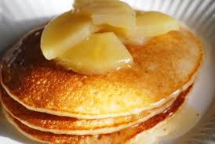](http://www.google.com.au/imgres?imgurl=https://cakesbook.files.wordpress.com/2012/09/apple-pancakes-10.jpg&imgrefurl=https://cakesbook.wordpress.com/tag/apple-pancakes/&h=268&w=400&tbnid=h_cy0H8FfNa39M:&zoom=1&q=apple+pancakes&docid=AZ798oNzVv0o4M&ei=Ju74VLD2DcG1mAWSsIDIAw&tbm=isch&ved=0CCsQMygPMA8)**Batter Ingredients:**

2 Eggs

1 cup of Flour

1 cup Milk

1 tsp of Powdered Sugar

Additional Ingredients:

1 Large Apple

2 Tbsp. Butter

Powdered Sugar

Powdered Cinnamon

**Instructions:**

1. Peel, core and slice apple. Mix all Batter Ingredients.
2. Melt 1/2 Tbsp. of Butter in Skillet on med-high heat
3. Arrange 1/4 of Apple Slices in desired non-touching pattern in hot Skillet
4. Allow Apple Slices to fry for 30-45 seconds
5. Pour about 1/4 of Batter into Skillet, allowing apple slices to peak out above batter
6. When edges are dry and the centre has mostly set, carefully flip pancake
7. After an additional minute, remove Skillet from heat
8. Slide Pancake onto serving plate
9. Add another 1/2 Tbsp. of Butter to Skillet for each new pancake
10. Dust Pancakes with Powdered Sugar and Cinnamon
11. Serve

**German Farmer’s Breakfast (Bauernfruhstuck)**

[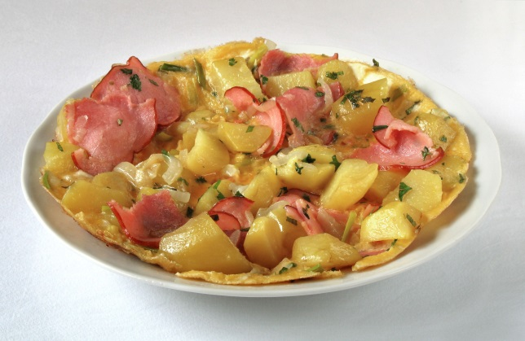](http://www.google.com.au/url?sa=i&source=images&cd=&cad=rja&uact=8&ved=0CAgQjRw&url=http://commons.wikimedia.org/wiki/File:Bauernfr%C3%BChst%C3%BCck.jpg&ei=CfL4VOH2KeX2mQWi_oGYDQ&psig=AFQjCNEtZkNWQu709q1ZuWuHNrRqsFDn0g&ust=1425687433740913)**Ingredients**

* 3 large potatoes, skinned and quartered lengthwise
* 3 Tbsp bacon fat or olive oil
* 2 cups roughly chopped green and white onions   
  (include the greens from the green onions)
* 2 cups roughly chopped bell peppers
* Salt to taste
* 1-2 cups chopped ham
* 1/4 cup chopped parsley
* 4 eggs, whisked

**Method**

1. Boil the potatoes in a saucepan of lightly salted water for 10-15 minutes until just cooked (test for doneness). Drain, rinse with cold water to cool. Cut into 1-inch squares. Set aside.

2. Heat 2 Tbsp bacon fat (or olive oil) in a large skillet on medium high heat. Add the onions and chopped bell peppers. Increase the heat to high. Brown the onions and bell peppers, stirring frequently, about 2-3 minutes.

3. Push the vegetables to the side of the pan, add the potatoes and another Tbsp of bacon fat (or olive oil) to the pan. Brown the potatoes for about 2 minutes, stirring frequently. Sprinkle on salt to taste as you cook. Add the ham to the potatoes and cook, stirring frequently until the ham is heated through, 1-2 minutes.

4. Mix all of the vegetables, potato and ham together and mix in the parsley. Add the eggs, stirring to distribute the eggs among the vegetables and ham. As soon as eggs begin to firm up, remove from heat.

5. Serve immediately. Great with tomato sauce on top.

­

­