Mental Health and Well Being
CROSSROADS
P.D.H.P.E
Year 11 and 12
Term 2, 2016

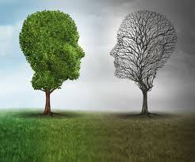

Focus Area:
Owning Yourself

Content Focus:
Self Awareness and Self Regulation

Outcome:
2.3
Evaluate the skills and actions that could be used in various situations which
Promote the health, safety and wellbeing of self and others.

Skills:
Skills for managing emotions — managing anger, dealing with grief and anxiety,
Coping with loss, abuse, and trauma.

Connection to other Focus Areas:
PERSONAL IDENTITY

Self awareness

SELF EFFICIACY AMD MENTAL FITNESS

Emotional awareness is the ability to identify emotional experiences and self regulation is about controlling the emotional response/actions to external events. Emotional awareness and self regulations are two skills that contribute to resilience and are key in managing tough times. These skills allow a person to be comfortable with, and show their emotions (they don’t keep them inside) and express them according to the situation they are in, promoting their own and others’ wellbeing and moving forward through tough times.

Part 1

What Is Emotional Awareness?
______________________________________________________________________________________________________________________________________________________________________________________________________________________________________________________________________________________________________________________________________________________________________________________________________

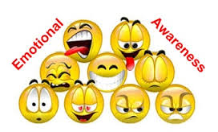
BRAINWRITING

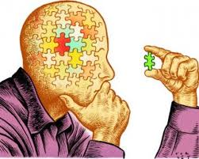

Students use one small index card (5x7) each.

Write down what you know about emotional awareness.

Place your card on the wall or designated space for display.

Explore the cards on display. Students use post it notes to vote for
Cards they agree with. If you agree put your post it note on top of the
Card.

Discuss the top three response cards voted for.

Develop a group definition.
__________________________________________________________________________________________________________________________________________________________________________________________________________________________________________

HOW MANY EMOTIONS CAN YOU NAME?

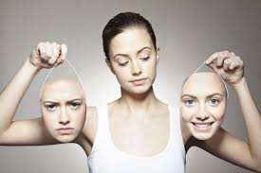

Using the Emotions A-Z worksheet, list as many emotions as you can think of for each letter of the alphabet. After 1 minute, pair up and share their lists.

Share your ideas as a whole group.

Provide list of emotions.

CATCH and TAG

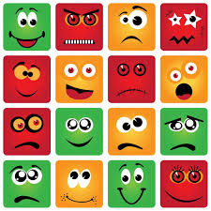

Students choose 5 emotions from the List of emotions to display using their faces with a
Partner. Take turns in guessing what emotion they are expressing.

Group discussion:

How do we use this skill in recognising emotions on peoples’ faces?

What can happen when we get it wrong?

What can happen when we get it correct?

Part 2
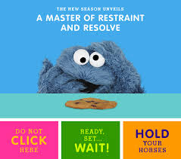
Write what you think self regulation is?
________________________________________________________________________________________________________________________________________________________________________________________________________________________________________________________________________________________________________________________
Discuss as a group.

Write about a time when you did not use self regulation.
________________________________________________________________________________________________________________________________________________________________________________________________________________________________________________________________________________________________________________________________________________________________________________________________________________________________________________________________________________________________________________________________________________________________________________________________________________________________________________________________________________________________________________________________________________________________________________________________________________________________________________________________________________________________________________________________________________________________________________________________________________________________________________________________________________________________________________________________________________________________________________________________________________________________________________________________________________________________

Write about a time when you did use self regulation.
_______________________________________________________________________________________________________________________________________________________________________________________________________________________________________________________________________________________________________________________________________________________________________________________________________________________________________________________________________________________________________________________________________________________________________________________________________________________________________________________________________________________________________________________________________________________________________________________________________________________________________________________________________________________________________________________________________________________________________________________________________________________________________________________________________________________________________________________________________________________________________________________________________________________________________________________________________________________________
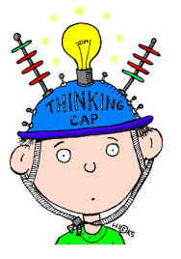
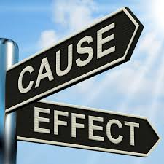
Compare the two situations. What impacted your ability to self regulate and what were the outcomes of each situation.
________________________________________________________________________________________________________________________________________________________________________________________________________________________________________________________________________________________________________________________________________________________________________________________________________________________________________________________________________________________________________________________________________________________________________________________________________________________________________________________________________________________________________________________________________________________________________________________________________________________________________________________________________________________________________________________________________________________________________________________________________________________________________________________________________________________________________________________________________________________________________________________________________________________________________________________________________________________________

Watch Ted talk ‘Joachim de Posada: Don’t eat the marshmallow!’
http://www.ted.com/talks/joachim_de_posada_says_don_eat_the_marshmallow_yet
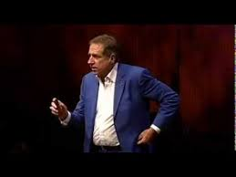
Record three pieces of information you heard or saw during the clip.
1._______________________________________________________________________
2._______________________________________________________________________
3._______________________________________________________________________
Discuss the clip.

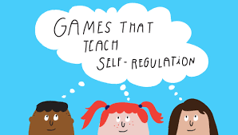

Play the self regulation game. Work in pairs.
Who was able to use their self regulation skills the longest?
_________________________________________________
What did using self regulation feel like? Look like? Sound like?
________________________________________________________________________________________________________________________________________________________________________________________________________________________________________________________________________________________________________________________
What situations/places could self regulation is used?
_________________________________________________
How could self regulation be a useful skill for young people?
________________________________________________________________________________________________________________________________________________________________________________________________________________________________________________________________________________________________________________________

Activity Theme 2:
OPTIMISM
Focus Area:
Owning Yourself

Content Focus:
Self Awareness and Self Regulation

Outcomes:
5.3
Apply skills and strategies to achieve a positive outcome in a range of different
contexts.

Skills:
Skills for managing stress — time management, positive thinking, relaxation
techniques, seeking help

Learning the skills of optimism can help protect against depression and anxiety. It involves learning to think positively about the future – even when things go wrong. Learning the skills of optimism includes the skills to look objectively at a situation, make a conscious and realistic decision and to focus on the good when headed through challenging situations.

Small group
Individual activities
Offline + online

Equipment required:
Picture cards — A4 cards each displaying an image. Images should vary and come from images from media sources including magazines, newspapers, Twitter, Pinterest, Instagram or through Creative Commons licenses.

Butchers paper (enough for 1 between 3 students)

Pens/pencils

Camera/ tablet/ phone

Internet access
WHAT IS OPTIMISM?

Select a media image from the classroom floor.

Choose a card they see as representing optimism or being optimistic.

Discuss what is optimism.

Explain how you see optimism and why you made the image selection you did.

Learning the skills of optimism can help protect against depression
and anxiety. It involves learning to think positively about the future – even when things go wrong. Learning the skills of optimism includes the skills to look objectively at a situation, make a conscious and realistic decision and to focus on the good when headed through challenging situations.

When do you feel most optimistic?
_______________________________________________________________________________________________________________________________________________________________________________________________________________________________________________________________________________________________________________________________________________

What helps you to think more positively when you don’t feel optimistic?
____________________________________________________________________________________________________________________________________________________

HUNTING FOR OPTIMISM

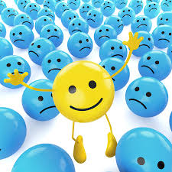

Work in two groups for 2 minutes. Create two lists of positive things or thoughts that make you happy.

Things that make me happy...at school.

Things that make me happy...at home/outside of school.

Merge with the other group and share lists. Groups record their list on butcher’s paper for both school and at home.

Discuss where can you go for help when we are not feeling optimistic?
________________________________________________________________________________________________________________________________________________________________________________________________________________________________________________________________________________________________________

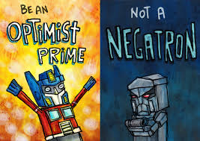

Create a whole group list of where to go for help.

At school | At home
1. | 1.
2. | 2.
3. | 3.
4. | 4.
5. | 5.
6. | 6.
7. | 7.
8. | 8.
9. | 9.

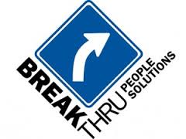

What/who are the supports available?
______________________________________________________________________________________________________________________________________________________________________________________________________________________________________________________________________________________________________________________________________________________________________________________________________________________________________________________________________________________________________________________________________

