Sport Studies
Name:
Fitness

Fitness is such a broad term and a complex subject which can include health and skill related fitness. Health and skill related fitness is often divided into twelve other components which form our overall health status. Each of these components relating to our health and skills can be tested. Each component requires testing to be completed to gain an understanding of an athlete’s level of health or skill.
Health Related Components | Skill Related Components
Cardiovascular endurance | Agility
Body composition | Balance
Strength | Reaction time
Muscular endurance | Power
Muscular strength | Coordination
Flexibility | Speed

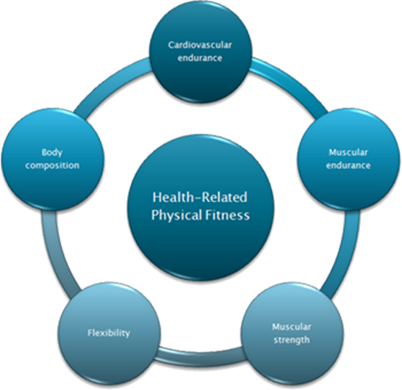
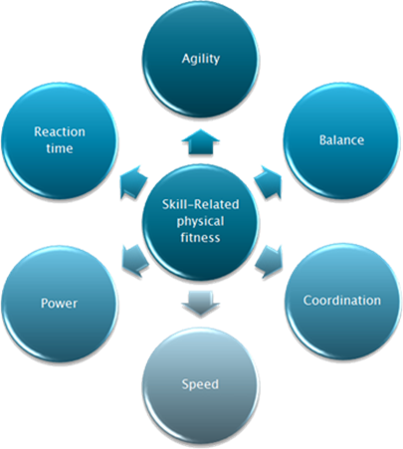

Health Related Components of Fitness
Cardiovascular Endurance
This is also sometimes known as stamina and is the ability of your body to continuously provide enough energy to sustain submaximal levels of exercise. To do this the circulatory and respiratory systems must work together efficiently to provide the working muscles with enough Oxygen to enable aerobic metabolism.
This type of fitness has enormous benefits to our lifestyle as it allows us to be active throughout the day, for example walking to the shops, climbing stairs or running to catch a bus. It also allows us to get involved in sports and leisure pursuits.
If we have good cardiovascular fitness then our health is also good as it helps with:
•Fat metabolism
•Improved delivery of Oxygen
•Faster removal of waste products
•Decreased levels of stress
Beep Test
This test involves continuous running between two lines 20m apart in time to recorded beeps. For this reason, the test if also often called the 'beep' or 'bleep' test. The students stand behind one of the lines facing the second line, and begin running when instructed by the recording. The speed at the start is quite slow. The students continue running between the two lines, turning when signalled by the recorded beeps. After about one minute, a sound indicates an increase in speed, and the beeps will be closer together. This continues each minute (level). If the line is reached before the beep sounds, the student must wait until the beep sounds before continuing. If the line is not reached before the beep sounds, the subject is given a warning and must continue to run to the line, then turn and try to catch up with the pace within two more ‘beeps’. The test is stopped if the subject fails to reach the line (within 2 meters) for two consecutive ends after a warning.
Record your result below once eliminated.
Result: ___________
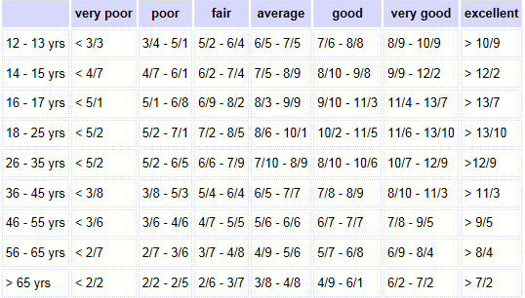
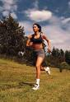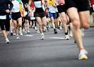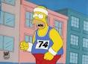
Strength
Strength is vitally important, not only in sports but in day-to-day life. We need to be strong to perform certain tasks, such as lifting heavy bags or using our legs to stand up from a chair. Strength is defined as the ability of a muscle to exert a force to overcome a resistance.
Strength is important for our health as it enables us to :
•Avoid injuries
•Maintain good posture
•Remain independent (in older age)

Handgrip test
The student holds the dynamometer in the hand to be tested, with the arm at right angles and the elbow by the side of the body. The handle of the dynamometer is adjusted if required - the base should rest on first metacarpal (heel of palm), while the handle should rest on middle of four fingers. When ready the student squeezes the dynamometer with maximum effort, which is maintained for about 5 seconds. No other body movement is allowed. The subject should be strongly encouraged to give a maximum effort.
Record your result for both left hand and right handed tests.
Result
Left Hand: ___________ Right Hand: __________
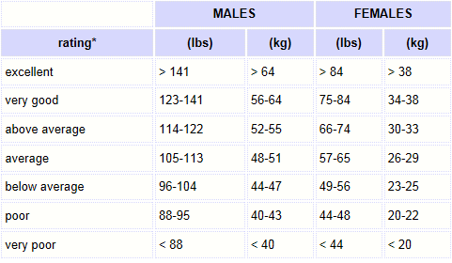

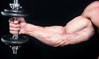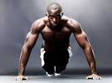
Flexibility
Flexibility is the movement available at our joints, usually controlled by the length of our muscles. This is often thought to be less important than strength, or cardiovascular fitness. However, if we are not flexible our movement decreases and joints become stiff. Flexibility in sports allows us to perform certain skills more efficiently, for example a gymnast, dancer or diver must be highly flexible, but it is also important in other sports to aid performance and decrease the risk of injury.
In daily activities we must be flexible to reach for something in a cupboard, or off the floor. It also helps:
•Prevent injuries
•Improve posture
•Reduce low back pain
•Maintain healthy joints
•Improve balance during movement

Sit and reach
This test involves sitting on the floor with legs stretched out straight ahead. Shoes should be removed. The soles of the feet are placed flat against the box. Both knees should be locked and pressed flat to the floor - the tester may assist by holding them down. With the palms facing downwards, and the hands on top of each other or side by side, the subject reaches forward along the measuring line as far as possible. Ensure that the hands remain at the same level, not one reaching further forward than the other. After some practice reaches, the subject reaches out and holds that position for at one-two seconds while the distance is recorded. Make sure there are no jerky movements.
Result: _______
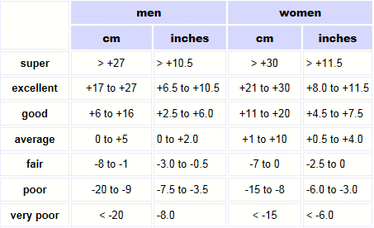
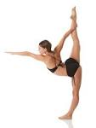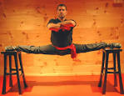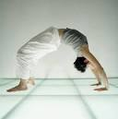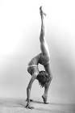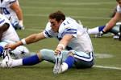
Muscular Endurance
Muscular endurance, unlike strength, is the ability of a muscle to make repeated contractions over a period of time. This is used in day-to-day life in activities such as climbing stairs, digging the garden and cleaning. Muscular endurance is also important in sports, such as football (repeated running and kicking), tennis (repeated swinging of the arm to hit the ball) and swimming (repeating the stroke).

Push ups
A standard push up begins with the hands and toes touching the floor, the body and legs in a straight line, feet slightly apart, the arms at shoulder width apart, extended and at a right angles to the body. Keeping the back and knees straight, the student lowers the body to a predetermined point, to touch some other object, or until there is a 90-degree angle at the elbows, then returns back to the starting position with the arms extended. This action is repeated, and test continues until exhaustion, or until they can do no more in rhythm or have reached the target number of push-up.
Max push ups: ______
Men
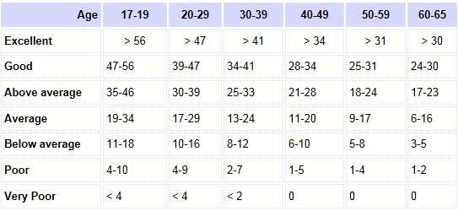
Women
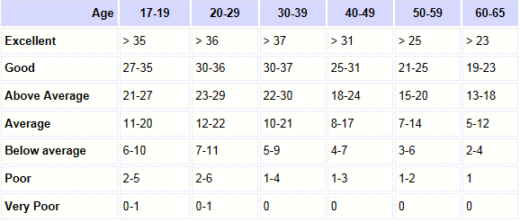
Sit ups
The student lies on a cushioned, flat, clean surface with knees flexed, usually at 90 degrees. Some techniques may specify how far the feet are from the buttocks, such as about 12 inches. A partner may assist by anchoring the feet to the ground. The position of the hands and arms can affect the difficulty of the test. They are generally not placed behind the head as this encourages the subject to stress the neck and pull the head forward. The hand may be placed by the side of the head, or the arms crossed over the chest, reaching out in front. Some protocols use curl up strips or other marks on the ground to slide the hands along and indicate how much to curl up. The subject raises the trunk in a smooth motion, keeping the arms in position, curling up the desired amount. The trunk is lowered back to the floor so that the shoulder blades or upper back touch the floor.
Max sit ups: _______
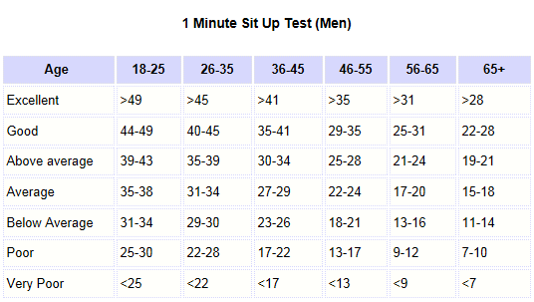
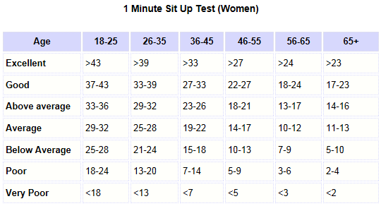
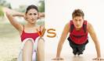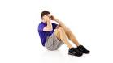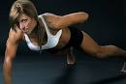

Body Composition
Body composition is the amount of muscle, fat, bone, cartilage etc that makes up our bodies. In terms of health, fat is the main point of interest and everything else is termed lean body tissue. The amount of fat we carry varies from person to person and healthy averages vary with gender and age. A healthy amount of fat for a man is between 15&18% and for women is higher at 20-25%. It is important to maintain a healthy percentage of body fat because:
•Excess body fat can contribute to developing a number of health problems such as heart disease and diabetes
•Places strain on the joints, muscles and bones, increasing the risk of injury

BMI
BMI stands for Body Mass Index. It is a measure of body composition. BMI is calculated by taking a person's weight and dividing by their height squared.
BMI is calculated from body mass (M) and height (H). BMI = M / (H x H), where M = body mass in kilograms and H = height in meters. The higher the score usually indicating higher levels of body fat.
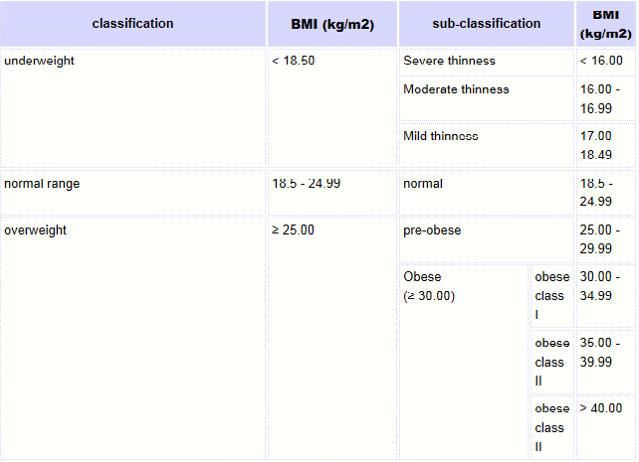
Result: ______

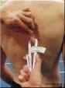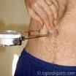
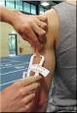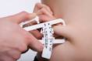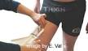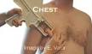

Skill Related Components of Fitness
Speed
Most sports and activities require some form of speed. Even long distance running often requires a burst of speed to finish the race ahead of your competitors. Speed is defined as the ability to move a body part quickly. Speed is not always about how quickly you can move your whole body from A to B. It also relates to body parts. For example, when playing golf, the speed of your arms and upper body in creating the swing are vital in driving the ball over a long distance.
35m Sprint
Students attempt to run the fastest time they can over 100m. Each student should look to complete 3 tests and record the fastest time from each trial.
Result: _____
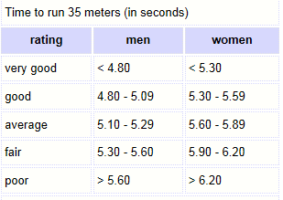
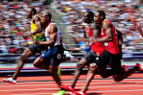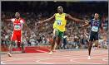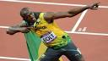

Reaction Time
Reaction time is how quickly your brain can respond to a stimulus and initiate a response. This is important in most sports. The most obvious being responding to the gun at the start of a race, but also a goalkeeper saving a penalty, or a badminton player reacting to a smash shot. The examples in sport are endless!
Ruler test
The student to be tested stands or sits near the edge of a table, resting their elbow on the table so that their wrist extends over the side. The assessor holds the ruler vertically in the air between the subject's thumb and index finger, but not touching. Align the zero mark with the student’s fingers. The student should indicate when they are ready. Without warning, release the ruler and let it drop - the student must catch it as quickly as possible as soon as they see it fall. Record in meters the distance the ruler fell. Repeat several times (e.g. 10 times) and take the average score.
Result: ______
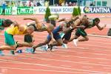
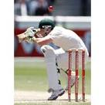
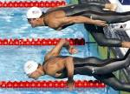
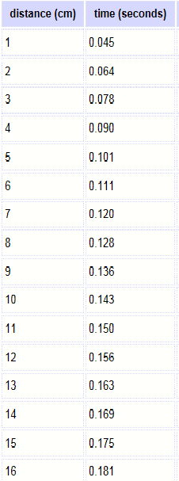
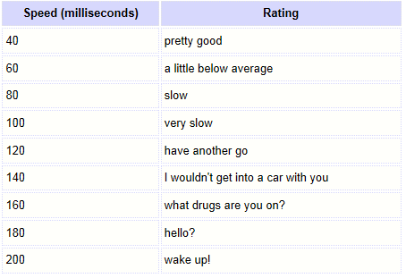

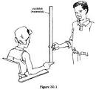
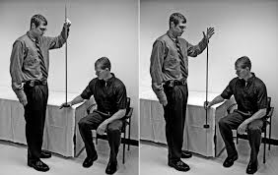

Agility
Being agile is all about being able to change your direction and the speed at which you are travelling, quickly and efficiently. This is common in sports such as football and rugby where the player with the ball dodges a defender, or in badminton or tennis, moving around the court quickly to reach the shuttlecock/ball in time.
Illinois run
The length of the course is 10 meters and the width (distance between the start and finish points) is 5 meters. Four cones are used to mark the start, finish and the two turning points. Another four cones are placed down the centre an equal distance apart. Each cone in the centre is spaced 3.3 meters apart. Student should lie on their front (head to the start line) and hands by their shoulders. On the 'Go' command the stopwatch is started, and the student gets up as quickly as possible and runs around the course in the direction indicated, without knocking the cones over, to the finish line, at which the timing is stopped.
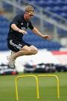
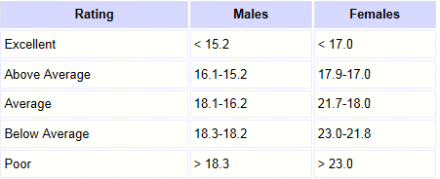
Result: _______

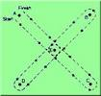
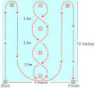
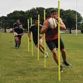
Balance
Balance is the ability to maintain equilibrium whilst stationary, or moving. Balance whilst moving is often called dynamic balance. Balance is important in all kinds of sporting situations, most notably in gymnastics and ballet but also contact sports where having good balance may prevent you being tackled to the floor! Balance is linked to agility, as in order to quickly and efficiently change direction you must be balanced.
Standing stork test
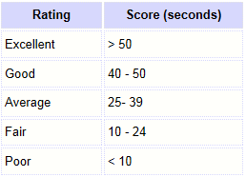
Place the hands on the hips, then position the non-supporting foot against the inside knee of the supporting leg. The student is given one minute to practice the balance. The student raises the heel to balance on the ball of the foot. The stopwatch is started as the heel is raised from the floor. The stopwatch is stopped if any of the following occur:
◦ The hand(s) come off the hips
◦ The supporting foot swivels or moves (hops) in any direction
◦ The non-supporting foot loses contact with the knee.
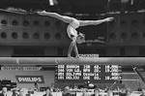
◦ The heel of the supporting foot touches the floor.
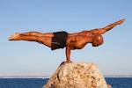
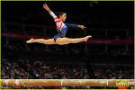
Result: _______

Coordination
Coordination is the ability to use the body parts and senses together to produce smooth efficient movements. We have all seen someone who is uncoordinated; their movement looks awkward and shaky. Being co-ordinated is vital in all sports, for example hand-eye coordination in racket sports and the co-ordination to use the opposite arm and leg when sprinting.
Ball to wall test
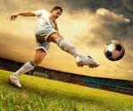
In this wall test, students will use a tennis ball and throw it up against the wall from 2m away. Students must count how many times they catch the ball from its return from the wall. Students must only use 1 hand to throw and catch the ball. Each student is allowed a 1 minute time frame as well as the opportunity to use both hands.
Result: Left- _______
Right- ______
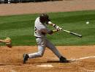
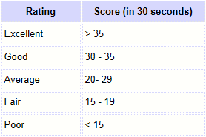
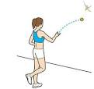

Power
Power is the product of strength and speed. When we perform a task as quickly and as forcefully as we can, the result is powerful. For example, a sprint start, a shot-put or javelin throw or long-jump.
Vertical Jump
Students must attempt to jump as high as they can from a standing position. A student’s reach is firstly measured up against the wall. Each student will then attempt to jump as high as possible and in doing so touch the wall at the highest point they can. Each student gets 3 attempts and their highest touch against the wall will be recorded.
Result: __________
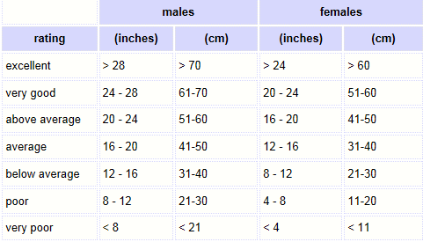
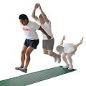
Standing long jump
Students must attempt you jump as far as they can from a standing position. The length each student jumps is measured and recorded. 3 jumps should be completed and the largest jump recorded.
Result:_________
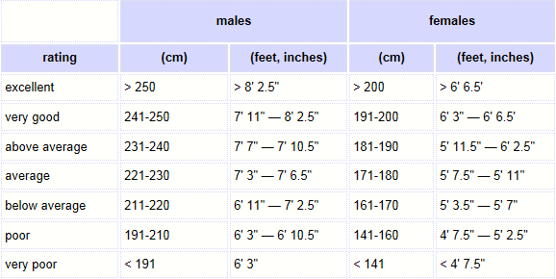

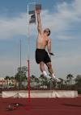
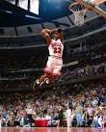
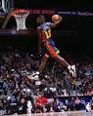

Create a table in the space provided that includes your results for each of the tests compared to the norms tables provided.

Quiz
Figure 1 shows a sprinter at the start of a race.
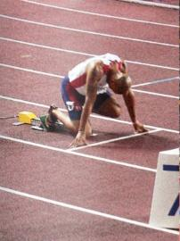
1. Which of the following is an example of an essential component of health-related exercise for the sprinter?
a) Reaction time c) Power
c) Cardiovascular fitness d) Muscular strength
3. Name a different component of skill-related fitness to complete each of the following statements:
a) Basketball players need this in order to dodge around their opponents
Answer:
b) A good ......................................................... allows the runner to begin to move as soon as the gun sounds.
Answer:
c) Footballers need good ......................................................... to remain upright when they are being physically challenged
Answer:

2. Which aspect of skill-related fitness is most important in each of the following situations?
a) A gymnast running across the floor in preparation for a vault
Answer:
b) A high jumper at take off
Answer:
c) A goalkeeper diving to save a deflected shot on goal
Answer:
3. Which of the following gives the best explanation of muscular endurance?
a) The ability to exercise the entire body for long period of time
b) The ability to exercise the heart, lungs and muscles in the body for long periods
c) The ability to exercise the muscles of the body for long periods of time without tiring
d) The ability to exercise your legs for long periods of time
Answer:
4. Co-ordination can be an example of:
a) Working together in a team for the benefit of all
b) How well a task is completed
c) The ability to change position quickly and with control
d) The ability to use two or more body parts together

5. Agility and speed are both components of skill-related fitness:
Explain the terms agility and speed

6. The images show different athletes from different codes of sport. Next to their pictures, state the different components of fitness required for their sport.
Athlete | Components of fitness
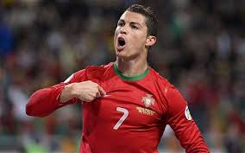
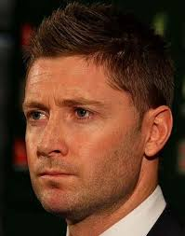

7. From the list below select the fitness test that would be most appropriate for measuring balance:
a) Harvard Step test

b) Sergeant Jump test

c) Standing Stork test

d) Standing Broad jump

8. What sport do you play or enjoy playing the most? Identify the different components of fitness you would need to compete in that sport.

9. After completing the tests and comparing yourself to the norms data tables, what do you need to improve on? How can you do so?

10. Identify your strengths and weaknesses throughout the testing period. Do they relate to the types of sports and activities you do?

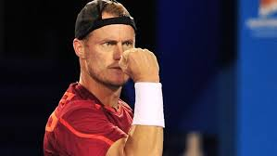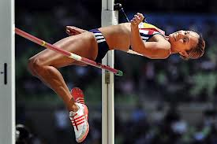

Select an athlete of your choice and complete a research task identifying what specific components of fitness they are involved in their chosen sport. Each report should outline;
- Background information on the athlete
- What specific components of health and fitness are involved in his sport
- Specific test results
- What training would be involved to maintain levels of health and fitness

