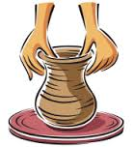 Ceramics Skills Checklist 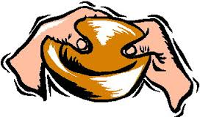
Student Name: | No | Sometimes | Usually | Yes | Always
Achieves success when using and manipulating clay
Displays interest in the form of ceramics
Perseveres with a variety of ceramics tasks
Enjoys experimenting with a variety of ceramic materials
Demonstrates skill in pinching clay to form a pinch pot
Demonstrates skill in using clay to model, form and shape a ceramic piece
Demonstrates skill in slab construction
Demonstrates skill in coil construction
Pays close attention to detail
Carefully plans and executes the task at hand
Demonstrates ability to use slip when joining clay
Uses ceramics equipment with knowledge and confidence
Enjoys exploring the tactile qualities of clay
Demonstrates understanding of safety procedures when using ceramic tools
Is able to carry out the ceramics process with minimal assistance
Can create suitable designs for ceramics
Displays interest when approaching ceramic artworks and artists
ASSESSMENT - Achievement: Effort:
Comment:
ASSESMENT – YEARLY Achievement: Effort:
Comment:

