Verona Experiment Performa
Experiment Name:
Aim:

Hypothesis:

Method:
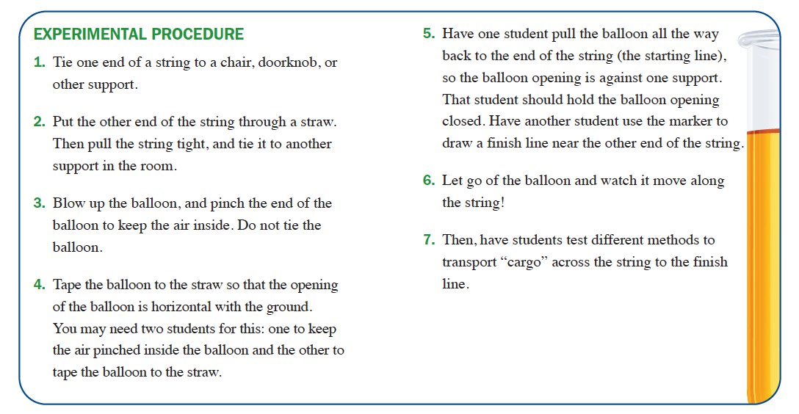

Draw a diagram of the experiment

Results/observations:

Balloon Type | Distance Travelled
Large

Small

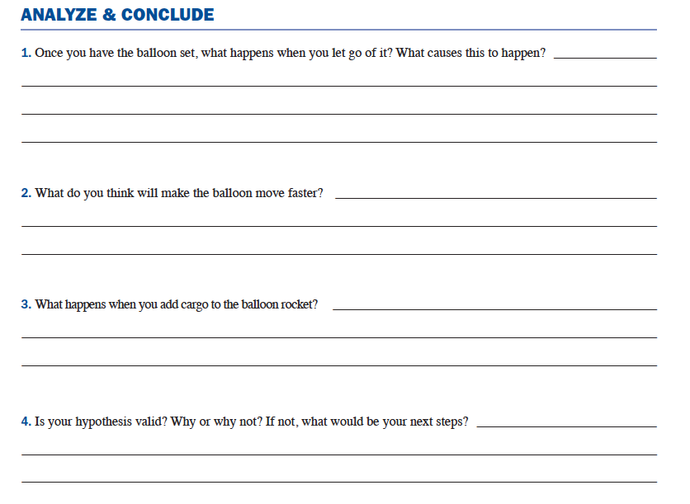

Evaluation:

Conclusion:

