Australia’s Defence links
The Australian Department of Defence and the Department of Foreign Affairs and Trade are responsible for the protection of Australia and our national interests. In 2009 the ADF employed 51 500 full-time active personnel and 19 500 reservists. This includes 10 000 women currently serving in the Navy (18 per cent), Army (12 per cent) and Air Force (17 per cent). Australia has a small defence force compared to the global figure of 17 442 000 active troops. The amount and percentage of military expenditure per GDP is also smaller than most countries. The government aims to increase defence expenditure by 3 per cent each year until 2016 to fund resistance to potential terrorist attacks; to purchase new destroyers and fighter planes; and to provide assistance after natural disasters.

Throughout its history, the ADF has established special military forces to help protect Australia's interests. These include:
•Australian Reserve Forces. These served in China during the Boxer Rebellion, in South Africa during the Boer War and in both World Wars. They assist after disasters and provide security at major events.
•Special Operations Command (SOCOMD). This force is trained for unconventional warfare and counter-terrorism. It is involved in Timor-Leste, Afghanistan and Iraq and provided security for the Commonwealth Games (2006) and Rugby World Cup (2003).
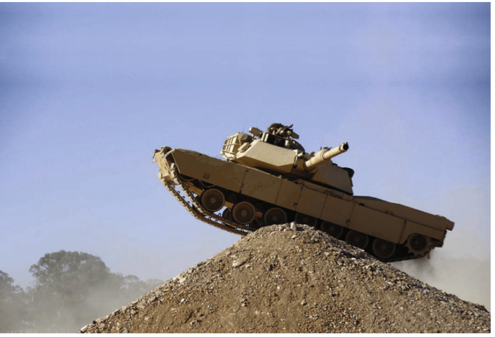
•Tactical Assault Group (TAG). This group is trained to conduct counter-terrorism activities including the recovery of hostages.
•Incident Response Regiment (IRR). This regiment responds to chemical, biological, radiological, nuclear and explosive incidents.
•Royal Australian Medical Corps (RAAMC) and Royal Army Nursing Corps (RAANC). These care, treat and evacuate sick and wounded soldiers and civilians.

The ADF is supported by government bodies that include:
•Australian Federal Police (AFP), for people-smuggling and terrorism
•Australian Defence Force Academy (ADFA), for military training
•Australian Security Intelligence Organisation (ASIO), for gathering information about criminal activity or security threats
•Australian Customs Service, Australian Quarantine and Inspection Service and Department of Immigration and Multicultural Affairs, for border security
•Australian Government Aid Agency (AusAID), for humanitarian relief to people affected by conflict.
Australia’s defence links
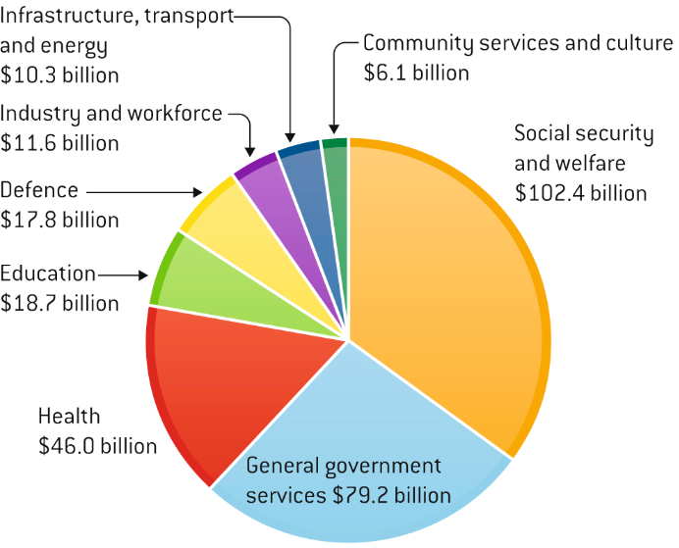

USING YOUR SKILLS
Refer to the pie graph.
Calculate the proportion of money spent on defence compared to health, education and social services

Australia's diverse defence policy

Even though defeating terrorism and countering the proliferation of weapons of mass destruction remains high on Australia's defence policy agenda, its main objectives are to:
•protect and defend Australia's land and marine territories
•keep Australia and the Australian people safe from attack or the threat of attack, and from economic and political coercion
•support and maintain strategic stability and peace in the Asia–Pacific region
•support the international community to uphold global security organisations such as the United Nations.

These objectives form the basis of Australia's defence agreements — bilateral (joint military activities with the United States, Canada, Singapore, New Zealand, Britain and PNG), multilateral (United Nations) and regional (ANZUS) defence agreements.

Defence agreements with Asia–Pacific countries
Australia has an obligation to its Asia–Pacific neighbours to assist in maintaining peace under the following agreements:

•ANZUS (Australia, New Zealand, United States). Beginning in 1952, the ANZUS treaty promotes regional security through peaceful means.
•Closer Defence Relations (CDR). This is an informal agreement entered into with New Zealand during the 1990s and emphasises intelligence sharing and joint exercises between the two countries.
•Five Power Defence Arrangements (FPDA). This arrangement between the United Kingdom, Australia, New Zealand, Malaysia and Singapore was adopted in 1971. It involves consulting each other if there is a threat to attack Malaysia or Singapore.
•ASEAN Regional Forum (ARF). The principal security forum in the Asia–Pacific region, the ARF fosters dialogue on political and security issues of common concern.

Under the 1989 Joint Declaration of Principles (JDP), Australia agreed to commit forces to resist external aggression against Papua New Guinea. The Australia–Indonesia Security Agreement (2007) focuses on reducing international terrorism and transnational crime and the JANZUS Agreement between Japan, Australia, New Zealand and the United States (2007) aims to develop closer security ties with Japan. Australia participates in joint exercises with South-East Asian countries, deploys warships and aircraft to patrol Pacific waters and is responsible for the defence of Nauru.

