Volume 2 – Hard Roads to Glory
Phar Lap

1. Connecting to the text.
What knowledge do you have of Phar Lap? _________________________________
__________________________________________________________________________________________________
__________________________________________________________________________________________________
__________________________________________________________________________________________________

Where have you seen or heard about him before? ________________________________________
__________________________________________________________________________________________________
__________________________________________________________________________________________________
__________________________________________________________________________________________________

Make a list of words that relate to horse racing?
_____________________________ ______________________________ _______________________________
_____________________________ ______________________________ _____________________________
______________________________ ______________________________ ____________________________
_____________________________ _____________________________ ______________________________
2. Vocabulary Builder: Clarify the key words and concepts. Place a tick (√) next to the words in the word bank you understand and a question mark (?) next to the words you are unsure of the meaning. Check the meaning and record in the table.

punters bookies lengths illegal handicap live admired favourite drastic impending lightning Icon fear money unsuccessful crippling strapper Phar Lap hand me down
mysterious syndicate carnival

Word | Definition

3. Vocabulary Builder: Cloze Passage – Fill in the blanks using the word bank

Phar lap was ______________________________ fast, big hearted and since exploding onto the racing scene in 1929, Phar Lap has struck __________________________ into the hearts of bookies with a streak of 19 wins from 22 starts. For the ______________________________, he is the good news story that keeps delivering during the ________________________________ Depression. ________________________________ was a symbol of thought that things were going to get better. In the hope of winning people were driven to ____________________________off track gambling dens including SP Bookies operating in pubs with their business made easier through race ____________________ calls on the radio. In 1930 Phar Lap was the red-hot ____________________________ to win both the Caulfield and Melbourne Cups. A shady ______________________________ backed the second placed favourite Amounis to win the Caulfield and Phar Lap to win the Melbourne Cup and as a result the ________________________ gave them very generous odds of 20 – 1.

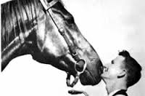 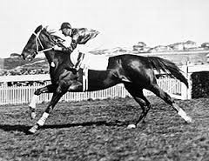 Together with Phar Lap mysteriously scratched from the Caulfield Cup and the ____________________________victory to Amounis … and if Phar Lap was to win the Melbourne Cup then hundreds of bookies stood to lose big __________________________, that was unless something _____________________________ happened. On Nov 1 1930 in Caulfield, Melbourne, Robert Philpots rode his new birthday present that was a _______________________________________ bike. On that day he saw two unusual things, a flash new American car and the most universally _______________________ Australian of the day – Phar Lap. On this day Phar Lap had a brush with death when an attempt to shoot him down was ____________________________. Leading into the week long Melbourne racing carnival _________________________ Tommy Woodcock lived by his side and Phar Lap won on every day of the ________________________________ and then carrying a massive ______________________________ just four days after an attempt on his life he won the Melbourne cup by three ___________________________ and as a result busted bookies all over the country. Three years and 15 wins later after his first victory in America the horse that carried Australia’s hopes died in _______________________________ circumstances. Phar Lap is remembered as a champion and an Australian ______________________.

4. What other information would you like to investigate about Phar Lap? _________
__________________________________________________________________________________________________
__________________________________________________________________________________________________
____________________________________________________________________________________________________________________________________________________________________________________________________
__________________________________________________________________________________________________

5. What interesting facts or information did you find throughout your investigation? __________________________________________________________________________________________________
____________________________________________________________________________________________________________________________________________________________________________________________________
__________________________________________________________________________________________________
__________________________________________________________________________________________________

Sites for Further Information and You Tube Clip
Phar Lap Australia’s Famous Race Horse
http://www.pharlap.com.au
Phar lap wins the Agua calient Handicap – 1932
https://www.youtube.com/watch?v=bROtR5ivyZw

Time 19:05 to 25:26 minutes

Volume 2 – Hard Roads to Glory
Ruby Payne-Scott

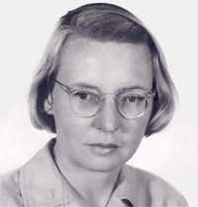
Background: Ruby Payne-Scott was the first female radio astronomer (Radio astronomers use radio telescopes to detect and amplify radio waves from space turning them into signals so they can better understand the Universe). During World War II she was involved in top-secret work to perfect an aircraft warning radar system for the defence of Australia.

1. Read the following statements and make the prediction whether you believe the statements are True or False.
Statement | True  (√) | False  (√)
Ruby Payne-Scott was one of only five women who worked as scientists employed by the Australian Government
The British would not share their basic secrets or knowledge of radar with Australian scientists
Ruby invented a simulated electronic plane way before digital technology
Ruby used mathematics to make the radar signals clearer and faster
The Australian radar was used by the Americans in the battle of the Pacific War to detect Japanese bombers before they attacked

2. Vocabulary Builder: Clarify the key words and concepts. Place a tick (√) next to the words in the word bank you understand and a question mark (?) next to the words you are unsure of the meaning. Check the meaning and record in the table.

vulnerable blips invasion radar detected echo crucial decimation physicist unique muster vast
pinpoint simulate Fleet uncountable
perfect laboratory perseverance roaming

Word | Definition

3. Vocabulary Builder: Cloze Passage – Fill in the blanks using the word bank

In 1941, with the Pacific War going bad including the __________________________________ by the Japanese of the US Pacific _______________________________ at Pearl Harbour, their __________________________________ of PNG, and the improvements with the latest warplanes and aircraft carriers Australia was ________________________________ to a possible Japanese invasion. The race was on to ________________________________ radar technology that will work across the _______________________________ distance between Australia and the Pacific. The great advantage with an early-warning ______________________ system is that the enemy can be seen in bad conditions, can be seen through clouds, can be seen at night and the enemy can be ______________________ from hundreds of kilometres away and as a result provide an opportunity to _________________________ the troops. In a top-secret government ___________________________ Australian scientists worked around the clock with Ruby Payne-Scott the key ____________________________ involved in the attempt to perfect radar. On the Australian radar screens everything was showing up as ________________________ and was certainly not accurate enough to detect Japanese bombers. Since testing with real fighter planes was too expensive and not really practical Ruby invented a way to __________________________ a plane electronically. She simulated a bombing raid on Sydney Harbour with the flying ___________________________ across the screen and another part of the system trying to find that echo. With Japanese aircraft carriers _____________________________ the seas north of Australia Ruby needed to make the radar signals clearer and faster indicating the _______________________________ direction and speed of the enemy aircraft up to 160kms away. Ruby’s persistence created a _______________________________ mathematical formula for visibility that isolated the fast moving aircraft on the screen from further away and with more detail than ever before. Unfortunately, it was too late to save Darwin. On February 19, 1942, there was no radar in place to detect the 200 Japanese aircraft that were sent to attack … resulting in over 70 Australian deaths. However, a few months later in the Solomon Islands Ruby’s groundbreaking radar was ____________________________ to the winning of one of the most important battles of the war and directly influenced the outcome of the Pacific War. The Australian radar was used by the Americans to detect the Japanese bombers well before they attacked. Ruby’s brilliance, _________________________ and her scientific triumph have saved an ________________________________ amount of lives.
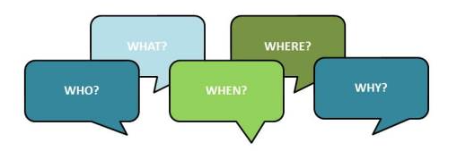
4. Summarise the story using the 5 W’s ________________________________________________
__________________________________________________________________________________________________
__________________________________________________________________________________________________
__________________________________________________________________________________________________
__________________________________________________________________________________________________

__________________________________________________________________________________________________
__________________________________________________________________________________________________
__________________________________________________________________________________________________

__________________________________________________________________________________________________
Sites for Further Information
Making Waves – The Life of Ruby Payne-Scott
http://www.springer.com/gp/book/9783642357510

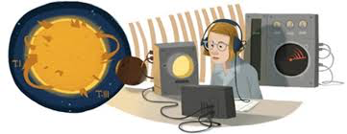
This doodle was a change made to the Google logo to celebrate the 100th birthday of Ruby Payne-Scott

Time: 25:52 to 34:33 minutes
Volume 2 – Revolution
Beach Wars

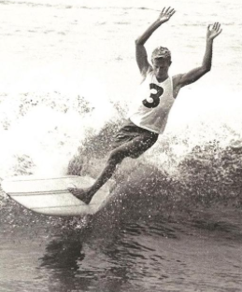

1. Connecting to the text.
Make a list of words that relate to the beach?
______________________________ ______________________________ _______________________________
______________________________ ______________________________ _______________________________
______________________________ ______________________________ _______________________________
______________________________ ______________________________ _______________________________
______________________________ ______________________________ _______________________________
______________________________ ______________________________ ______________________________
What knowledge do you have of Surf Clubs and Surf Lifesavers? ___________________________________________________________________
__________________________________________________________________________________________________
__________________________________________________________________________________________________
__________________________________________________________________________________________________
__________________________________________________________________________________________________
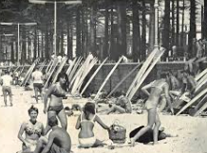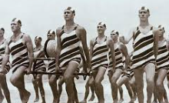

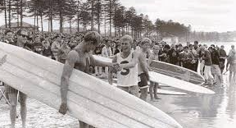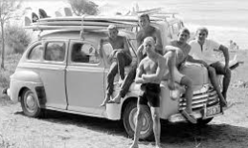

In the 1950’s Australians surfed straight, long unturnable boards on strictly controlled beaches. The local surf lifesaving clubs controlled Australian beaches with young men that devoted their leisure hours to making the beaches safe. Surfing under the control of the clubs was regimented and they enforced strict regulations with surfboards needing to be registered, be of 5 metres in length and stored at the clubs. Long boards were impossible to turn and the surfers’ aim was to get all the way to the beach without getting their hair wet.

In 1956 a new kind of board and way of life exploded onto Australian beaches with a US lifeguard team going to Manly to demonstrate their much shorter lightweight boards they do something no-one here has seen before when they turn and ride across the waves. Within days, locals like Midget Farrelly, cheeky, inventive and a future surfing legend make their own boards and start carving up Australian Waves. By today’s standards they are still long but in 1956 they are nothing short of radical. Surf club bosses were not impressed as the boards were not suitable for saving lives, which resulted in the clubs banning them. This was the start of a split between young surfers and old guard clubbies that never fully healed.

In 1962, Sydney boy Midget Farrelly travelled to Hawaii and devoted himself to mastering his art. He rode his home-made board against the best Americans on the legendary waves of surfing’s birthplace. There was already rivalry with surfing an American invention and now Australia starting to vie with the Americans as a surfing nation. In 1963, the kid from down under, against the odds, took on US champ Mike Doyle and became the first ever outsider to take Hawaii’s biggest surfing prize. Back home in Australia surfers turned their backs on the clubbie-controlled beaches close to town and headed out along the coast to discover surfing hot spots like Bells Beach, Byron Bay, Winkipop and Margaret River. Surfing boomed in popularity and no longer was just viewed as a sport but a new way of life expressing an old ideal … freedom. You could throw a short board in your car and head down the coast and look for your secret spot.

Midget’s Hawaiian victory helped attract 65 000 people on May 17, 1964 to Manly Beach, Sydney for the first ever-official World Surfing Championship. At 19 years of age, he together with the world’s best surfers competes over two days. Once again, Midget faced Mike Doyle in the Final where he was the underdog, however, with his final cutback blew every one away and impressed the judges for the win. Midget and short boards changed surfing in Australia and around the world. In the next 50 years 19 Australians have been crowned World Surf Champions and that is more than any other country. Australian surfing entrepreneurs created global brands and a multi-million dollar industry and transformed the way we live on the vast coast of our continent.
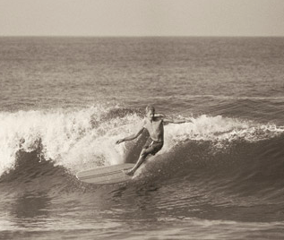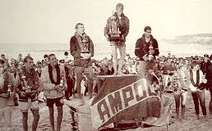

2. Clarify - Vocabulary Builder: Find a synonym in the text for the following words or phrases. A synonym is (a word or phrase that means exactly the same as another word or phrase)

Word or phrase | Synonym in the text | Word or phrase | Synonym in the text
famous |  | compete
set of laws |  | burst
perfecting |  | spare time
stopping |  | mischievous
dedicated |  | ideas people
disciplined |  | show
awarded |  | fast growth
strong competition |  | creative
find |  | changed
drastic change |  | enormous

3. Using any of the following question words (who, what, where, when, why, how) to create three questions to ask of other students.
______________________________________________________________________________________________________________________________________________________________________________________________________________________________________________________________________________________________________
__________________________________________________________________________________________________
__________________________________________________________________________________________________
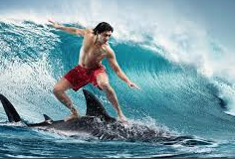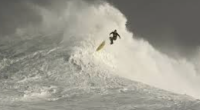

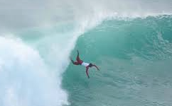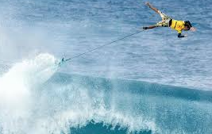

4. List any questions you have about the text or the documentary and something you want to know about in relation to surfing.
__________________________________________________________________________________________________
__________________________________________________________________________________________________
__________________________________________________________________________________________________
__________________________________________________________________________________________________

Sites for Further Information and You Tube Clip
Greatest Wipeouts: The Best of 2014
https://www.youtube.com/watch?v=gIlDiz2MA8o

Midget Farrelly surfing in 1964
https://www.youtube.com/watch?v=ezeMfwFaV08

Time 7:08 to 15:40 minutes

2. Clarify - Vocabulary Builder: Find a synonym in the text for the following words or phrases. A synonym is (a word or phrase that means exactly the same as another word or phrase)

Word or phrase | Synonym in the text | Word or phrase | Synonym in the text
famous | legendary | compete | vie
set of laws | regulations | burst | explode
perfecting | mastering | spare time | leisure
stopping | banning | mischievous | cheeky
dedicated | devoted | ideas people | entrepreneurs
disciplined | regimented | show | demonstrate
awarded | crowned | fast growth | boomed
strong competition | rivalry | creative | inventive
find | discover | changed | transformed
drastic change | radical | enormous | vast

