Volume 2 – Hard Roads to Glory
Charles Kingsford-Smith

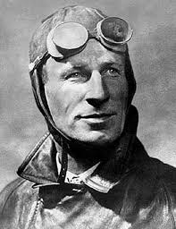

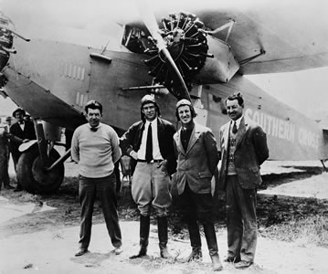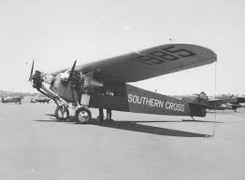

1. What information do you expect this documentary will provide?
__________________________________________________________________________________________________
__________________________________________________________________________________________________
__________________________________________________________________________________________________
______________________________________________________________________________________________________________________________________
2. Vocabulary Builder: Clarify the key words and concepts. Place a tick (√) next to the words in the word bank you understand and a question mark (?) next to the words you are unsure of the meaning. Check the meaning and record in the table.

coverage three stuntman engines heroes disaster Morse code Fiji nine Jim Warner plunge Charles Ulm
endured announced America tear Southern Cross windshields first crucial

Word | Definition

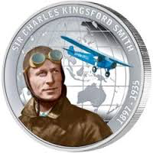
3. Vocabulary Builder: Cloze Passage – Fill in the blanks using the word bank

Charles Kingsford Smith was a World War 1 flying ace and a Hollywood _______________________ who together with his co pilot _________________________________ and crew attempted to be the first to fly from ____________________________to Australia setting off on May 31, 1928 from San Francisco. By boat the trip took ________________ weeks, however, Smithy believed he could fly the almost 12 000kms in ___________________days. He hoped to be the _____________________to fly across the Pacific Ocean, however, on June 8, 1928 the attempt to cross the world’s largest ocean nearly ended in ____________________ as he flew blind, off course with no place to land and in a storm that threatened to __________________________ the plane apart.
The ‘Southern Cross’ was a basic plane made from steel tubes and canvas with no heating and no seat belts. ___________________________________ the radio operator would communicate in _________________________________________ by tapping out progress reports that were heard by Australians on their radios. This was the first live _______________________________ of an international event that helped capture the imagination of Australians throughout the night.
In the rush to leave _____________________________ for the last leg of the three-legged marathon, the plane’s most _____________________________ instrument, the Earth Inductor Compass had forgotten to be oiled meaning it was no longer working, leaving the crew with only a rough idea where they were and going. The ________________________________ faced other difficulties travelling through that intensive storm with the rain becoming too much for the _______________________________ and the crew getting wet and cold. The plane became extremely tough to control, the __________________________ began to falter and the crew knew if they had stopped they would ____________________________into the ocean. Smithy took a massive risk diving into the storm to keep the fading engines turning over. It was reported on Australian radio _____________________________ that the crew had not been heard from for over two hours. They had ______________________________ the storm and after eighty-three flying hours they arrived in Brisbane where 15000 people greeted them to a _____________________________ welcome. The trans-Pacific flight is regarded as one of the most remarkable achievements in Aviation History.

4. Were any of your predictions accurate? ____________________________________________
__________________________________________________________________________________________________
__________________________________________________________________________________________________
__________________________________________________________________________________________________
__________________________________________________________________________________________________

Sites for Further Information
Australian – Charles Kingsford Smith
http://www.abc.net.au/btn/v2/australians/cksmith.htm

5. After further research of Charles Kingsford-Smith list four additional interesting facts about his life. _______________________________________________________________
__________________________________________________________________________________________________
__________________________________________________________________________________________________
__________________________________________________________________________________________________
__________________________________________________________________________________________________
__________________________________________________________________________________________________
Time: 0:00 to 10:10 minutes

Volume 2 – Hard Roads to Glory
The Sydney Harbour Bridge

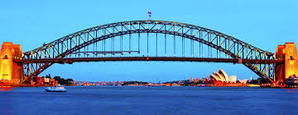

1. KWL Chart. In the first column, write what you already know. In the second column, write what you want to know. In the third column, write what you learned.
What I Know | What I Want to Know | What I Learned

2. Vocabulary Builder: Clarify the key words and concepts. Place a tick (√) next to the words in the word bank you understand and a question mark (?) next to the words you are unsure of the meaning. Check the meaning and record in the table.

recognisable arch alignment goliath
construction labour metres engineering
anchored coathanger hinges workmanship

Word | Definition

3. Vocabulary Builder: Cloze Passage – Fill in the blanks using the word bank

August 19, 1930 Sydney Harbour. The greatest __________________________ feat of the day was nearing completion. After seven years of backbreaking ________________________, enough money to bankrupt New South Wales and Engineer John Bradfield’s 40-year dream was about to be realised. Two ___________________________________ arches, weighing 20 thousands tonnes each, 134 metres above the harbour, must meet with pinpoint accuracy. Giant cables half a metre thick were slowly loosened cm by cm until the arches met, they were 13mm off perfect ________________________________. In July 1923 the _______________________________ of the Harbour Bridge began. The total length of the steel arch bridge is 1149 metres with the ______________________ span 503 metres ______________________________ by four hewn-stone pylons with the two halves attached on each shore by ______________________________. A blend of Bradfield’s vision, Australian _________________________________ and the courageous man power from up to 4000 men working 130 _______________________ above sea level (with no helmets or guard rails) created one of the world’s most ________________________________ and greatest engineering feats. Premier Jack Lang played an important role in keeping funds flowing for the project throughout the depression. The ‘______________________________ ’ fondly known by locals came at a big cost, in all 50000 tonnes of steel, 6 million rivets, 270 000 litres of paint and 16 workers losing their life.

Sites for Further Information, Short Film and Photos
Construction of Sydney Harbour Bridge his short film documents the construction of one of the world's great landmarks in its various stages, and provides a fascinating glimpse of life around Sydney Harbour and Circular Quay in the twenties and thirties.
https://www.youtube.com/watch?v=Jy5cZ-IO0Eg

20 Interesting Facts About the Sydney Harbour Bridge
http://www.buzzfeed.com/bradesposito/facts-about-the-sydney-harbour-bridge#.cnX7vdWM03

Powerhouse Museum - Photos of the Sydney Harbour Bridge Construction
https://www.flickr.com/photos/powerhouse_museum/albums/72157632276855595/with/8283759450/

4. Create a time line by matching the image with the year
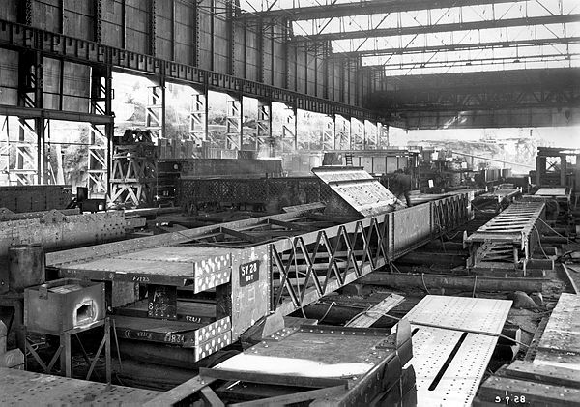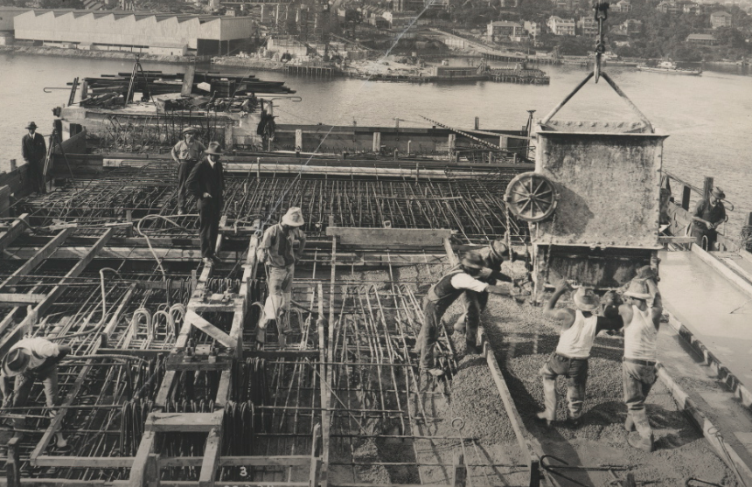
Image A Image B
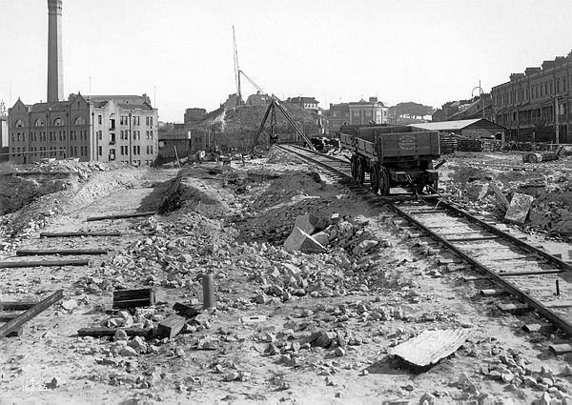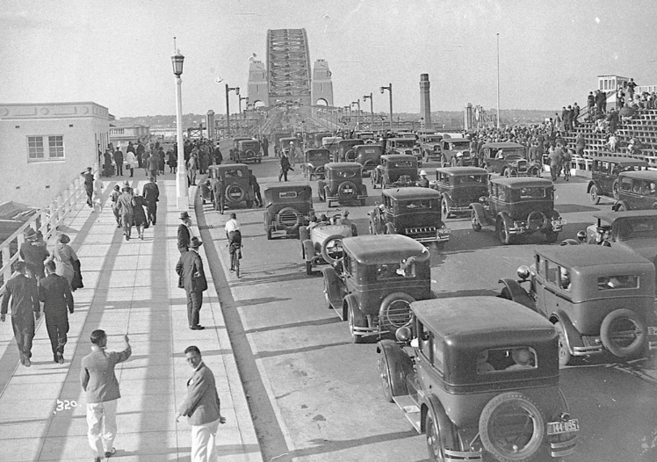
Image C Image D
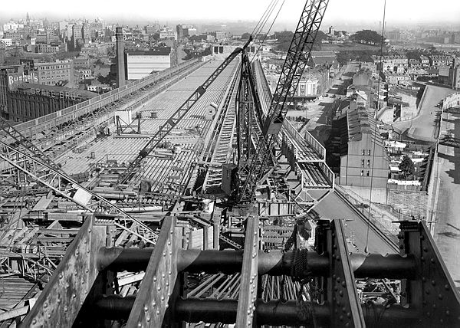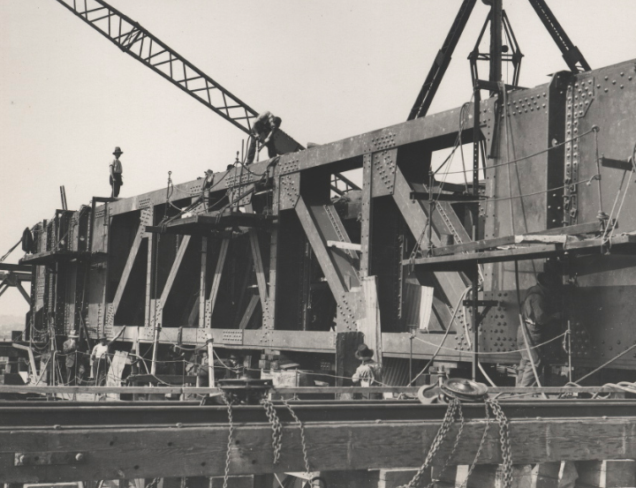
Image E Image F

1. 1932 motorcars driving across the bridge ___________
2. 1928 erection of metal formwork ___________
3. 1929 looking along the steel decking ___________
4. 1928 assembly section steel fabrication workshop ___________
5. 1928 pouring concrete on the southern platform ___________
6. 1925 clearing for southern end approaches ___________
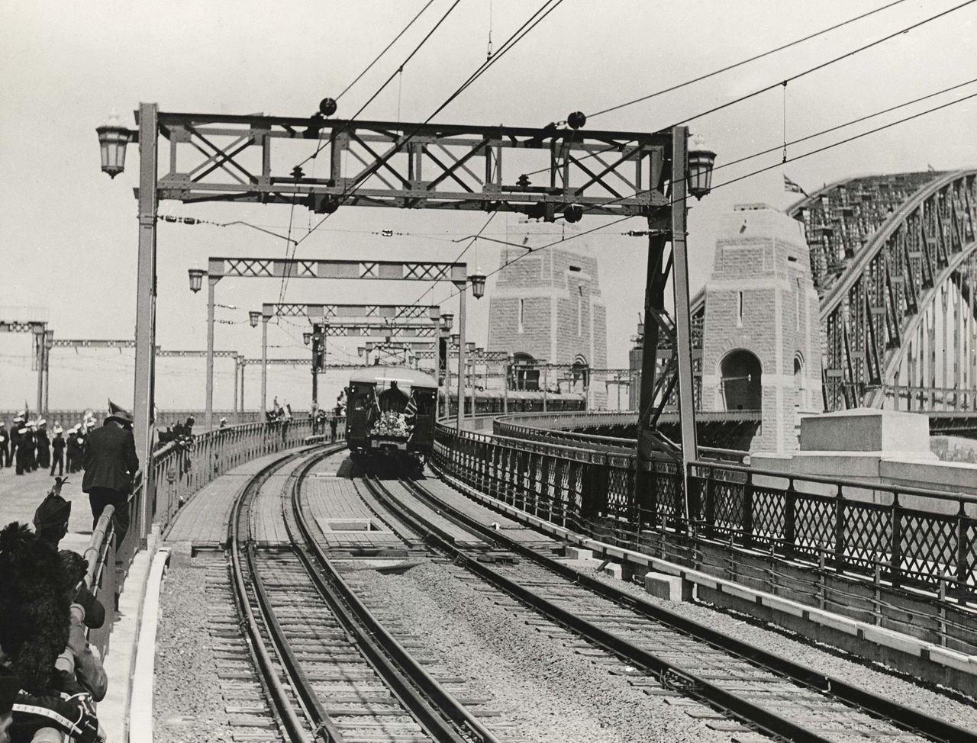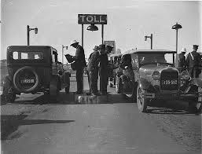
Image G Image H
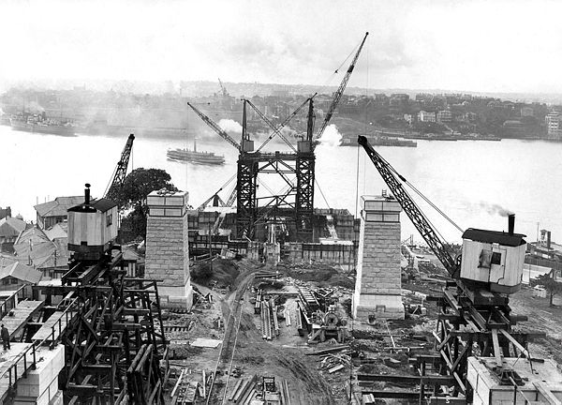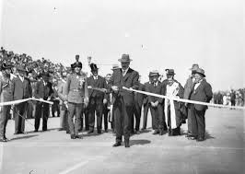
Image I Image J
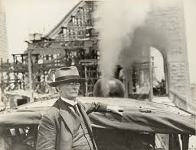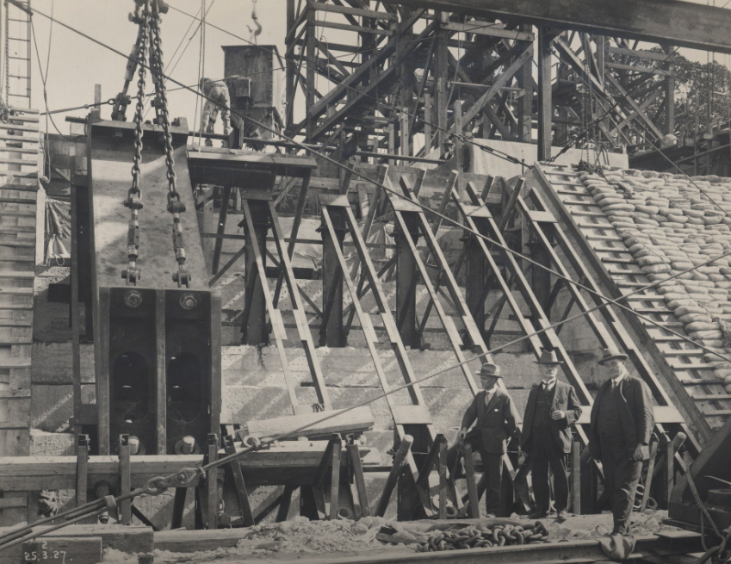
Image K Image L

7. 1927 construction on the southern bank looking north ___________
8. 1927 construction of bridge’s main bearing ___________
9. 1932 Engineer John Bradfield ___________
10. 1932 First passenger train crossing the bridge ___________
11. 1932 official opening ceremony ___________
12. 1932 first cars at the toll bay ___________
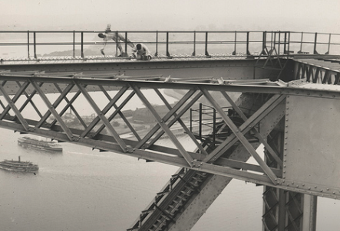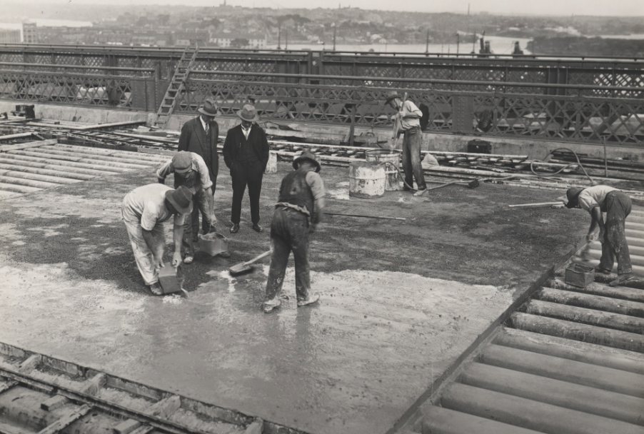
Image M Image N
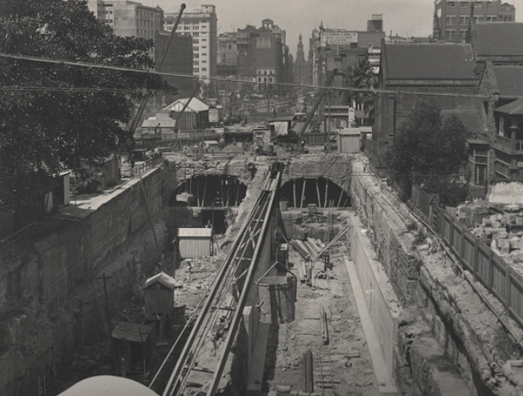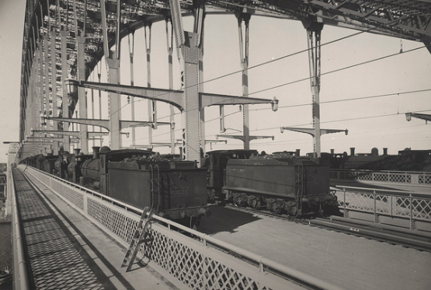
Image O Image P
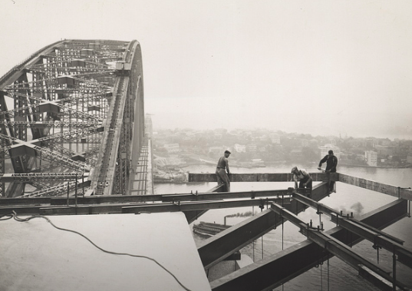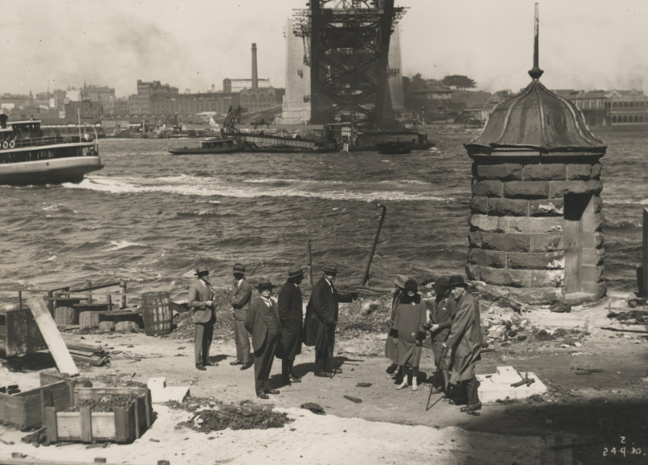
Image Q Image R

13. 1932 steam trains on the Harbour Bridge ___________
14. 1931 laying the road surface of the bridge ___________
15. 1928 construction of railway tunnels ___________
16. 1930 dignitaries viewing the construction ___________
17. 1932 painters on the arch of the bridge ___________
18. 1932 workmen attaching the supports to a pylon ___________

Time 10:10 to 19:05 minutes

Volume 2 – Hard Roads to Glory
The Sydney Harbour Bridge

1. KWL Chart. In the first column, write what you already know. In the second column, write what you want to know. In the third column, write what you learned.
What I Know | What I Want to Know | What I Learned

2. Vocabulary Builder: Clarify the key words and concepts. Place a tick (√) next to the words in the word bank you understand and a question mark (?) next to the words you are unsure of the meaning. Check the meaning and record in the table.

recognisable arch alignment goliath
construction labour metres engineering
anchored coathanger hinges workmanship

Word | Definition

3. Vocabulary Builder: Cloze Passage – Fill in the blanks using the word bank

August 19, 1930 Sydney Harbour. The greatest __________________________ feat of the day was nearing completion. After seven years of backbreaking ________________________, enough money to bankrupt New South Wales and Engineer John Bradfield’s 40-year dream was about to be realised. Two ___________________________________ arches, weighing 20 thousands tonnes each, 134 metres above the harbour, must meet with pinpoint accuracy. Giant cables half a metre thick were slowly loosened cm by cm until the arches met, they were 13mm off perfect ________________________________. In July 1923 the _______________________________ of the Harbour Bridge began. The total length of the steel arch bridge is 1149 metres with the ______________________ span 503 metres ______________________________ by four hewn-stone pylons with the two halves attached on each shore by ______________________________. A blend of Bradfield’s vision, Australian _________________________________ and the courageous man power from up to 4000 men working 130 _______________________ above sea level (with no helmets or guard rails) created one of the world’s most ________________________________ and greatest engineering feats. Premier Jack Lang played an important role in keeping funds flowing for the project throughout the depression. The ‘______________________________ ’ fondly known by locals came at a big cost, in all 50000 tonnes of steel, 6 million rivets, 270 000 litres of paint and 16 workers losing their life.

Sites for Further Information and Photos
Construction of Sydney Harbour Bridge his short film documents the construction of one of the world's great landmarks in its various stages, and provides a fascinating glimpse of life around Sydney Harbour and Circular Quay in the twenties and thirties.
https://www.youtube.com/watch?v=Jy5cZ-IO0Eg

20 Interesting Facts About the Sydney Harbour Bridge
http://www.buzzfeed.com/bradesposito/facts-about-the-sydney-harbour-bridge#.cnX7vdWM03

Powerhouse Museum - Photos of the Sydney Harbour Bridge Construction
https://www.flickr.com/photos/powerhouse_museum/albums/72157632276855595/with/8283759450/

4. Create a time line by matching the image with the year
Image A Image B
Image C Image D
Image E Image F

1. 1932 motorcars driving across the bridge D
2. 1928 erection of metal formwork F
3. 1929 looking along the steel decking E
4. 1928 assembly section steel fabrication workshop A
5. 1928 pouring concrete on the southern platform B
6. 1925 clearing for southern end approaches C
Image G Image H
Image I Image J
Image K Image L

7. 1927 construction on the southern bank looking north I
8. 1927 construction of bridge’s main bearing L
9. 1932 Engineer John Bradfield K
10. 1932 First passenger train crossing the bridge G
11. 1932 official opening ceremony J
12. 1932 first cars at the toll bay H
Image M Image N
Image O Image P
Image Q Image R

13. 1932 steam trains on the Harbour Bridge P
14. 1931 laying the road surface of the bridge N
15. 1928 construction of railway tunnels O
16. 1930 dignitaries viewing the construction R
17. 1932 painters on the arch of the bridge M
18. 1932 workmen attaching the supports to a pylon Q

Time 10:10 to 19:05 minutes

