Volume 1 – Worlds Collide
The Death Fleet

Background: Captain Arthur Phillip and the First Fleet (a fleet of eleven ships) arrived on 26th January 1788 at Sydney Cove with officers, marines, soldiers their wives and 750 plus convicts and their children. The journey from Great Britain lasted eight months. It was the start of a plan to transport thousands of criminals. With Great Britain having a convict problem, that is too many criminals and nowhere to put them - the land discovered by British Explorer Captain Cook in 1770 was decided as a suitable place for a settlement. It was Phillip, the first Governor of New South Wales task to build a new society in the face of violence, death and imminent starvation.
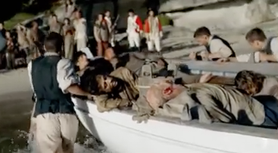
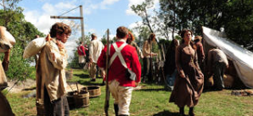

1. Vocabulary Builder: Clarify the key words and concepts. Place a tick (√) next to the words in the word bank you understand and a question mark (?) next to the words you are unsure of the meaning. Check the meaning and record in the table.

inevitable convicts survive starvation farmer arrived transported Penal compost Governor seed rotting flourished Agriculture stealing unfruitful
Word | Definition

2. Vocabulary Builder: Cloze Passage – Fill in the blanks using the word bank.

Just over two hundred years ago the British ________________________________with almost 800 convicts. Nearly two years later the first British ________________________________ colony is on the verge of _________________________________ with supplies from England either ______________________ or running out. They could not feed themselves and six desperate men had been hung for _____________________________. The second fleet that arrived on June 26, 1790 was not the British Army it was tragically full of __________________________ starving and dying of scurvy. James Ruse, who had been sentenced to seven years for stealing two silver watches, was a ______________________________ in his homeland before being _______________________________ as a convict and together with Elizabeth Parry who herself was banished to Sydney for stealing clothes realised they needed to show the rest of the colony how to farm and ______________________________. James Ruse approached the _________________________________ and was given land near Parramatta together with ________________________ and convict labourers. Seeing the land was _________________________ he used ash to fertilise the soil. He was not used to the weather conditions, the infertile land and growing crops new to the area and consequently the first crop failed. Death was __________________________________ if they did not have success but he did not give up. He managed to save enough seed, dug in _____________________________ and struggled with Australia’s drought conditions, and then when all seemed lost the heavens opened up, the corn _________________________________ and they became the first colonists to feed themselves. James Ruse is regarded as the Father of ____________________________________ paving the way for family farms and showing Australians how to feed themselves.

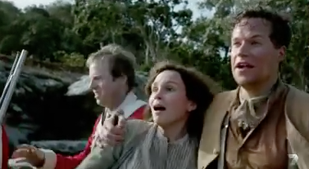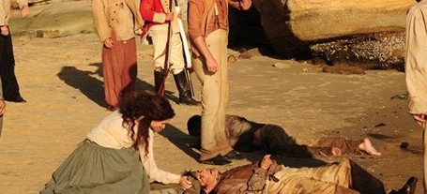

3. Imagine you are in the same situation as the convicts with your food supplies running out, what would you have done in order to survive?
__________________________________________________________________________________________________
__________________________________________________________________________________________________
__________________________________________________________________________________________________
__________________________________________________________________________________________________
__________________________________________________________________________________________________
__________________________________________________________________________________________________
__________________________________________________________________________________________________
4. Summarise the story using the 5 W’s ________________________________________________
__________________________________________________________________________________________________
____________________________________________________________________________________________________________________________________________________________________________________________________
__________________________________________________________________________________________________
__________________________________________________________________________________________________
__________________________________________________________________________________________________
__________________________________________________________________________________________________
__________________________________________________________________________________________________
__________________________________________________________________________________________________

Time: 1:01 to 10.04 minutes

Volume 1 – Worlds Collide
Prehistoric Australia

1. What images do you expect to see in a documentary titled – Prehistoric Australia?
__________________________________________________________________________________________________
__________________________________________________________________________________________________
__________________________________________________________________________________________________
______________________________________________________________________________________________________________________________________

2. Vocabulary Builder: Clarify the key words and concepts. Place a tick (√) next to the words in the word bank you understand and a question mark (?) next to the words you are unsure of the meaning. Check the meaning and record in the table.

carnivorous descendants lethal Goannas
inhospitable marsupial roamed gathering
generations educated Aboriginal flightless mega guts cutters country potent

Word | Definition

3. Vocabulary Builder: Cloze Passage – Fill in the blanks using the word bank.

45 000 years ago in the Darling Downs of Queensland to the Margaret river in the west mega beasts _________________________ the country. ______________________________ the size of utes , two tonne wombats, a large ___________________________________ bird more than three metres tall with claws to match and football sized eggs together with a meat eating ______________________________________ mean enough to kill them all, lived amongst people whose _______________________________ was drying up fast with food hard to find. Australia is drying up with rivers and lakes evaporating and half of all species dying out with only the fittest to survive. Aboriginal people were __________________________ from up to 30 metres with a spear. Their most ___________________________ weapon however, was knowledge that was past down through hundreds of ________________________________ teaching their __________________________________ how to respect the land, live from the land and eat from the land. Australia had their own marsupial lion, the world’s deadliest ___________________________________ mammal with 8 cm long claws that could tear the ____________________ out of any animal or human, jaws like bolt _________________________ and weighed over 90 kg. Like all the _____________________________ beasts they struggled to survive needing massive amounts of food to eat in a drying continent where food was running out. The _______________________________________ Australians survived by making the most every opportunity with women and children _______________________________ small plants, fish and water from billabongs. They _____________________________ themselves with better ways of surviving and developed a culture to live in the most ___________________________ conditions.

4. Were any of your predictions accurate? ____________________________________________
__________________________________________________________________________________________________
__________________________________________________________________________________________________
__________________________________________________________________________________________________
__________________________________________________________________________________________________

Australia’s Megafauna (large bodied mammals from a given area)

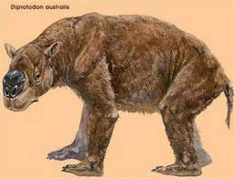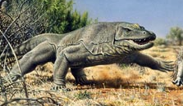
Diprotodon – giant wombat Megalania - Goanna

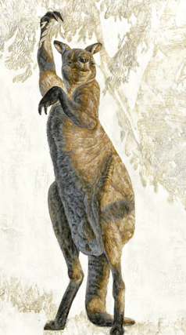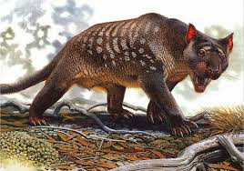
Procoptodon - giant
short-faced kangaroo Thylacoloe carnifex – Marsupial Lion

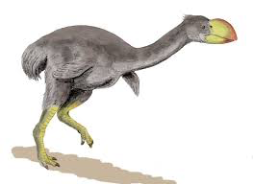
Dromornis Stirtoni – giant flightless bird

5. List any questions you have about the text or the documentary and something you want to learn about in relation to Prehistoric Australia or Megafauna.
__________________________________________________________________________________________________
__________________________________________________________________________________________________
__________________________________________________________________________________________________
__________________________________________________________________________________________________
__________________________________________________________________________________________________
__________________________________________________________________________________________________
__________________________________________________________________________________________________
_________________________________________________________________________________________________
Sites for Further Research
National Geographic
http://ngm.nationalgeographic.com/2010/10/dreamtime-animals/achenbach-text/1
ABC – Australian Beasts
http://www.abc.net.au/science/ausbeasts/history.htm
Australian Museum
http://australianmuseum.net.au/mammals

Time: 10.04 to 17:00 minutes
Volume 1 – Fair Go
Birth of Australian Rules Football

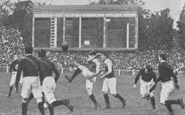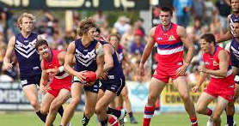

1. Connecting to the text. Make a list of words that demonstrates your knowledge of Aussie Rules Football.
______________________________ ______________________________ _______________________________
______________________________ ______________________________ _______________________________
______________________________ ______________________________ _______________________________
______________________________ ______________________________ _______________________________
______________________________ ______________________________ _______________________________
2. Read the following statements and make the prediction whether you believe the statements are True or False.
Statement | True  (√) | False  (√)
Australian Rules football was invented in Melbourne in the 1890’s
Originally AFL was called VFL
Aussie rules came from marn-grook a traditional Aboriginal game
Cricket player Tom Wills played a role in forming the first code of rules
First written rules of Football stated tripping & pushing are both allowed
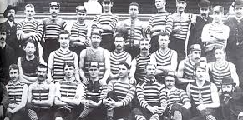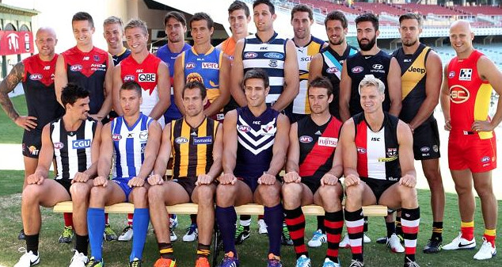

3. Vocabulary Builder: Clarify the key words and concepts. Place a tick (√) next to the words in the word bank you understand and a question mark (?) next to the words you are unsure of the meaning. Check the meaning and record in the table.

possum England foundations spread referees annual swift sport soaring cricketers Victorian civilians marn grook toughest define obsession
Word | Definition

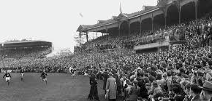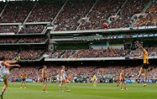

4. Vocabulary Builder: Cloze Passage – Fill in the blanks using the word bank.

On June 5 1869 the Melbourne Football club clashed with Her Majesty’s troops in the ____________________________ football match at the Melbourne Cricket Ground (MCG) in Richmond, Melbourne. The _______________________________ had battled with the soldiers for almost two hours and one of the founders of Victorian Rules Football, Tom Wills, a famous Victorian cricket captain was desperate for the win because success against the British would help promote the game and lay the _____________________________ for this uniquely Australian Sport.

It was 1958 when Tom decided that the colony’s ________________________ needed a winter sport to keep them fit. He went to school in ________________________ and while he played rugby and saw soccer played everywhere Tom wanted a new Australian game, a game of their own, a game with the best action from each sport. One of the tactics and the skills that ____________________________ Aussie Rules is the mark. It was years earlier, Tom, who grew up neighbouring boys from the Djab Wurrung and Jardwadjali people witnessed his first high mark in a game called ______________________. A traditional game that the Aboriginal people used to play called marn grook had up to 50 players on each side. They used to fill a _____________________________ skin up with charcoal, kick it, hand pass it, throw it and mark it all day long, sometimes over three four days. What Tom Wills saw stayed with him for the rest of his life.

The next year, Tom and the others decided on the first rules of an Australian football code. Tom suggested the mark would encourage kicking to hand and ___________________

movement of the ball from one end of the ground to the other. They put their signatures to 10 key rules and Aussie Rules footy was born. The timing was perfect with the economy booming, wages were ____________________________ and there was more time to play with workers in Melbourne locking in an eight-hour day. Before the good times only rich people played ____________________________. Now it was for everyone. Before the rule book games were an excuse to have a punch-up and with no ____________________________________ even within organised games the first proper footy games were still rough.

On that winter day back in 1869 Team captain Henry Harrison, Melbourne’s best and _____________________________ set up play wherever possible. When the first and only goal was kicked late in the match the Victorians beat the British soldiers one-nil. The game grew and ___________________________ through the southern and western colonies. In a decade, the ______________________________ Football League (VFL) kicked off and in 1990 the game became a national code the Australian Football League (AFL). Aussie Rules has become an Australian _____________________________________ with an opportunity for all people of different sizes and shapes, different cultures, different religions to play and support the game.

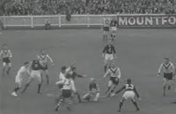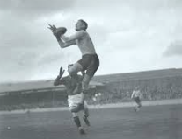

5. Create a Game
Short description
Give a short explanation of what the game is about.
Players
How many teams and how many players per team?
Playing area
Where are we going to play the game and how big an area do you need?
Equipment
What type of ball, cones, tags?
Game play and basic rules
What do you have to do?
Scoring
What do you have to do to score points?

Sites for Further Information and You Tube Clip
Museum Victoria
http://museumvictoria.com.au/discoverycentre/discovery-centre-news/2008-archive/the-history-of-australian-rules-football/
The first written Rules of Football, May 1858
http://www.afl.com.au/afl-hq/the-afl-explained/first-written-rules-of-football-may-1858
Top 10 AFL Marks of All Time
https://www.youtube.com/watch?v=Sfy1LtHXF_U

Time 16:32 to 24:15 minutes

Volume 1 – Break Out
Gold Discovery

1. What images and information do you expect to see in a documentary and text titled – Gold Discovery?
__________________________________________________________________________________________________
__________________________________________________________________________________________________
__________________________________________________________________________________________________
______________________________________________________________________________________________________________________________________
______________________________________________________________________________________________________________________________________

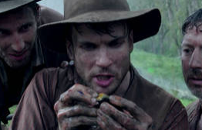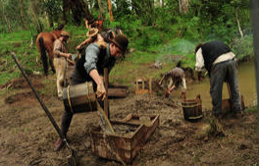
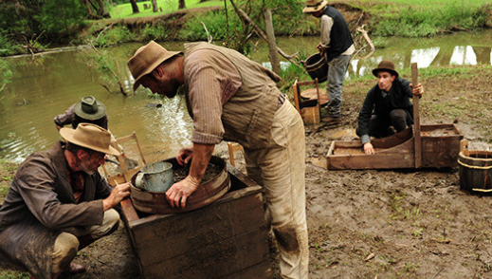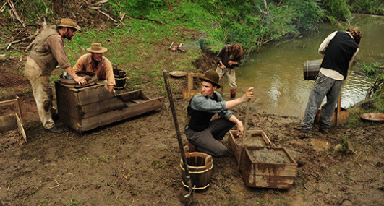

2. Vocabulary Builder: Clarify the key words and concepts. Place a tick (√) next to the words in the word bank you understand and a question mark (?) next to the words you are unsure of the meaning. Check the meaning and record in the table.

stake prospecting construction Lured
nugget immigrant disputes population
skyrocket tent richness fierce
Bendigo Yarrowee directed equivalent

Word | Definition

3. Vocabulary Builder: Cloze Passage – Fill in the blanks using the word bank.

It was September 10 1851 in the ____________________________ Valley of Victoria, 100km west of Melbourne, where Australia’s population and wealth was about to _________________________ because of one man, James Esmond. He like many others who were motivated for _______________________________ searched for their fortune in the earth _________________________________ for gold. Gold diggers believed that the best place to strike gold was close to creeks and riverbeds, however, another prospector by the name of James Oddie was the first to _________________________ a claim for the land that James had planned to search. With the possibility of great wealth competition for land was _______________________ and Oddie and his men were not going to give up the land without a fight. At the dawn of the gold rush there was little law and order and the resolving of _______________________ was brutal. Oddie had forced Esmond to try his luck a few hundred metres away on higher ground that was considered much less likely to contain gold. Unknowingly, Oddie had _________________________ his rival to a fortune with Esmond’s first find a huge 250g _____________________________ of pure gold and over a period of two days he and his men found 27kg of gold … the _______________________________ of a million dollar pay day. While, they tried to keep their find a secret the word got out with people coming from everywhere. A ______________ town erupted around Esmond’s diggings becoming the wealthy town of Ballarat. A ____________________________ boom resulted and railways connected Melbourne to the gold towns including __________________________ and Castlemaine. Built on gold wealth, Melbourne became the biggest and richest city in Australia. In the 1850’s a third of the world’s gold supply came from Victoria. _____________________________ by the chance of getting rich hundreds of thousands of prospectors flooded Victoria and in less than a decade the _______________________________ rocketed from 25 000 to more than half a million. For 40 years miners struck gold around the continent making Australia one of the richest places in the world and bringing _______________________________________ from 150 nations of the world here to Australia.

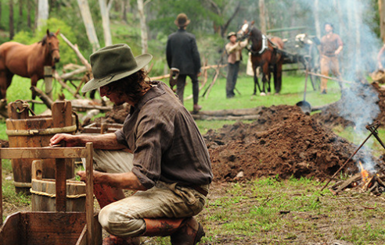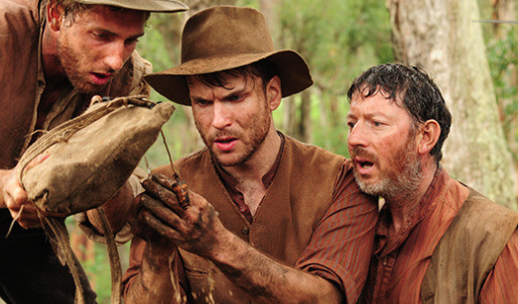

4. Were any of your predictions accurate? ____________________________________________
__________________________________________________________________________________________________
__________________________________________________________________________________________________
__________________________________________________________________________________________________
__________________________________________________________________________________________________

5. List any questions you have about the text or the documentary and something you want to learn about in relation to Gold Discovery in Australia.
__________________________________________________________________________________________________
__________________________________________________________________________________________________
__________________________________________________________________________________________________
__________________________________________________________________________________________________
__________________________________________________________________________________________________
__________________________________________________________________________________________________
__________________________________________________________________________________________________
_________________________________________________________________________________________________

Sites for Further Research
History Today - Australian prospectors struck gold on February 12th, 1851.
http://www.historytoday.com/richard-cavendish/australian-gold-rush-begins
Kidcyber – Gold Rush in Australia
http://kidcyber.com.au/topics/australia/gold-rush-australia/

Time: 23:10 to 29.11minutes

Volume 1 – Break Out
Eureka Stockade

1. Look at the pictures below and record what you think the story will be about.
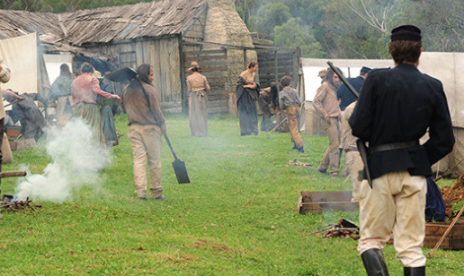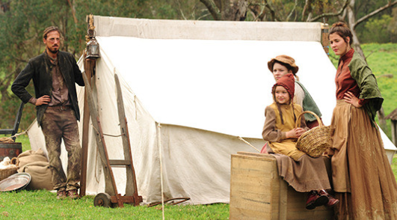

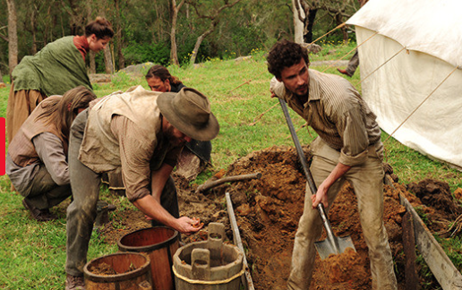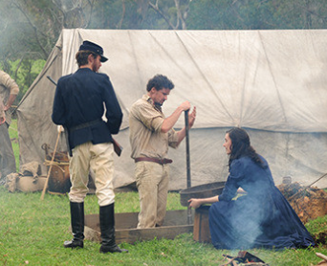

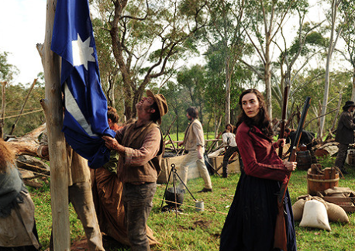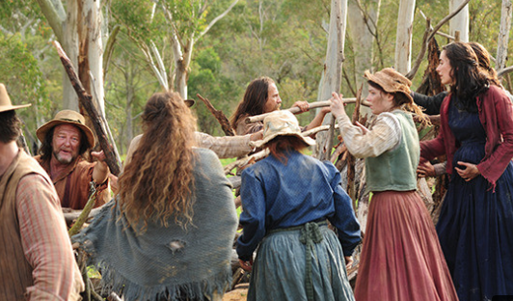

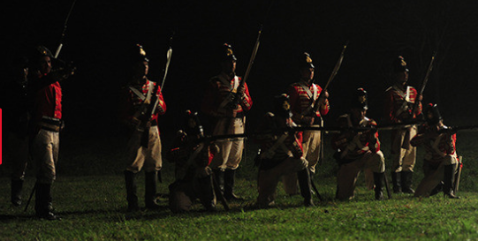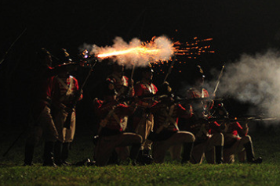
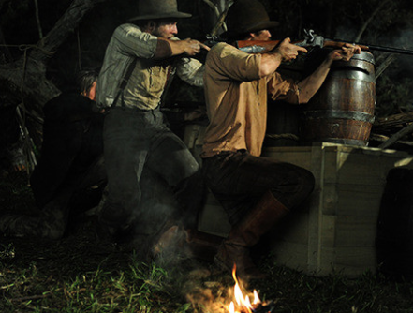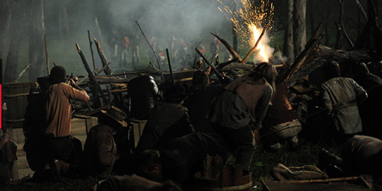

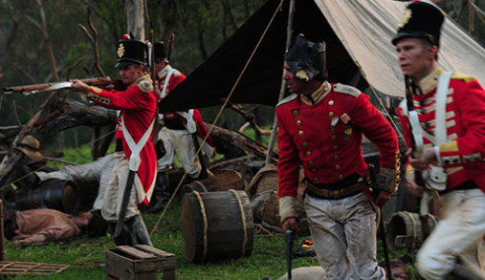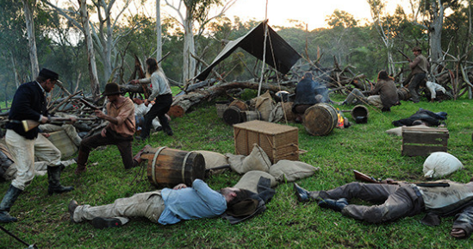

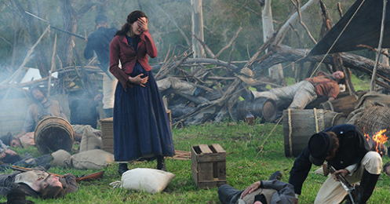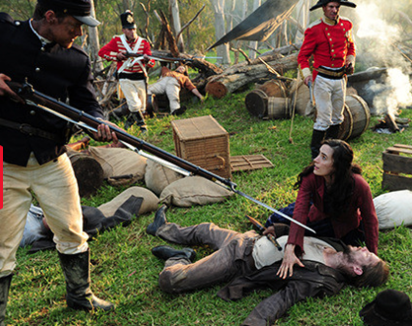

__________________________________________________________________________________________________
____________________________________________________________________________________________________________________________________________________________________________________________________
__________________________________________________________________________________________________
__________________________________________________________________________________________________
__________________________________________________________________________________________________
__________________________________________________________________________________________________
__________________________________________________________________________________________________

Three years after James Esmond hit his pay dirt, prospectors from around the world were still flocking to the Victorian goldfields. It was in November 1854 in Ballarat, 115 km west of Melbourne that Gold Fever was about to reach boiling point in a battle over mining licences. The Government had a mining tax which meant to dig you must have a licence. Not everyone struck it rich on the goldfields with most people barely making ends meet, however, the government still demanded the money be paid whether the diggers found gold or not. The tax was enormously unpopular with the police cracking down on miners who could not or would not buy a licence. John Hynes fresh off the boat from Ireland believed in justice and freedom for all. The brutality and the unfairness of the taxes infuriated miners like Hynes and unified the diggers against the Government that led them to take part in an armed rebellion … that was crucial to the rise of Australian Democracy.

In an act of defiance the miners burnt their licences. They banded together, armed themselves and built a fortress that became known as the Eureka Stockade. They raised their own flag, the Southern Cross being a symbol of ‘our place under the stars’, however, the Government saw this as an act of rebellion that would not be tolerated. It was December 3 1854 at 3am, the miners had been held up in their stockade for three days. 276 British soldiers and police took up positions around it with a plan to take the rebels by surprise and crush the resistance. Led by Hynes this was the first time Australians took up arms against the Crown in pursuit of democratic rights.

Despite all the firepower and ferocity of the soldiers the miners held on and killed six troops. However, Hynes died along with 21 of his mates and in the morning the troopers chased down the survivors. In spite of this, the survivors lived to see that the miners’ sacrifice was not in vain. In the wake of Eureka the colonies reinvented themselves with the Government scraping mining licences, both Victoria and South Australia become the first places in the Empire where all British men over the age of 21 had the right to vote, Victoria become the most democratic place in the world and Australia led the world in democratic reforms.

2. Using any of the following question words (who, what, where, when, why, how) to create three questions to ask of other students.
______________________________________________________________________________________________________________________________________________________________________________________________________________________________________________________________________________________________________
__________________________________________________________________________________________________
__________________________________________________________________________________________________
__________________________________________________________________________________________________
__________________________________________________________________________________________________

3. Clarifying the key phrases in the text. Search for the phrase in the text, read the words around the phrase for clues and write what you think the phrase means.

hit his pay dirt | I think it means
 | In fact it means
flocking to | I think it means
 | In fact it means
reach boiling point | I think it means
 | In fact it means
barely making ends meet | I think it means
 | In fact it means
cracking down | I think it means
 | In fact it means
fresh off the boat | I think it means
 | In fact it means
armed rebellion | I think it means
 | In fact it means
banded together | I think it means
 | In fact it means
held up | I think it means
 | In fact it means
took up positions | I think it means
 | In fact it means
took up arms against the Crown | I think it means
 | In fact it means
In spite of this | I think it means
 | In fact it means
sacrifice was not in vain | I think it means
 | In fact it means
In the wake | I think it means
 | In fact it means
democratic reforms | I think it means
 | In fact it means

Sites for Further Research
My Place - Eureka Stockade
http://www.myplace.edu.au/decades_timeline/1850/decade_landing_15_1.html?tabRank=2&subTabRank=2

Time: 29.11 to 36.33 minutes

Volume 1 – Break Out
Eureka Stockade

1. Look at the pictures below and record what you think the story will be about.

__________________________________________________________________________________________________
____________________________________________________________________________________________________________________________________________________________________________________________________
__________________________________________________________________________________________________
__________________________________________________________________________________________________
__________________________________________________________________________________________________
__________________________________________________________________________________________________
__________________________________________________________________________________________________

Three years after James Esmond hit his pay dirt, prospectors from around the world were still flocking to the Victorian goldfields. It was in November 1854 in Ballarat, 115 km west of Melbourne that Gold Fever was about to reach boiling point in a battle over mining licences. The Government had a mining tax which meant to dig you must have a licence. Not everyone struck it rich on the goldfields with most people barely making ends meet, however, the government still demanded the money be paid whether the diggers found gold or not. The tax was enormously unpopular with the police cracking down on miners who could not or would not buy a licence. John Hynes fresh off the boat from Ireland believed in justice and freedom for all. The brutality and the unfairness of the taxes infuriated miners like Hynes and unified the diggers against the Government that led them to take part in an armed rebellion … that was crucial to the rise of Australian Democracy.

In an act of defiance the miners burnt their licences. They banded together, armed themselves and built a fortress that became known as the Eureka Stockade. They raised their own flag, the Southern Cross being a symbol of ‘our place under the stars’, however, the Government saw this as an act of rebellion that would not be tolerated. It was December 3 1854 at 3am, the miners had been held up in their stockade for three days. 276 British soldiers and police took up positions around it with a plan to take the rebels by surprise and crush the resistance. Led by Hynes this was the first time Australians took up arms against the Crown in pursuit of democratic rights.

Despite all the firepower and ferocity of the soldiers the miners held on and killed six troops. However, Hynes died along with 21 of his mates and in the morning the troopers chased down the survivors. In spite of this, the survivors lived to see that the miners’ sacrifice was not in vain. In the wake of Eureka the colonies reinvented themselves with the Government scraping mining licences, both Victoria and South Australia become the first places in the Empire where all British men over the age of 21 had the right to vote, Victoria become the most democratic place in the world and Australia led the world in democratic reforms.

2. Using any of the following question words (who, what, where, when, why, how) to create three questions to ask of other students.
______________________________________________________________________________________________________________________________________________________________________________________________________________________________________________________________________________________________________
__________________________________________________________________________________________________
__________________________________________________________________________________________________
__________________________________________________________________________________________________
__________________________________________________________________________________________________

3. Clarifying the key phrases in the text. Search for the phrase in the text, read the words around the phrase for clues and write what you think the phrase means.

hit his pay dirt | I think it means
 | In fact it means he discovered something valuable, the miner discovered gold
flocking to | I think it means
 | In fact it means like a group of animals, large crowds of people moving to and gather in the Victorian Gold Fields
reach boiling point | I think it means
 | In fact it means emotions involved are so strong, the miners are so upset about paying licence fees
barely making ends meet | I think it means
 | In fact it means living with little money after expenses, miners struggling to pay for food, clothing and then to pay licence fees
cracking down | I think it means
 | In fact it means to become strict about rules, the government and police strict and severe on the miners having a licence to dig
fresh off the boat | I think it means
 | In fact it means newly immigrated, people were attracted to the Victoria gold fields from other countries in the hope of finding their fortune in gold
armed rebellion | I think it means
 | In fact it means refusal to obey the rules or openly oppose the authorities with the use of guns
banded together | I think it means
 | In fact it means forming a group and uniting together to rebel against the government
held up | I think it means
 | In fact it means the miners were settled in and continued to stay in their fortress
took up positions | I think it means
 | In fact it means take up a spot, the army and the police arranged themselves around the stockade
took up arms against the Crown | I think it means
 | In fact it means use of weapons against the government and the Kingdom of England’s legal system
In spite of this | I think it means
 | In fact it means even though the police and the army killed many of the miners and took all the survivors the rebellion the government still listened to the miners concerns
sacrifice was not in vain | I think it means
 | In fact it means the giving up of their life to fight for what they believed in ended with the desired outcome of better conditions and expanded rights for their friends and families
In the wake | I think it means
 | In fact it means as a result of the Eureka Stockade the colony changed with the government altering laws in particular awarding voting rights to the men
democratic reforms | I think it means
 | In fact it means making changes in a political sense, the government is voted on by the people meaning they had a say in how the colony was run

Sites for Further Research
My Place - Eureka Stockade
http://www.myplace.edu.au/decades_timeline/1850/decade_landing_15_1.html?tabRank=2&subTabRank=2

Time: 29.11 to 36.33 minutes

