BREAKFAST
WORLD TOUR
JOURNAL 2016
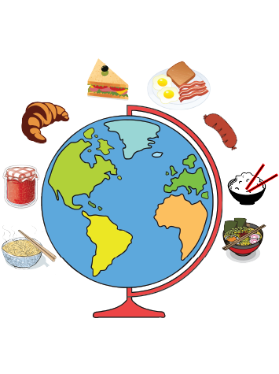.
NAME:
DATE:

Breakfast World Tour

Name of country: ________________________________________________________
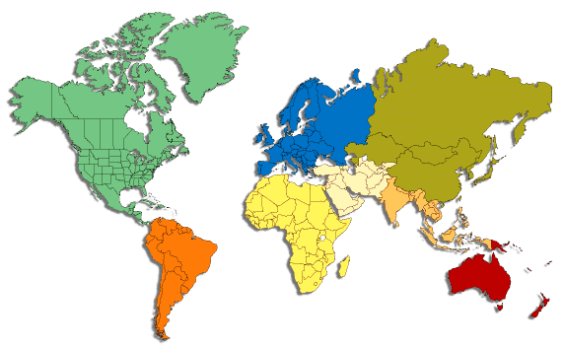
Label on the map below the country, capital city and its two closest countries

Draw and colour its flag

Population: _________________________________________
Hemisphere: ________________________________________
Currency: ___________________________________________
Area km² : ___________________________________________
Government leaders name: _________________________
Exports: _____________________________________________
Language: ___________________________________________
Find 3 words or phrases in this language include the English translation:
- ___________________________________________________________________________
English: ________________________________________________________________________
- ___________________________________________________________________________
English: ________________________________________________________________________
- ___________________________________________________________________________
English: ________________________________________________________________________
Find 2 landmarks for this country, include an image:
- ___________________________________________________________________________

- ___________________________________________________________________________

Find a festival this country celebrates and describe it: ________________________________________________________________________________________________________________________________________________________________________________________________________________________________________________________________________________________________________________________
Find a youtube clip of music from this country and include link: ______________________________________________________________________________
National dish: _______________________________________________________________
Include an image below

Breakfast dish: _____________________________________________________________
Include a recipe below:

National costume: __________________________________________________________
Image:

Find 2 celebrities or famous sports stars from this country, explain who they are and why they are well known and admired: ____________________________________________________________________________________________________________________________________________________________________________________________________________________________________________________________________________________________________________________________________________________________________________________________________________________________________________________________________________________

Where could you go in Sydney to eat food from this country?
____________________________________________________________________________________________________________________________________________________________

Name the most interesting fact you have learnt about this country:
____________________________________________________________________________________________________________________________________________________________
What would be the worst thing about living there?
____________________________________________________________________________________________________________________________________________________________
What would be the best thing about living there?
____________________________________________________________________________________________________________________________________________________________
Three words you think best describe this country, its food and people:

If you were to visit this country, what would you do first? Why?
________________________________________________________________________________________________________________________________________________________________________________________________________________________________________________________________________________________________________________________
Rate on the scale how much you enjoyed exploring this country:
1 2 3 4 5 6 7 8 9 10
Not moderately A lot
at all

