Ancient Egypt creation story: Video Questions

1 Who was the first god?
____________________________________________________________________

2) How did Atum create Shu and Tefnut?
____________________________________________________________________

3 )What was Shu and Tefnuts job?
____________________________________________________________________

4) What is Maat?
____________________________________________________________________

5) Who did Shu and Tefnut give birth to?
___________________________________________________________________

6) What were Humans made out of?
___________________________________________________________________

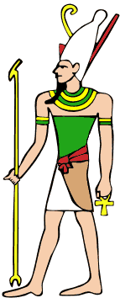

Ancient Egyptian Gods Comprehension

Introduction
There were hundreds of gods and goddesses in ancient Egypt. Often they had the body of a human and the head of an animal, which is quite strange to us!

Animal Heads and Human Bodies
They chose animals who were like the god, for example, the goddess of war had the head of a lion, because lions are very strong and win in battle.

Ra
Ra was one of the most important Egyptian gods.
They believed that Ra was in control of the
seasons. He had a Sun disk on his head.
He had a falcon head because falcons have very
good eye sight and they thought he would soar
across the sky and watch everything on earth.

Anubis
Anubis is one of the best known Egyptian gods. Anubis
had the black head of a jackal. Ancient Egyptians
believed that Anubis would help to decide who would
go on to the Afterlife.

Conclusion
Now you know the names of some important Egyptian gods and why some of them have animal heads, why don’t you find out more about them yourself?

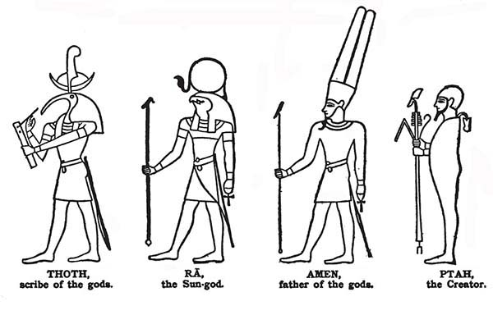

Reading Comprehension
1. How many Ancient Egyptian gods and goddesses were there? (Introduction)
____________________________________________________
2. What seems strange to us? (Introduction)

______________________________________________________

3. Why was the goddess of war shown as a lion?
(Animal Heads and Human Bodies)
______________________________________________________

4. Who was one of the most important Gods?
______________________________________________________

5. Why did Ra have a falcon’s head? (Ra)
______________________________________________________

6. Which sort of animals was the god Anubis? Tick one box

□camel □ jackal
□rhino □ crocodile

7. What did the Ancient Egyptian believe Anubis helped to do?
_______________________________________________________

8. In the conclusion what does it suggest you could do now?
_______________________________________________________

