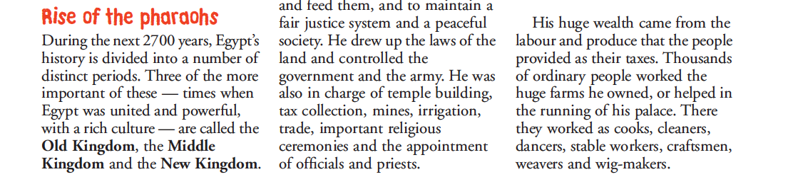
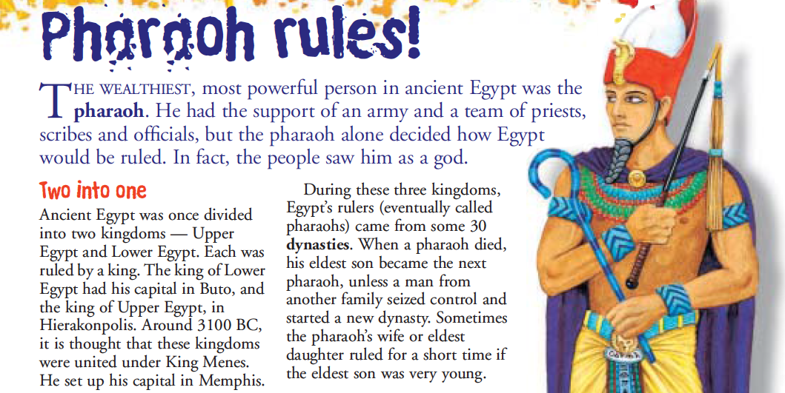
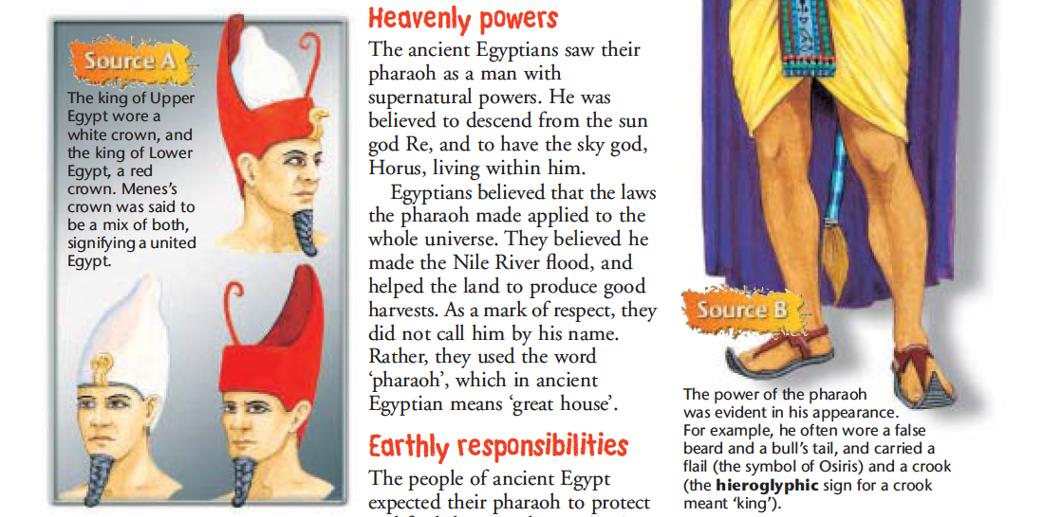

Egyptian Pharaohs

- Who was the first Pharaoh of Egypt, he united upper and lower Egypt?
A: Ramses II B: King Menes C: Tutankhamen

- What are the names of the three periods when Egypt was united and powerful?
A: 1st Period, 2nd period and 3rd periods
B: Old period, Middle period and New Period
C: Old Kingdom, Middle Kingdom and New Kingdom

- When a pharaoh died who usually took over control of the kingdom?
A: His first born Daughter
B: His first born Son
C: Another family would seize control

- What was started when another family took control of Egypt?
A: A new dynasty B: A new Kingdom C: A new Empire

- Explain why the Ancient Egyptian thought that laws made by the Pharaoh applied to not only Egypt but the whole universe as well.
_____________________________________________________________________________________________________________________________________________________________________________________________
- What did the people of Egypt expect from their Pharaoh?
_____________________________________________________________________________________________________________________________________________________________________________________________
- Make a list of things the Pharaoh was in charge of.
____________________________________________________________________________________________________________________________________________________________________________________________________________________________________________________________
- Where did the Pharaohs wealth come from?
_____________________________________________________________________________________________________________________________________________________________________________________________
- Extension: Think about what you know about the word ‘Dynasty’. Explain what you think a dynasty is. _____________________________________________________________________________________________________________________________________________________________________________________________

Both
Queen Elizabeth II Egyptian Pharaoh
Queen Elizabeth II VS an Egyptian Pharaoh

Queen Elizabeth II Vs an Egyptian Pharaoh

Queen Elizabeth II and the Egyptian Pharaoh are similar because ____ ________________________________________________________________________________________________________________________________________________________________________________________________________________________________________________________________________________________________________________________________________________________________________________________________________________________However, they are different because Queen Elizabeth _______________
________________________________________________________________________________________________________________________________________________________________________________________________________________________________________________________________________________
________________________________________________________________________________________________________________________________________
Where as the Egyptian Pharaoh _____________________________________
________________________________________________________________________________________________________________________________________________________________________________________________________________________________________________________________________________
________________________________________________________________________________________________________________________________________

