Influences on a sense of self

Influences on me

- What five things significantly influence you?

5 things that influence me
1.
2.
3.
4.
5.

- How does the degree of influence change in different situations for each?

- What factors had the greatest influence on you when you were in Year 4/5? Why?

- What factors do you think will have the greatest influence on you when you are in Year 10? Why?

- Explain how the factors that influence you may change as you become older.

What can and can’t I control?

- Explore the ways in which each of the factors below influence a person’s sense of self by completing the tables.
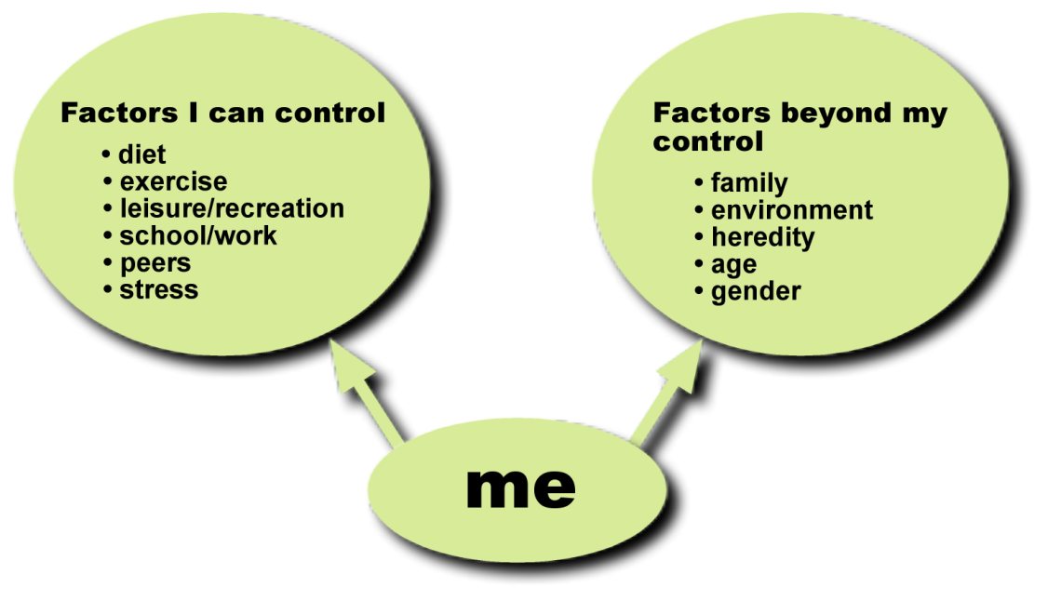

Factors I can control | How can they influence a person’s sense of self?
1. Diet
2. Physical activity
3. Leisure/recreation
4. School/work
5. Peers
6. Stress

If you feel like you do not have control of some of these factors, describe strategies that you could put in place to take control of these.

Factors beyond my control | How can they influence a person’s sense of self?
1. Family
2. Environment
3. Heredity
4. Age
5. Gender

