A Sense of Self
Our sense of self is mad up of four parts-
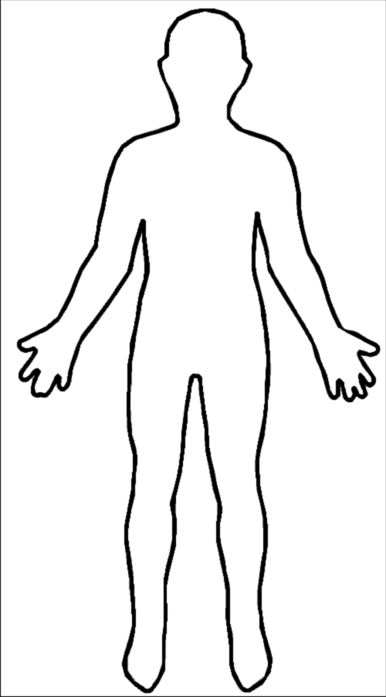
Weather we do or don’t feel a connection to the mysterious affects our sense of self. For some people religion is important to who they are.
Our relationship with other people affects how we feel. Positive friendships can help us have a good sense of self.
This is our mental health. The way we think, feel and behave is affected by our mental health and this affects our sense of self.
This is how we see our body. How we feel about our bodies affects how we feel about ourselves.
Spiritual Self
Social Self
Physical Self
Mental/Emotional self

